Introduction to redcap
Basic user guide

Version. 1 February 2023
Contents
Overview 6
Level of Support 7
Online Help 7
Additional Education and Training Resources 7
Logging into REDCap 8
Request a REDCap project 8
Navigating from within a Project 8
Project Access 8
Your Project’s unique ID 9
Project Status 9
1. Development 9
2. Production 9
3. Inactive 9
4. Archived 9
Project Setup 9
Main project settings 9
Use Surveys in this Project 10
Use Longitudinal Data Collection 10
Modify Project Title, Purpose, etc. 10
Design your Data Collection Instruments 10
Navigating to Online Designer 11
Data Collection Instruments 11
Enable Optional Modules and Customizations 11
Repeatable Instruments 12
Auto-numbering for Records 12
Scheduling Module (longitudinal only) 13
Randomization Module 14
Designate an Email Field for Sending Survey Invitations 14
Additional Customizations 14
Setup project Bookmarks 19
User Rights and Permissions 20
Test your project thoroughly 20
Purpose of Testing 20
Adding Test Data 20
Save Options for Data Entry 21
Adding Test Data for Surveys 22
Move project to production status 23
How to Move Your Project to Production Mode 24
Advantage of Being in Production Mode 25
Making Design Changes in Production 25
Project Status Change 26
Online Designer 26
Create a New Form 27
Delete a Form 28
Reorder Forms (Move instruments) 28
Caution on moving instruments 28
Rename a Form 29
Designing within an instrument 30
Record Identifier 31
User-generated record identifier or auto-numbered identifier 31
Add Fields to Your Data Collection Instruments (add questions to your data collection instruments) 31
Choosing a field type 32
Field Elements 33
Examples of Field Types 34
Edit, Copy, Move, or Delete a Field 49
Stop Actions for Survey 50
Add Branching Logic 50
Add Piping Logic 53
To see Piping in action, you may view a live demo of Piping on a survey. 54
Add Styling with HTML and CSS 55
Shared Library 55
Smart Variables 55
Enabling Repeatable Instruments 56
Surveys 57
Quick Guide to Survey Setup 58
Enable Surveys within the Project 58
Enable your Instrument as a Survey 58
Stop Action 59
Enable Repeating Instruments for a Survey 60
Survey Login 62
Survey Settings 64
Survey Status 64
Basic Survey Options 64
Survey Design Options 64
Survey Customizations 65
Survey Access 68
Survey Termination Options 70
Survey Inactive Options 73
Best Practices for Survey Settings when Collecting Personal Health Information 77
How to Change an Instrument from a Survey back into a Data Entry Form 77
reCAPTCHA 77
Survey Notifications 78
Survey Delivery Options. 78
Automated Survey Invitations (ASIs) 90
Longitudinal projects 99
Project Setup 100
Design instruments 100
Enabling repeating instruments and events in a longitudinal project 101
Design your event grid 101
Define My Events 102
Designate instruments for My Events 103
Defining Arms 105
Creating a new record: Arms 105
Switching Arms: Correcting an incorrect arm assignment 106
Switching Arms: Progression through study 107
Scheduling 107
Enabling scheduling module 107
Create a schedule 108
Automatic generation of schedules 109
View/edit schedules 109
Calendar 109
Calendar Events 110
Exporting longitudinal data 110
Longitudinal reports 111
Importing data for longitudinal projects 111
Public survey links within a longitudinal project 112
Double Data Entry 112
Codebook 113
Collapse/expand instruments in Codebook 114
Data dictionary 115
Making changes to your project with the Data Dictionary 116
Download current Data Dictionary 117
Download the Data Dictionary 117
Edit the Data Dictionary 119
Saving the Data Dictionary 120
Upload the Data Dictionary 120
Viewing Data Dictionary history 121
Other Functionality 121
Move to inactive Status (production only): 122
Move to production status 123
Copy the project 124
Delete the project (development only): 126
Archive the project 127
Data 128
Add data 128
View data 129
View individual record 129
Search records 131
Record status dashboard 131
Viewing Aggregate Data 132
Printing PDFs of your Data 132
Change Data 134
Edit records 134
Delete Records 136
Double Data Entry 137
Applications 137
Alerts and Notifications 137
To create Alerts and Notifications 138
Optional setting in Alert 142
Deactivating Alert 144
Editing Alert 144
Data Exports, Reports and Stats 145
Create a Custom Report 145
Custom report: step 1 146
Custom report: step 2 146
Custom report: step 3 147
Custom report: step 4 148
Managing and using your Reports 149
1. View Report 149
2. Export Data 149
4. Edit report 149
5. Copy report 149
6. Delete report 149
7. Reorder report list 150
Reports and Data Exports with Repeating Instruments and Events 150
Export Data 151
Export Formats 152
De-identification 152
Downloading 153
Note on CSV Files 153
PDFs and Other Export Options 154
Data Import Tool 155
Import Template 155
Importing to Checkbox Fields 155
Importing to Data and DateTime Fields 156
Importing to Data Access Groups 156
Calculated Fields 156
Upload File 156
Upload Summary 157
Data Comparison Tool 157
Logging 158
Field Comment Log 159
File Repository 160
Data Export Files 161
Upload New File 161
Data Access Groups (DAGs) 162
Adding Users to DAGs 163
Data Imports 167
File Repository 169
E-signature and Locking Management 170
Data Quality 171
eConsent 173

Overview
REDCap (Research Electronic Data Capture) is an electronic data capture (EDC) system that is HIPAA compatible, web-based, and easy to use. REDCap was developed by Vanderbilt University and is free to use by NSH affiliated researchers. REDCap is secured by Level 2 Access, UM Firewalls, Audit Trail and Data Back-up and is a user friendly, cost-effective alternative to Microsoft Excel and Access to capture and manage research study data.
You can think of a REDCap project as being analogous to a project database file from Microsoft Access: the terms ‘project’ and ‘database’ are essentially synonymous. Similarly, an Excel Workbook is analogous to a REDCap project, with the different instruments within a REDCap project being similar to the different tabs or sheets within an Excel workbook.
REDCap is used for:
- Research Data
- Single or Multi-site Studies
- Low to Moderate Complexity Studies
This REDCap study guide is a high-level application overview offering a structured, hands-on experience to create a basic research project.
The use of REDCap must follow the REDCap Terms of Services found on the NSH REDCap website: https://www.cdha.nshealth.ca/REDCap.

Level of Support
REDCap is available to all NSH affiliated end users at no cost. To keep the use of REDCap free to end users, we offer a self-serve model. This means that end users can take ownership in learning as much as they can through the resources built into REDCap, the trainings we offer and through testing projects themselves. Once you have tried all these resources, you are most welcome to seek help through the options below.

Online Help
You may access REDCap online help any time. Look for the following links in the top bar of your starting page.
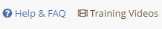

Additional Education and Training Resources
For additional REDCap training modules, please check this video
If you are unable to build a REDCap database by yourself or require additional training, the Research Methods Unit (RMU) can provide assistance on a fee-for-service basis. Please contact the RMU for specific assistance at RMU@nshealth.ca.
Definitions and Helpful Terms
REDCap | Research Electronic Data Capture
Data Collection Instrument | A form or survey created for capturing data. Similar to a sheet or tab within an Excel Workbook.
Record | Similar to a row in an Excel sheet.
Record ID | A unique identifier for each record in your database.
Record Status Dashboard | A table that lists all existing records and their status for every data collection instrument
Data Dictionary | A spreadsheet containing the data entry fields for your project
Variable | The name of the field or answer choice that is stored in the database
User | A person who is given access to a REDCap project (e.g. can login to REDCap and go into the project.) If you are the creator of a REDCap project, you are a user on that project. Anyone else you add to the project is a user on the project.
Participant | A person who completes a survey. This person does not see other participants’ survey results because they are not logging into REDCap to enter their results.
Survey | Data collection instrument that can be completed by someone who is not a user on a REDCap project.
Project | Similar to an Excel workbook. Contains the instruments that will capture your data. All instruments within a project are tied together.
Field Comment | Users with access to data entry forms may leave one or more comments on any field on a data collection instrument by clicking on the field comment, after which the balloon icon will stay lit up to signify that comments exist for that field for this record.
Online Designer | Allows you to create/modify/delete data collection instruments and fields

Logging into REDCap

Request a REDCap project
Please submit a project initiation form, which you can access here: https://www.cdha.nshealth.ca/REDCap
Click on the link shown below to access the form:
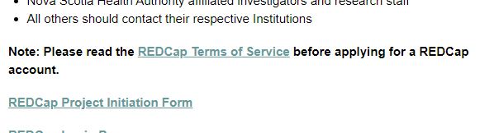
The REDCap administrator will set up the project and user accounts when the project is initiated. Please allow up to 10 business days for your REDCap project request to be processed. If you do not receive a response after 10 business days please email: REDCap.Administrator@nshealth.ca to inquire.

Navigating from within a Project

Once you are in a REDCap project, you will notice that the screen is divided into two parts:
1. The left-hand navigation menu, which you will always have access to when you are within a project
2. Your workspace, which is the area on the right. This is where you will be designing your project, entering data, viewing data, etc.
Your project itself is a series of webpages, made up of the different components of the left-hand navigation bar and your workspace. All of these pages are tied together via that unique PID.
You can click any of the buttons on the left-hand navigation bar or on your workspace and stay within the project. The only exceptions are:
My Projects – this button is essentially like hitting the escape key. It will take you out of your project to the page that lists all of your projects (the tab called “My Projects”)
The REDCap logo – this button will take you out of your project to the My Projects tab
You will notice that as you click on any of the buttons on the left-hand navigation menu or do any work in your workspace, your PID will be somewhere in the URL. You can right-click on any of the links within your project and open that page on a new tab.

Project Access
By default, a project is private. No one can access your project unless you add them as a user to the project.
Access to individual projects is coordinated by the project owner. The REDCap administrator will add to or remove users from projects upon request of the project owner.

Your Project’s unique ID
Each project has a project ID number (PID.) When you are within a project, you can see pid=xxxx in the URL (xxxx being your project’s unique id.)

Project Status

A REDCap project can exist in one of four status categories at any given time:

1. Development
A project in the design, setup, and testing phase. No real data is entered. By default, a project is in Development mode when it is created.

2. Production
Real data is being collected. Alterations to project configuration and setup are possible but should be infrequent and minor. A project is in Production mode only when a user on the project moves it to production. This is the final step on the Project Setup page.

3. Inactive
The project is essentially complete. Most functionality is disabled – including access to individual records – but data can still be exported.

4. Archived
As for inactive projects, functionality is limited. Moreover, the project is no longer shown in the My Projects list unless the Show Archived Projects option is selected.

Project Setup

You must have Project Design & Setup permissions to perform actions on the Project Setup page. In order to ensure quality, you may want to consider limiting the number of team members who have design and setup permissions.

Main project settings

Select your data collection type:

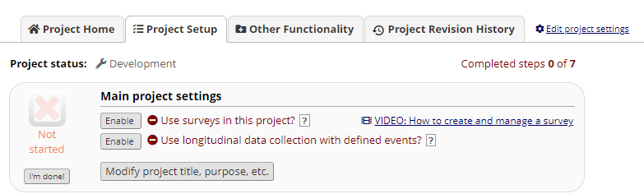

Use Surveys in this Project
Click Enable if your project will contain surveys. (Reminder – per the Helpful Terms above, you would enable surveys if the person entering the data is someone who is not a user on the project. For instance, if a research participant is entering the data about themselves). For more information on surveys, please go here.

Use Longitudinal Data Collection
Use longitudinal data collection with repeating forms: Click Enable if your project will contain instruments that will be used to collect data numerous times. For an example, you are going to collect lab results over ten visits for the same participant. Use surveys in this project: Click Enable if your project will contain surveys. For more information on surveys, please go here.

Modify Project Title, Purpose, etc.
Click this icon if you would like to change your project title or purpose.
Once you are finished with your main project settings, click “I’m done!” This will serve as a visual check mark that this section is completed. Note: You can always go back and change your settings while in Development mode.

Design your Data Collection Instruments
Online Designer: Click Online Designer to start building your data collection instrument(s). For more information on Online designer, go here.
Data Dictionary: Alternatively, you may upload your data dictionary via an Excel csv file in order to build your data collection instruments. Note: This is considered an advanced step and should not be used unless you are an experienced user. For more information on Data Dictionary, go here.

Navigating to Online Designer
You can access the Online Designer via the Designer link on the left-hand navigation bar under Project Home and Design:
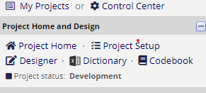
Alternatively, you can access Online Designers via the Setup page under “Design your data collection instruments”.
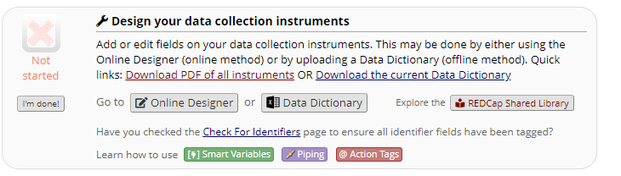

Data Collection Instruments
The term “instrument” is synonymous with “form” in referring to a discrete page on which data is entered and viewed in fields. In this context the terms “field” and “variable” are also essentially synonymous.
REDCap provides two methods for creating and editing data collection instruments: using the online designer and via upload of a data dictionary file that is composed in CSV [^] format, typically using Microsoft Excel.
For a video introduction to Instrument Development, please see this link. It is 6 ½ minutes in length. You can access the video from the Home or My Projects tab by clicking on Training Videos. If you are in a REDCap project, look on the left-hand navigation bar under the Help & Information section at the bottom of the navigation bar.

Enable Optional Modules and Customizations
The third box on the Project Setup page lists several optional modules that you can enable for your project:
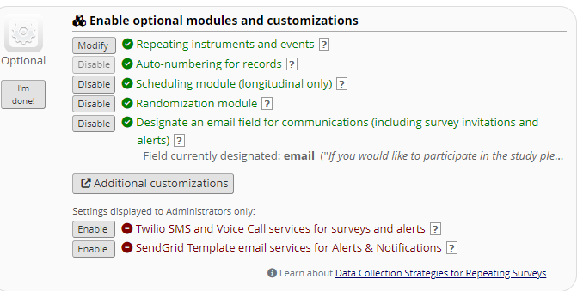

Repeatable Instruments
You can repeat a data collection instrument or a single predefined event dynamically and as often as you wish. This is useful when collecting data for multiple visits, concomitant medications, adverse events, or repetitive surveys (weekly, monthly, etc.) There is no need to pre-define a maximum number of repetitions, and the feature works in either classic or longitudinal projects.

Classic projects (i.e., in which the longitudinal module is not enabled) can utilize repeating instruments as a simple way of enabling longitudinal data collection.
For more information on repeatable instruments, go here.

Navigate to Project Setup, Optional Modules. Click “Enable” for repeatable instruments.

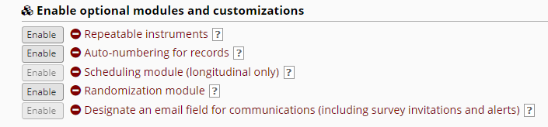

Note: You may repeat instruments and event in longitudinal projects.
Use the checkbox to indicate which data collection instrument may be repeated. For more information on how to use repeatable instruments, go here

Auto-numbering for Records
Auto-numbering will automatically be enabled for your project, unless you are using a project template that does not have it enabled. With auto-numbering enabled, you will see this when you navigate to the Add/Edit records page:
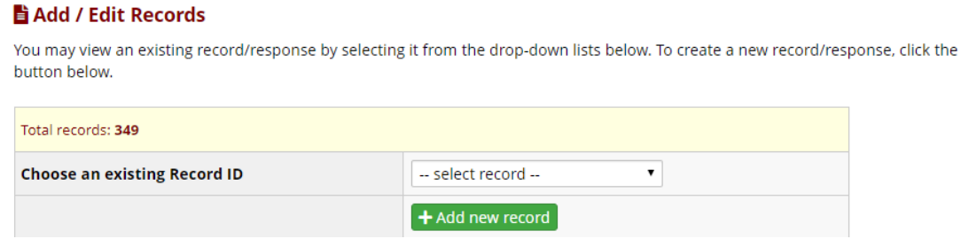
This option will remove the ability for users to name new records manually and will instead auto- generate a new unique record name, which will be numerical and will increment from the highest numerical record value in the project. If no records exist, it will begin with '1'.
If you want to create your own record identification, you may disable this feature and manually assign a record identifier.

Starting Record Numbering with a number other than 1
When using auto-numbering you can have your sequence begin with a number other than 1 using the following strategy:
- With record auto-numbering disabled, create a dummy record with an identifier one less than your desired start number
- Enable record auto-numbering
- Create a new record – this will become your first record
- Delete the dummy record
For example, if you want your first record to be numbered 1001, disable record auto-numbering, add a record with id=1000, enable record auto-numbering, create another new record (id=1001 will be assigned), then delete record 1000.

Manually Assign a Record Identifier
To manually assign the record identifier for your project, go to Project Setup and in the section ‘Enable optional modules and customizations’, click on the Disable button next to ‘Auto-numbering for records.’
When you go to Add/Edit records, you will see this (instead of the ‘Add record’ button:
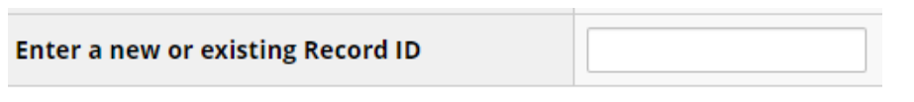
Enter the identifier you wish to use for the record and hit ‘enter.’
Please note: the Disable button will not be clickable if you already have records in your project or if the first instrument in your project is a survey.

Scheduling Module (longitudinal only)
The scheduling module can generate schedules for your project calendar that are auto-generated from project-defined events (e.g., visits, time-points). Scheduling is only available for projects using longitudinal data collection. To enable the scheduling module, your project needs to be enabled as a longitudinal project (under Step 1 on the Project Setup tab.) You can then click the enable button next to the Scheduling module in Step 3 of the Project Setup tab. For further information, see the Scheduling section of this User Guide. For further information, you can click on the question mark next to the module on the Project Setup page or search the Help & FAQ tab.

Randomization Module
Randomization is a process that assigns participants/subjects by chance (rather than by choice) into specific groups, typically for clinical research and clinical trials. This is considered an advanced feature so no further instructions will be available here. For further information, you can click on the question mark next to the module on the Project Setup page or search the Help & FAQ tab.

Designate an Email Field for Sending Survey Invitations
Enabled for use with Automated Survey Invitations or participant lists built via data entry form. Requires there to be a field within your project that is validated as an email field.
If you have a survey that you would like to have available via a public survey link (e.g. you don’t know the email addresses of the potential respondents) but then want to send a subsequent survey to the same respondents, this is a helpful feature. It requires you to request the respondent’s email address in the first survey. Then, when you use the ‘designate an email field’ module, you are telling REDCap that the email address captured in that initial survey is the email address that you want the subsequent surveys sent to. When participants complete the first survey, their email addresses will pre-populate the Participant Lists and will allow you to send additional surveys for the same record. E
Enabling this feature also automates the sending of survey confirmation emails (rather than relying on the survey participant to enter their email address on the survey completion screen to receive the confirmation email.)
Note: This feature should only be used if it is ok that survey responses are not anonymous.
For further information, you can click on the question mark next to the module on the Project Setup page or search the Help & FAQ tab.

Additional Customizations
There are additional features in RECap that can be customized. Select the “Additional customizations” tab and you will get a list of options:

Set a Custom Record Label
This tool assists you in identifying what is contained in a record (most commonly, the name of the person to whom the record belongs) when looking at a list of records (e.g. from the list of records on Add/Edit records or the Record Status Dashboard.) For instance, if you collect a person’s name in the project, you could set a custom record label to see that person’s name next to the record identifier. This will be visible via the add/edit records and record status dashboard as well as at the top of the form/survey. That way, you don’t have to open up the record to see who it belongs to.
To set a custom record label, go to the Project Setup page and under ‘Enable Optional Modules and Customizations’ click on “Additional Customizations”.

Tick the box and then put the variable names in square brackets that you wish to see next to the record identifier. In the above example, the variable name ‘fn’ captures the first name and the variable name ‘ln’ captures the last name.
Instead of this:
You will see this:

Design Tip:
You may decide to set the custom record label sometime after you have designed the project, so you may not remember
what you called the variable that you want to see in the record label. In those cases, you can check your Codebook to
see what name you gave the variable. You can access your Codebook via the link on the left-hand navigation bar
(under Project home and Design).

Designate a Secondary Unique Field
A field in addition to the primary record identifier for which REDCap will ensure the uniqueness of all values. Values will also be included alongside the primary record identifier in the record selection lists.
You may designate a text field to serve as a unique constraint whose value cannot be duplicated or shared by any other record in the project. When a value is entered or imported for the secondary unique field, it will be checked in real time to ensure it is not shared by another record, and if so, it will ask the user to enter another value. This means that if a participant is completing a survey for a second time in which this feature is enabled, they will see the following pop-up box:
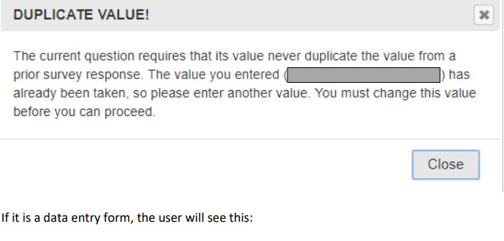
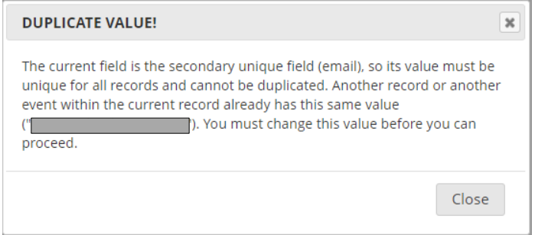
Note: this feature should be enabled before you start collecting real data. That is because if you are already collecting real data and there are duplicates in your project, you cannot enable this feature.
It is not possible to specify that the combination of two or more fields be unique.

Order the Records by Another Field
The default setup is that all records are ordered by their record name (e.g., Study ID) when displayed in the drop-down lists on your data collection instruments, but you may alternatively order the drop-down lists by the values of another field in the project (e.g., last name), if desired. If you wish to order the records by another field, you can select the field by which you wish to order records via this customization

Enable the Field Comment Log or Data Resolutions Workflow (Data Queries)
The Field Comment Log (enabled by default) allows users to leave comments for any given field on a data entry form by clicking the balloon icon next to the field.

PDF Customizations
Downloadable PDFs of data entry forms and surveys can be customized. See the options below:
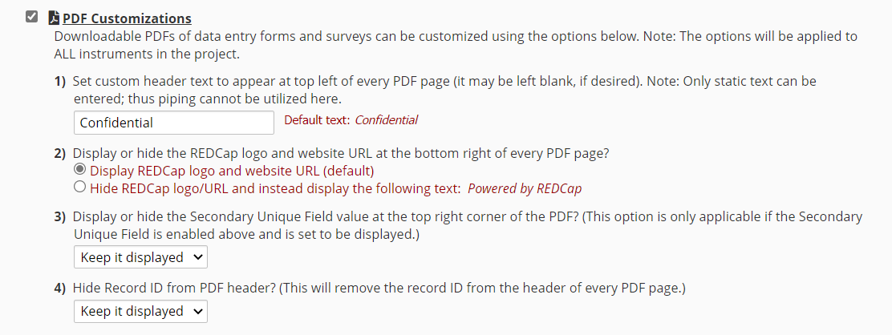

Missing Data Codes: Set up Your Missing Data Codes for This Specific Project
Fields that have a blank/missing value may be marked with a custom 'Missing Data Code' to note why the value is blank. These missing codes may be used to aid in data analysis by specifying why a field lacks a value. To enable this feature below, enter both the codes AND their labels for all the categories of missing data that you wish to use in this project. The missing codes should be coded just like the choices of a multiple-choice field with code + comma + label, in which the codes can only have letters, numbers, dots, dashes, and underscores (e.g., '-999, Not asked' or 'UNK, Unknown'). If no codes are entered, this feature will remain disabled.

Enable the Data History Popup for all Data Collection Instruments
When enabled, an icon will appear next to every field on a data collection instrument. When the icon is clicked, the history of all data entered into that field for that record will be listed chronologically and will display all previous values, who changed the value at each instance, and the time it was changed.
This setting is enabled by default. If you wish to disable the feature, go to Project Setup/Enable Optional Modules and Customizations, click on the Additional Customizations and un-tick the box (you will need to scroll down to see it):
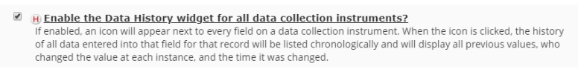

Enable the File Version History for “File Upload” Fields
The File Version History allows you to maintain previous versions of a file for a File Upload field on a form or survey. If a new version of a file needs to be uploaded for the field, instead of deleting the current file before adding the new one, you may simply upload a new file (via the 'Upload new version' link), in which all older versions will be kept and will be accessible for viewing/download in the Data History popup for the field. This feature provides the convenience of accessing older versions of the file instead of having to delete them. (Note: Older versions of a file will not be accessible anywhere else in the project except the Data History popup.
For instance, they will not be included in the zip file of all files uploaded for a given record or for the whole project.) Also, the Data History popup must be enabled (below) in order to use the File Version History.

Display the Today/Now Button for all Date and Time Fields on Forms/Surveys
If enabled, a 'Today' button will be displayed to the right of all date fields, and a 'Now' button will be displayed to the right of all time, date time, and date/ time/seconds fields. Clicking the button will automatically set the field's value with the current date or time. If you do not wish to have the Today icon appear next to your date fields, you may turn this setting off. Uncheck the box next to “Display the Today/Now button for all date and time fields on forms/surveys”.
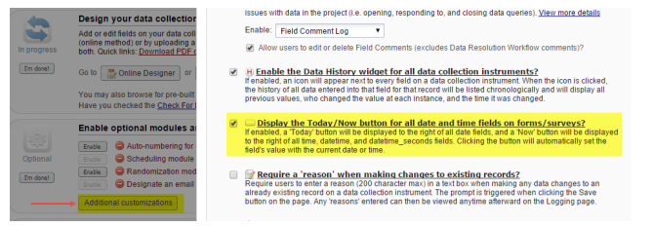

Note that this is a project-level setting – it is not possible to set this for individual fields.

Require a Reason When Making Changes to Existing Records
- With this option selected, the user must enter some text as a “reason for change” each time a form is saved – except when the record is initially created. The prompt is triggered when clicking the Save button on the page. Any 'reasons' entered can then be viewed anytime afterward on the Logging page.
Note: If the instrument does not yet have any data collected for it, then a reason will not be required (this includes importing data via the Data Import Tool). This feature is only triggered when adding, editing, or deleting data for an instrument that contains previously collected data for one or more fields on the instrument.
- Users may find this intrusive for longitudinal or multi-form projects as the dialog box appears even when entering new data on a form that is not the first form (i.e. when the record is created).

Data Entry Trigger
The Data Entry Trigger is an advanced feature. Enter a web address and whenever a data entry form or survey record is created or modified REDCap will post data to the specified URL.

Setup project Bookmarks
Your project is a series of webpages, so you can technically bookmark any one of those webpages and have it appear on the left-hand navigation menu. This will allow you to get to that page with one click. So, if you find yourself navigating to a particular section of your project over and over again and it is not already on the left-hand navigation bar, you can make it a bookmark so you can get to it in one click. You can also add a bookmark to any other URL outside of REDCap.
To add a bookmark of a page within your project:
- Copy the URL of the page you wish to bookmark (click on the browser bar, select all and copy)
- Right-click on the Project Setup link on your left-hand navigation bar and open link in new tab
- Scroll down to “Set up project bookmarks (optional)” and click on “Add or edit bookmarks”
- Paste the URL into the “Link URL/Destination box”
- Enter the name of the URL into the Link Label box (for instance, Online Designer or Codebook)
- Tick the box “Opens new window”
- Click the “Add” button
Once you have created your first bookmark within your project, you can go to the bookmarks section of your navigation bar and click on the “Edit” button to get to your project bookmarks. It’s only when setting up your first one that you have to go to the Project Setup page to access Bookmarks
Notes:
- Create a bookmark by completing the information required in the table row and click Add
- Bookmarks can be re-ordered by clicking and dragging a bookmark record
- Edit buttons 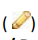 appear when you hover your mouse pointer over a bookmark’s Link Label
and Link URL / Destination values
- Use the delete button (X ) to remove a bookmark
- Link Type
  - REDCap Project: choose from the list of REDCap projects that you have permission to access
  - Simple Link: a simple URL to, for example, an external web page
  - Advanced Link: as with the Simple Link, a URL to, say, an external web page, but REDCap sends additional information (e.g. user and project info) to the target website as a means of verifying the identity of the REDCap user on that external site
- User Access: control which users of the current project can see the bookmark. Select either All users or select specific users individually by selecting Selected user.

User Rights and Permissions
In summary, the User Rights page enables you to:
• Add and remove access to your project for other REDCap users
• Control which Applications each user can access for your project
• Control the record operations that each user is permitted to perform
o Create records
o Rename records (i.e. edit a record id)
o Delete records
• Control the level of access each user is permitted to each specific data collection form
o No access o Read-only access
o Full edit access
• Define roles – templates of permissions – to which users may be assigned

Test your project thoroughly
It is extremely important to test your project before moving it into production!

Purpose of Testing
The purpose of a database - and the function of database software - is to provide your data with structure and integrity that cannot be enforced using unstructured formats such as text files or spreadsheets.
The purpose of testing your database is to ensure that it has the structure and integrity checks that you expect and that it meets your requirements.

Adding Test Data
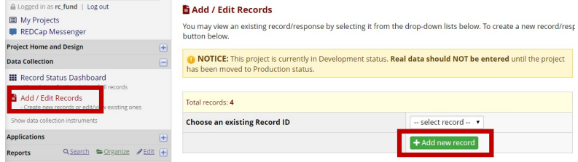
Try creating a few test records and enter some data to ensure that your data collection instruments look and behave how you expect, especially branching logic and calculations. You can do this by clicking Add/Edit Records on the left-hand navigation bar.
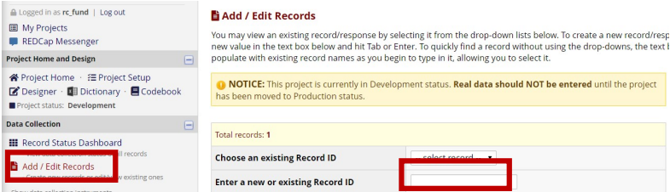
If you do not have auto-numbering enabled, you will enter the unique for the new record

If you have the auto-numbering feature enabled, you can click ‘add record’:
Enter test data into the data entry form

Save Options for Data Entry
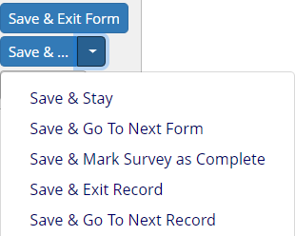
At the bottom of the page, you will see these options:

Save & Go To Next Form
Save and Go To Next Form is a good option if there are multiple instruments within the project and you want to enter data for the same record across multiple instruments. That option will take you to the next instrument for the same record you are currently on.

Save & Mark Survey as Complete
Save and Mark Survey as Complete is a good option if you are entering data on behalf of a survey participant. It’s important to use this option if there are subsequent surveys in the project. That is because if you are using the Survey Queue or Automated Survey Invitations, there are cases where the completion of an instrument AS A SURVEY determines whether or not a subsequent survey invitation gets sent. If you simply mark with one of the other save options, REDCap doesn’t know that the subsequent survey invitations should be triggered. Additionally, marking the form as a completed survey will generate a confirmation (if you have that set up in Survey Settings.) If you simply mark it complete as a data entry form, the confirmation email will not get sent.

Save & Exit Record
Save and Exit Record is an option you might use if you are only entering the data for one instrument for one record.

Save & Go To Next Record
Save & Go To Next Record is a good option when you are entering data for multiple records and you want to stay on the same instrument.

Adding Test Data for Surveys
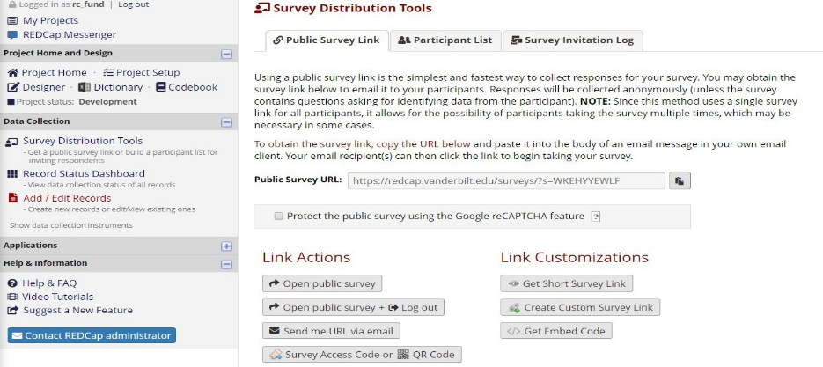If you have surveys, complete the surveys as if you were a participant by using the Public Survey Link. To access the public survey link, click on the Survey Distribution Tools link on the left-hand navigation bar and then Open Public Survey:

If you are not seeing the public survey link, that means you have either not enabled your first instrument as a survey or you have not set up your project to have surveys. You can enable surveys in your project in the first step listed on the Project Setup page. You can enable an instrument as a survey on the Online Designer page. (You can get to the Online Designer by clicking on the Designer button on the left-hand navigation bar under Project Home and Design.)

Specific Things to Check When Entering Data
- For continuous fields, such as dates and numbers, that have range validations, test around the boundaries by entering the minimum and maximum values (which should succeed) and then entering values just outside the valid range (which should trigger warnings). For example, if height should be 50 - 250 cm: ensure that 50 and 250 are accepted, and that 49 and 251 trigger a warning message.
- Test that your branching logic is working properly. For more information on branching logic, go here.
- Checked that required fields are marked as such.
Once you have some test records entered, review them by going to your Record Status Dashboard; create reports and export your data and view in Excel or one of the statistical analysis packages; review your Stats.
The best way to test your project is to use it as if you were entering real production data, and it is always helpful to have colleagues (especially team members) take a look at your project to get a fresh set of eyes on it.
Design Tip:
Test on the type of device that your participants will use to enter data
Designing a data entry form for use on a phone or tablet does not require many special considerations compared to data entry on a regular computer. However, it is important to test your forms on devices that will be used in the field. That way you will be able to identify any areas that may require changes.

One thing that can be worth considering is to use dropdown lists rather than text fields for entry of numbers. Even a lengthy dropdown list (one for weight, say, might have 20.0 kg up to 50.0 kg in 100g increments: 31 entries) might be easier for tablet users than a text box where they have to use the mobile keyboard.
Allow plenty of time for project development and testing.
This is the best way to ensure data quality once you start collecting data and that your forms/surveys function as you have intended. If your project has a deadline by when it needs to be launched, be sure to start testing it at least two weeks in advance. This will give you time to seek out our help if you have any problems.

Move project to production status
When a project is created, its default status is Development mode and any changes are deployed immediately, overwriting or deleting any existing data. This is fine because any data you are entering while in Development mode should only be test data, so it is ok if that data is damaged or deleted. Once you start collecting real data, however, it is always recommended that the project be in Production status.
Moving a project to Production status does three important things:
- It signals the data is real and important
- It makes the data recoverable in case of a data loss
- It creates a snapshot of the data dictionary so that when a database addition or edit is needed, any changes critical to the data are held until REDCap has the chance to review the impact of the change
You are strongly encouraged to test your project thoroughly before you move your project into Production.

How to Move Your Project to Production Mode
Once you have ensured your project is capturing all of the fields you need and has all of the design elements you want, contact the REDCap Administrator to request that your project be moved to production mode. Please make sure you let the REDCap Administrator know if your test data should be deleted before moving to Production Mode.

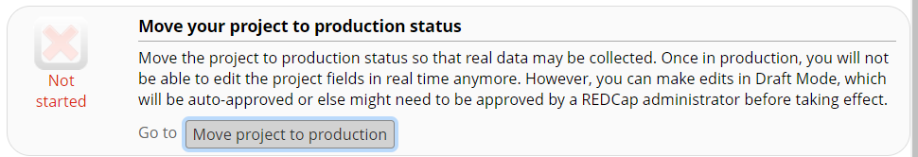
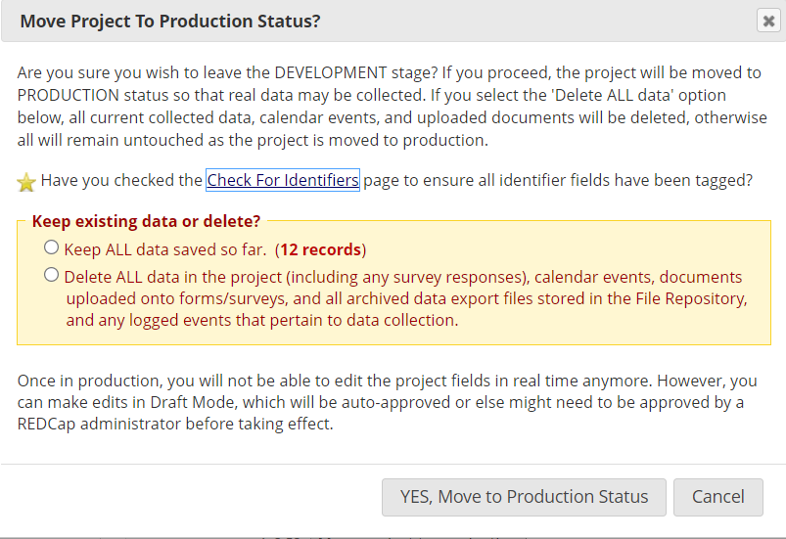

Check for Identifiers
Also note the Check for Identifiers step. It is recommended that you perform the check for identifiers to ensure that all fields that contain participant identifiers – or indeed may contain any information that could potentially be used to identify a participant – are marked as identifying fields. This helps to protect confidential data from access by users that are not permitted to view it.
Once in production, you can still make changes to your project design – it will just require a couple extra steps. You can make edits in Draft Mode, which will then need to be approved by a REDCap administrator before taking effect. Many times, these changes are approved automatically and within seconds.

Advantage of Being in Production Mode
If you make any design changes to your project while in Production, REDCap will check to make sure those changes don’t damage/delete your existing data.

Making Design Changes in Production
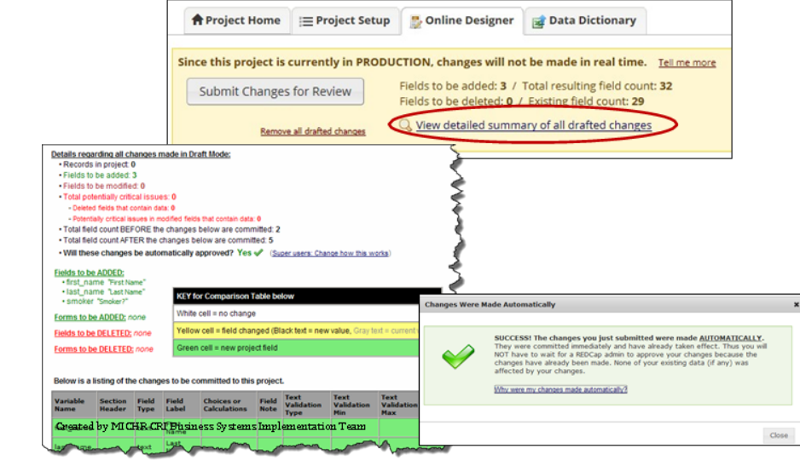
When your project is in Production mode, any design changes require that you change the Project Status to Draft Mode. When you access Online Designer, REDCap will prompt you to enter Draft Mode. Once in draft mode, you can make changes to the design of your instruments. You will then need to submit your changes for review. Prior to submitting the changes, you are encouraged to use “View detailed summary of all drafted changes’ to clearly understand the impact of the changes.

REDCap will automatically approve your changes for all non-critical post-production changes.
Changes that would result in data damage and/or loss will require written approval by you. The REDCap Administrator will send you an email, asking for your confirmation that you do wish to make the changes.
The changes will not go into effect until you respond to the email.

Project Status Change
Once your project is in production your project status will indicate Production on the left-hand navigation menu. Similarly, when you are on your My Projects page, you will notice that the icon next to your project name is changed from a wrench (for development) to a green box with a checkmark (for production.)

Online Designer
The Online Designer lists the instruments that exist in a project and provides functions for manipulating them at the instrument level (as opposed to the manipulation of items within an instrument). You can access Online Designer by clicking on the word ‘Designer’ on the left-hand navigation bar (under Project Home and Design’ or by clicking on the Online Designer button on the Project Setup page.
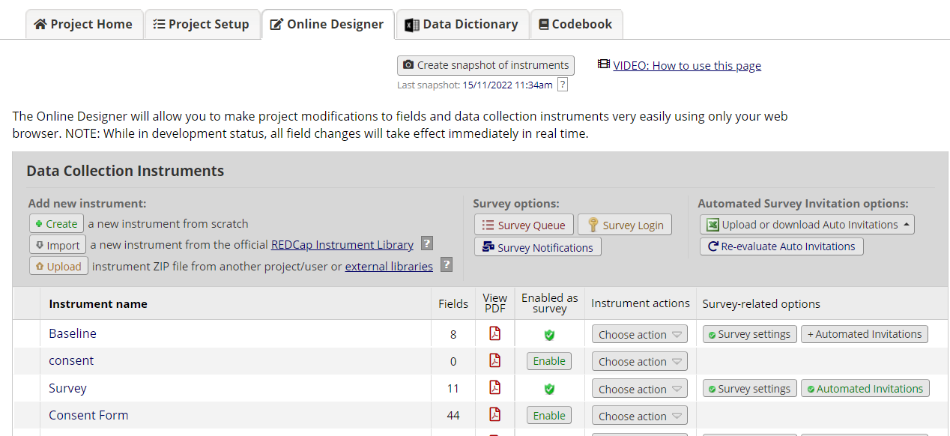

Create a New Form
1. Click Create
2. Click Add instrument here in the position in the list where the new form is to be created (this can be changed later)
3. Assign a name and click Create
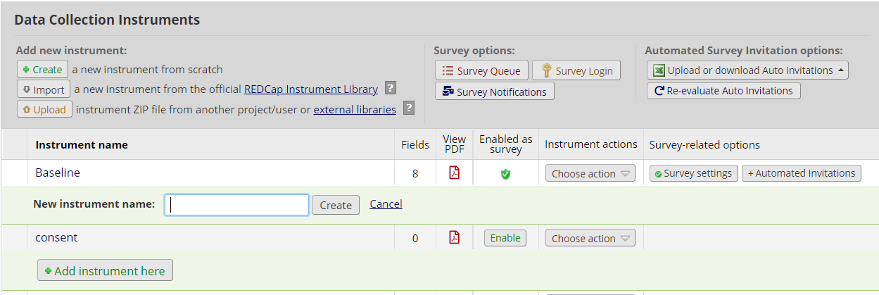
4. Add variables to the form. The new form will NOT be saved until at least one variable has been add

Delete a Form
1. Click the Delete button (under Actions) for the relevant form
2. Confirm the deletion. The form will be removed along with all of its variables

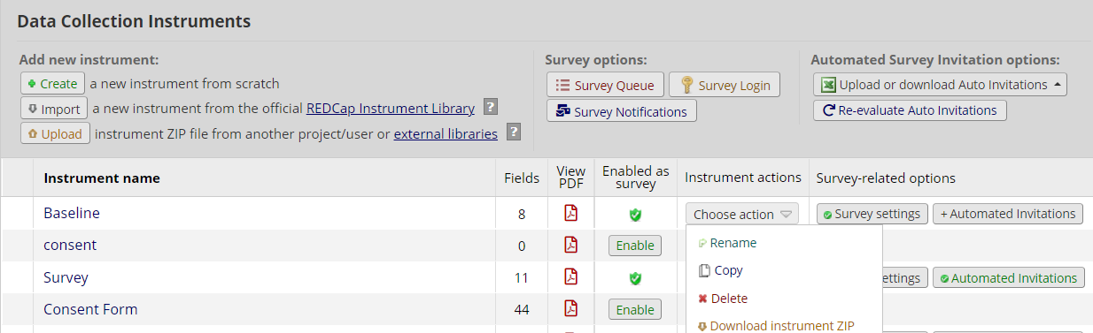

Reorder Forms (Move instruments)
1. Position your mouse cursor over the left-hand end of the form’s row
2. Click and drag the row to a new position

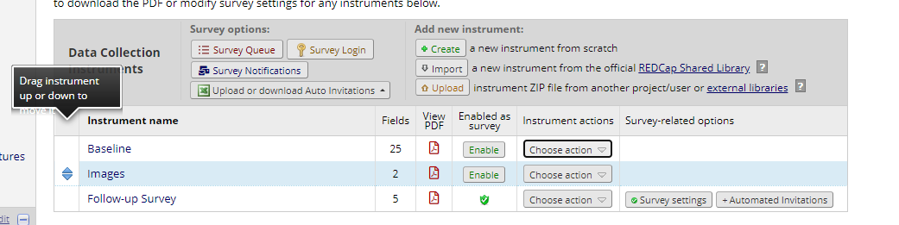

Caution on moving instruments
If you have surveys in your project and wish to use the public survey link, your survey needs to be the first instrument in the project, as seen in the image below:
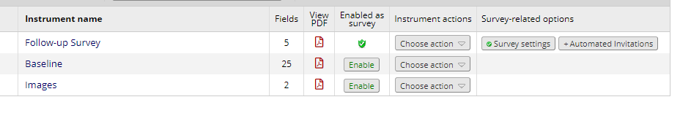

If the data entry form is first, as in the image below…
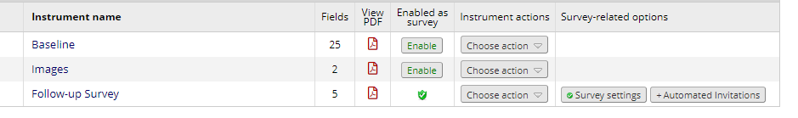
…your public survey link will be disabled.
Also keep in mind branching logic, piping and calculations when moving instruments. For instance, say you plan on entering data into Data Entry Form A, positioned as the first instrument within your project, which will then be piped into Data Entry Form B, positioned as the second instrument within your project. If you move Data Entry Form B to be the first instrument and enter the data into that form first, the field into which your piping should be seen on Data Entry Form A will not have a value.
Additionally, if you have a survey queue or auto-continue enabled, check to see how re-ordering the instruments impacts those features.
Finally, it’s a good idea to check the Survey Settings to see if you need to adjust the wording of the survey instructions and/or confirmation emails (if you have that enabled.) To get to Survey Settings, click on Designer on the left-hand navigation bar under Project Home and Design.
Please note that if you change the first survey (e.g. move survey B to come before Survey A), that changes the public survey link. If you had created a custom public survey link before moving the survey, that custom public survey link will no longer be valid. Any participant who clicks on the old survey link will get the message: Thank you for your interest, but you are not a participant for this survey. To solve this problem, delete the custom public survey link and then create it again.

Rename a Form
REDCap will begin your project with a data collection instrument titled “My First Instrument”. You will want to change the title so that it is reflective of the data you are collecting in it.
1. Click the Rename button (under Actions) for the form 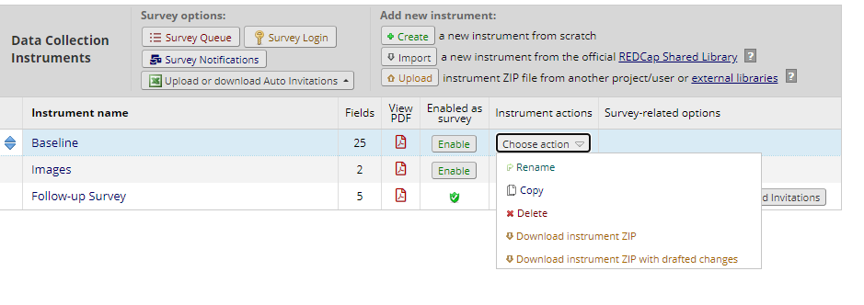
2. Enter the new name and click Save

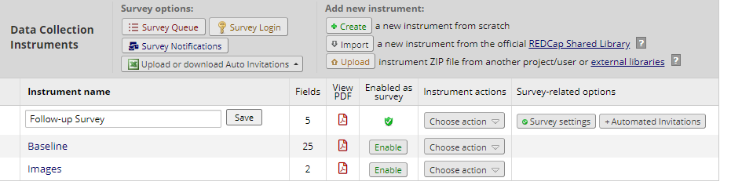

Designing within an instrument
To begin building your data collection instrument, click on the instrument name.
Design tip: add test records as you are designing your instrument.
This helps ensure that the instrument is coming along as you wish it to. Because your REDCap project is a series of webpages,
you can have the Online Designer open on one browser tab, and then have the Add/Edit records open on another browser tab.
Simply toggle back and forth between the two tabs to switch from design to adding test data.

Design Tip: Participant-Identifying Data
Think very carefully about exactly what confidential, participant-identifying data is required in your project. It is recommended that identifying information be kept separate from other project data, which can be done – in descending order of security by ensuring all identifying fields (see Check For Identifiers) are on separate forms to other data, and that access to these forms is restricted to the minimum set of users.

Record Identifier
As in any database, your project records must be uniquely identifiable. REDCap projects must all define a “record identifier” field as the first field on the first form
In any changes you make to your project’s data collection forms it is essential that the record identifier field remain the first field of the first form. The record identifier field cannot be deleted; however, you may rename this field by clicking on the pencil icon.

User-generated record identifier or auto-numbered identifier
The record identifiers can be automatically sequentially- generated (auto-numbered) or user-entered.
A good example of a user-entered identifier would be the patient’s MRN. A bad example would be a participant’s last name since there can be several individuals with the same last name (e.g. Smith, Jones, etc.).
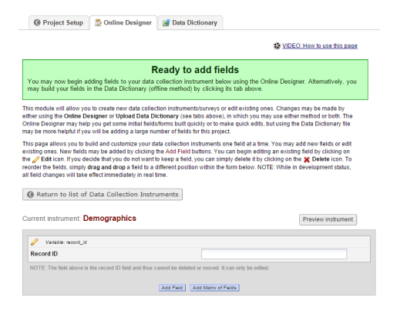

Add Fields to Your Data Collection Instruments (add questions to your data collection instruments)

- Click Add Field
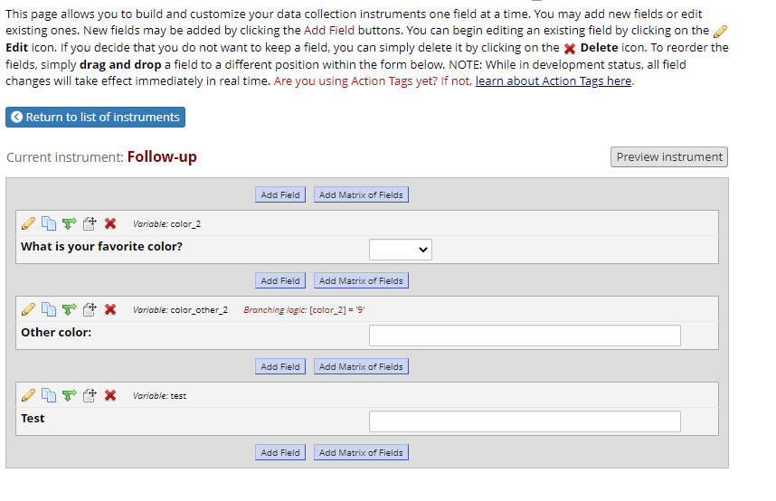
- The Add New Field dialog opens
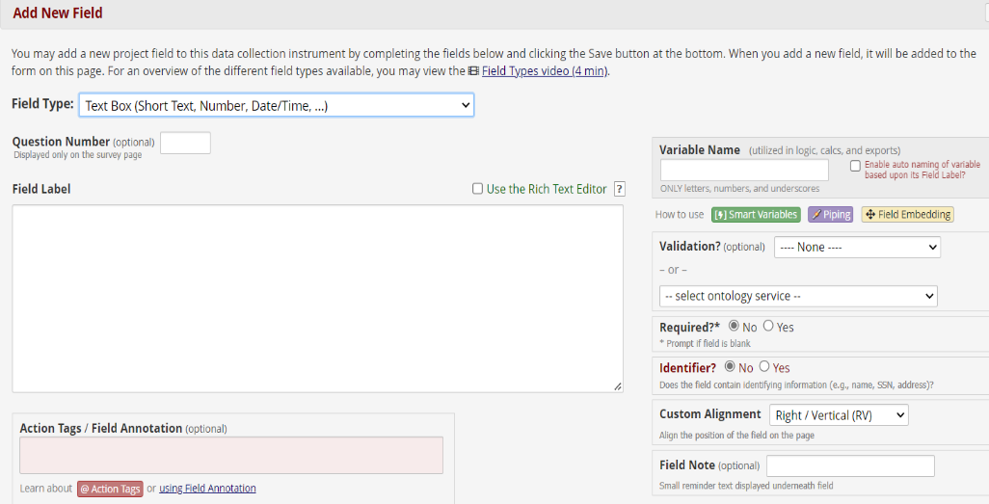

- Select one of the several field types available

- Enter your field elements (see further info below)
5. Click the save button

Choosing a field type
In general, it is best to select a field type that will collect data in a quantitative manner. For instance, select one of the multiple-choice field type options and provide a list of choices rather than selecting the text box or notes box field type and letting the person enter their own text. This prevents typos and ensures consistent data collection. Quantitative questions will yield graphical and statistical results.
If collecting alpha-numeric text, add validation, when possible, to restrict the type of text entered. Validation for these data points is available in the text box field type. For more information see Text Box (Short Text)

Field Elements
Once you have selected your field type, these are some of the elements available to you:
- Field Label: This is where you would format your question or data field.
- Field Annotation: This is primarily used for you to enter action tags and explanatory notes. These notes will not appear on your data collection instrument or survey.
- Variable Name: This is the name of your Field Label that is stored in the database and can be used in reports, exports and analysis. The variable names may contain letters, numbers and underscores but no spaces or special characters. If you decide to change the name of a variable prior to moving your project into production, you must change it everywhere that it is being used such as calculations, branching logic, etc.
- Required: Indicate if your field is going to be required. The default setting for all fields is set to No.
- Identifier: Indicate if your field is an identifier. All fields that could potentially identify a person should be marked as an identifier, regardless of who will be accessing your data. Especially for Research projects, you will want to mark identifying fields appropriately. This way, if you need to de-identify data, you can do so easily.
- To be HIPAA-compliant there are 18 pieces of information that must be marked as Identifiers in a project.
- Name
- Fax number
- Phone number
- E-mail address
- Account numbers
- Social Security number
- Medical Record number
- Health Plan number
- Certificate/license numbers
- URL
- IP address
- Vehicle identifiers
- Device ID
- Biometric ID
- Full face/identifying photo
- Other unique identifying number, characteristic, or code
- Postal address (geographic subdivisions smaller than state)
- Date precision beyond year

- Custom Alignment: Select the alignment for your field. The default setting is Right/Vertical.
- Field Note: Use this field to enter any notes, reminders or instructions for the person entering data.
Design Tip re: variable names
Variable names must be unique across your project. A best practice is to name your variables descriptively. For example, if you collect multiple dates in a project, provide each with a variable name to identify how the date relates to the project (visit date, screen date). This enables data exports (which utilize variable names) to have clear identifying information, differentiating variables from each other.

Action Tags
Action Tags are an excellent way to customize the data entry experience for surveys and forms. They are special terms that begin with the '@' sign that can be placed inside a field's Field Annotation when adding or editing a field. Each action tag has a corresponding action that is performed for the field when displayed on data entry forms and survey pages. You can use as many as you want for a single field, but if you do use more than one tag for a field, make sure to put a space or line break between them.
Because the action tags are used as part of the Field Annotation, they are not displayed anywhere on the page. To start using Action Tags, navigate to the Online Designer in a project, and when adding or editing a field, add the tag into the Action Tag/Field Annotation text box in the Edit Field popup.
For a list and definition of all action tags see this link.
Please note that Action Tags are case-sensitive. If you choose to manually type the action tag into the Action Tag box (rather than clicking on the Action Tag link and clicking on the ‘add’ button), you’ll want to write the Action Tag in all caps. If you were to type @hidden-survey, for instance, REDCap would not recognize that syntax. It needs to be @HIDDEN-SURVEY. Likewise, if you are referencing a variable name in an action tag (like you might when using the Default action tag), you need to make sure the variable name is in all lower-case.
Design Tip: Selecting the Field Type
In order to determine which field type you want, think about the type of data you wish to collect. In general, data is
more actionable if it can be captured quantitatively vs. qualitatively. Think of it as better to ask close-ended questions vs.
open-ended questions.
So, think about the question you are asking and see if it can be structured in a way that is close ended. For example, if you
are creating an employee directory, you could have a field in the directory that asks who the employee’s supervisor is. Technically you could leave that as an open-ended question. But if it’s a short list of supervisors, it would be better to make
it a multiple-choice question and list all the potential supervisors as the choices for that question.

Examples of Field Types

Multiple choice fields additional element
Choices: Enter the pre-determined choices for the question, one per line:
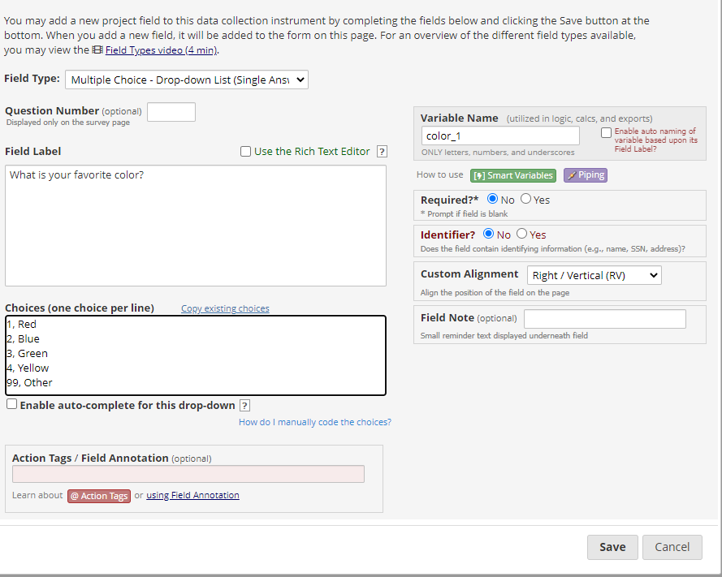

Text box field elements
For Text Box fields you have this additional element:

Validation: For the field type Text Box (Short Text) you have the opportunity to select a validation. If you would like to indicate how data in this field should be entered, use the drop down and select an option.

Validation Types
Date, Email, Integer, Number, Phone (North America), Postal Code (Canada), Time, Zip code (US)

Alphanumeric text
If you need the person entering data to enter alphanumeric text (rather than selecting from a pre-determined choice), you can select either the Text Box or Notes box as your field type.
If the text that will be entered is brief, select text box. If you want to allow more room for a response, select the notes box. You’ll see that the two options look different on the data entry form or survey because the Notes box is bigger. If you want the text to fit a certain format (like a date, email address, phone number, etc.) choose the Text Box field type. This will allow you to add validation, forcing the person entering data to enter data in the prescribed format.

Text Box (Short Text)
This field can be used to capture alphanumeric text. Use the Validation drop down whenever possible to restrict how data should be entered.
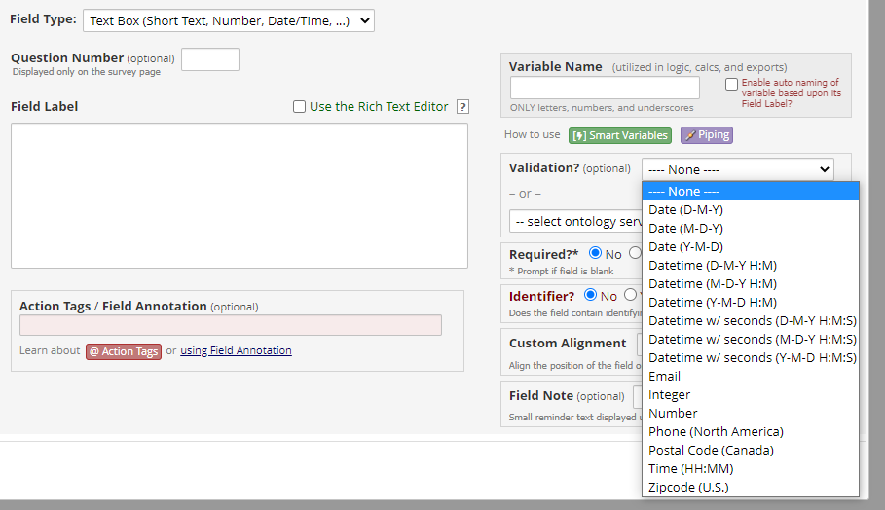

Design tip when collecting names
When collecting a person’s name, it is best to create two separate fields: one for first name and one for last name. This helps with sorting records.

Text Box (Short Text) with a validation of Date (M-D-Y)
The below example is a text box field with range checks (minimum and maximum fields). The field is marked as required and includes a field note.
How it appears in Online Designer:

How it appears to person entering data:

Text Box (Short Text) with a validation of email

Text Box (Short Text) with a validation of Number (allows decimals)

As a general rule, it is helpful to specify a range when using number validation.
Text Box (Short Text) with a validation of Integer (a whole number)
This field has range checks (minimum and maximum fields), is marked as required and includes a field annotation.
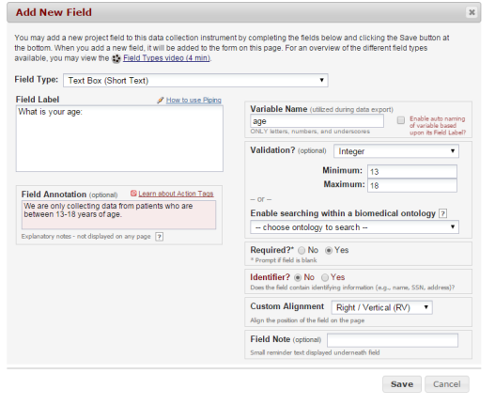
As a general rule, it is helpful to specify a range when using integer validation.

Notes Box (Paragraph Text)
This kind of field is helpful when you want to capture qualitative data and want the person entering the data to have a good bit of space in which to enter it. You’ll see that it is a bigger box than a Text Box field.

Calculated Field
This field can perform real-time calculations based on the data from other fields. For an example, you could create a calculation based off of the birth date field and visit date field in order to find out how old the participant was at the time of visit.
To make use of a calculated field, you must have two or more other fields created from which the calculated field will make its calculations. The fields from which the calculated field pulls must be text box fields validated as a number, integer or date.
Calculation results must be numeric, not text, Boolean or date/datetime. It is strongly recommended that you do not use "today" in calculated fields for age. This is because every time you access and save the instrument, the calculation will run. So if you calculate age as of today, a year later when you access the instrument to review or make updates, the age as of "today" will also be updated (+1 yr). A best practice is to calculate age utilizing a field collected in the course of the study (e.g. a fixed date such as screening date, enrollment date).
Build My Calc
If you need help writing your calculations, go to this link and provide the information requested. That link is an online, interactive tutorial designed to help you build your REDCap calculation one step at a time. The framework of the calculation is provided, and you fill in the blanks. How many blanks, and what kind of information is needed will depend on the calculation you want to build. As you specify the different elements, you can see them being added to the calculation in real time at the bottom of the page.
Design Tip: calculated field
When entering calculations, the syntax in your formula is very important. Note the difference between using square brackets -- used to designate REDCap variables and event names -- and round brackets or parentheses, which are used to group mathematical expressions. Variable names in the project can be used as variables in the equation, but you must place [ ] square brackets around each variable. Be sure that you follow the mathematical order of operations when constructing equations. Pay attention to open and closed quotation marks and brackets and parentheses.

Multiple Choice

Multiple Choice Drop Down List (Single Answer)
This field will display your answer choices as a drop-down list. This is helpful when you have a long list of choices and want to save screen space.
When a field contains multiple answer choices, you must give each answer choice a raw value. If you do not, REDCap will automatically assign them for you.

Auto-complete for drop-down choice
REDCap has an auto-complete feature for drop-down fields. When this is enabled, it allows the participant or data entry person to type in a couple of the characters of the answer choice and a list of matching options will appear. For an example, if I typed in Van, Vanilla would automatically appear. This is very helpful when you have a drop-down field that contains a large amount of possible answer choices.

Multiple Choice – Radio Buttons (Single Answer)
This field will display your answer choices as radio buttons. This means that all the answers are visible on the screen. This option is good if your list of potential answers is short.

Multiple Choice Checkboxes (Multiple Answers)
This field will display your answer choices as check boxes and will allow more than one answer.
Note: a field note that states “Check all that apply”.

Coding Suggestions for Multiple Choice questions - Unknown/Missing value
Code responses that represent an unknown type value with a number that is obviously out of normal range for any variable code or text response that makes sense or is missing.
Example: Has the patient tested his/her blood sugar levels every day this week?
1, Yes
0, No
97, Not Applicable
98, Other
99, Unknown
999, Missing

Reverse Coding
If questions have reverse scoring, code the selections according to the value unless otherwise specified. Here is an example, where #4 is coded normally and #5 is reversed:
4. Made me need someone to reposition me.
0, Never true for me
1, Rarely true for me
2, Sometimes true for me
3, Often true for me
4, Very often true for me

5. Helped me keep my muscles exercised.
4, Never true for me
3, Rarely true for me
2, Sometimes true for me
1, Often true for me
0, Very often true for me
Yes – No
This field will display Yes and No as radio button answer choices. Those are pre-populated by REDCap and cannot be altered.

Note:
The default setting for Yes/No questions is ‘1’ for the choice ‘yes’ and ‘0’ for the choice no. If you have other fields in your project that contain yes or no choices, you will want the choices to align the same. For instance, if you have a question with the choices yes, no, maybe, you would want the choice labels to be 1, 0, 2 to be consistent. Your statistician will thank you!

True – False
This field will display True and False as radio button answer choices.

Signature (draw signature with mouse or finger)
This field will allow the participant to add their signature digitally using their mouse or the finger (if using a tablet or touch screen device). It is sometimes called a digital signature or e-signature.

File Upload
This field gives the participant the ability to upload a file or image
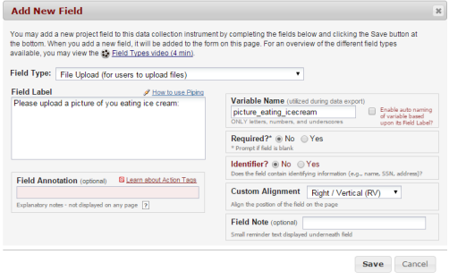
Be sure to test how your data results look when using this field type. Even if you set a number for the labels, those are not the values assigned to the data entered. All data is on a 1-100 scale.

Slider Visual Analog Scale
This field gives you a scale with three answer choices. If you select “Display number value (0-100)”, it will code the answer given.
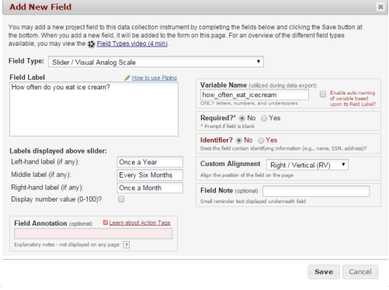
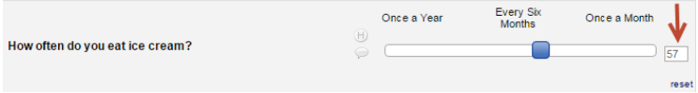

Be sure to test how your data results look when using this field type. Even if you set a number for the labels, those are not the values assigned to the data entered. All data is on a 1-100 scale.

Descriptive Text (with optional Image/File Attachment)
This field will allow you to add text such as instructions or additional information. It also gives you the option to add an image as a link or as an inline image.
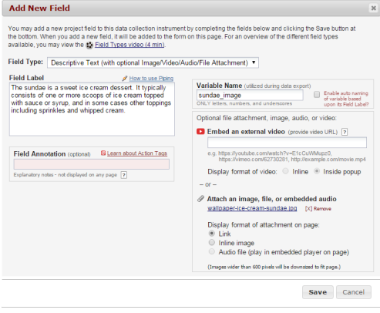
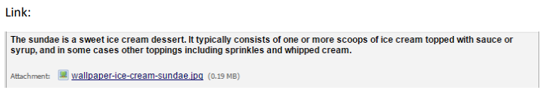
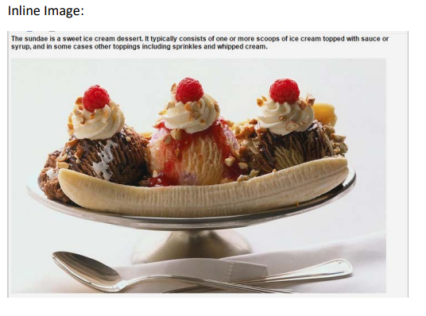
Because the content of a descriptive text field takes up the entire horizontal space, it makes a nice divider on the page. You can use that as an alternative to the ‘Begin New Section’ option, if you wish.

Begin New Section (with optional text):
This field is used as a section header. You can add text or leave blank.
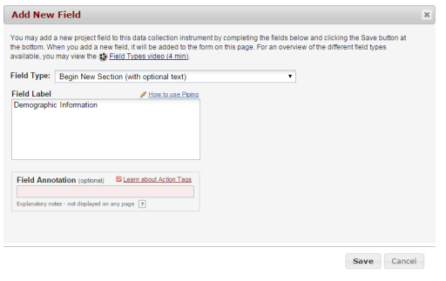
As a general rule, it is helpful to provide instructional text in headers. Example: Headache Disability: The following questions try to assess how much the headaches are affecting day-to- day activity. Your answers should be based on the last three months. There are no "right”, or "wrong" answers so please put down your best guess.
Please consider the following when adding ‘Begin New Section’
  - You cannot have two ‘begin new section’ field types in a row.
  - You cannot have ‘begin new section’ as the last field of an instrument
  - REDCap will automatically merge ‘begin new section’ with a matrix if the matrix follows the “begin new section” field.
  - When building an instrument that will have a lot of section headers, add a dummy field first, so that the section headers aren’t last.
Design Tip: When to add a “Begin new section” field
If the instrument is a survey and you want to break the survey up into several pages, you need to insert
“Begin New Section”, so that REDCap knows where to end/start a new page. Having a survey on multiple pages helps to break up the survey and prevents the participant from having to scroll down a long page to submit.

Matrix of Fields:
If you have a group of questions that all have the same answer choices, you can create a Matrix of Fields. Instead of clicking Add Field, you would click Add Matrix of Fields. You would add an optional header, your field labels and variable names, indicate which fields are required, add your answer choices and select whether these fields should be a single answer (radio button) or multiple answers (checkboxes). If you would like only one answer choice to be selected per column, enable ranking. You must also give your matrix a group name.
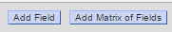
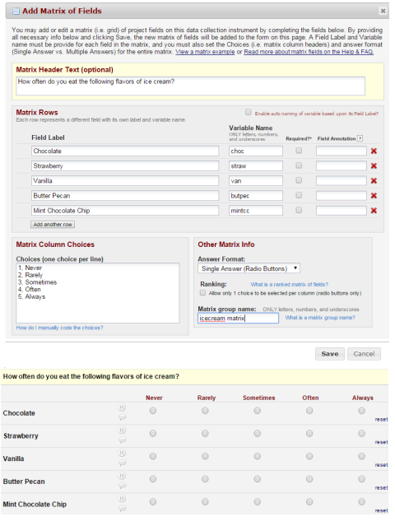

Enter the configuration information for your matrix:
  - Matrix Header Text: a section header to appear above the matrix
  - Matrix Rows: these are the fields that are incorporated within the matrix
  - Matrix Column Choices: the response values and labels shared by each field in the matrix
  - Answer Format: radio buttons or check boxes?
  - Ranking: with a radio button matrix you may opt for ranking. Ranking ensures no two fields in the matrix can have the same selected value for a column.
  - Matrix Group Name: a unique reference for the matrix
When adding a matrix field via Online Designer, you will not see the option for adding a Field Note unlike a regular field. However, you can download the data dictionary of your project and add your field note into column G, which is the column for Field Note.

Customizing Field Labels:
Simple HTML may be implemented in field labels. It may also be used to clarify or highlight information. Examples: <u>text</u> for underline, <i>text</i> for italicize, <div><span style='color:red;'>text</div> to color red and highlight the interviewer instructions.
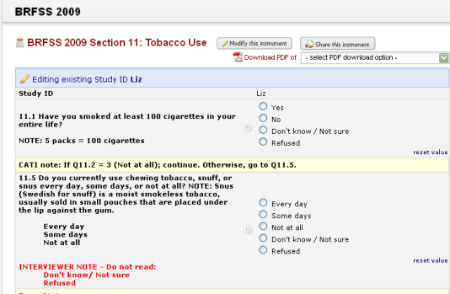
To learn more about HTML formats, see this link. It is an interactive online survey that provides information using HTML in REDCap.

Edit, Copy, Move, or Delete a Field:
Edit: To edit a field, click on the pencil icon
Copy: To copy a field, click on the double paper icon
Move: To move a field, click on the paper with pointer icon
Delete: To delete a field, click on the red X icon
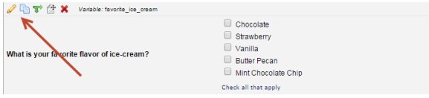

Stop Actions for Survey:
When an instrument is enabled as a survey, an additional option is included in the toolbar at the top of the field: the Stop Actions for Survey button, which appears as a stop sign. This feature allows you to prevent a participant from moving forward with a survey, based on how they answer a question. For instructions on how to set up Stop Actions for Surveys, please see this section of this User Guide.

Add Branching Logic:
Branching logic is used when you have a field/question that you only want to be visible when a specific answer is given to a previous question.
For an example, you might ask the below question:
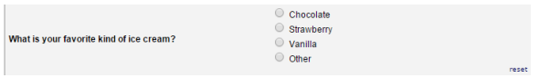
You’ll note that one of the choices is ‘other.’ If someone makes the choice ‘other’, you might want to ask a follow-up question to find out what this other ice cream flavor is. But you only want the follow-up question to appear if the answer to the previous question is the choice “Other”. To do this, you would create the follow-up question:

You would then, on the follow-up question, click on the double green arrows.
You will now see this logic builder:
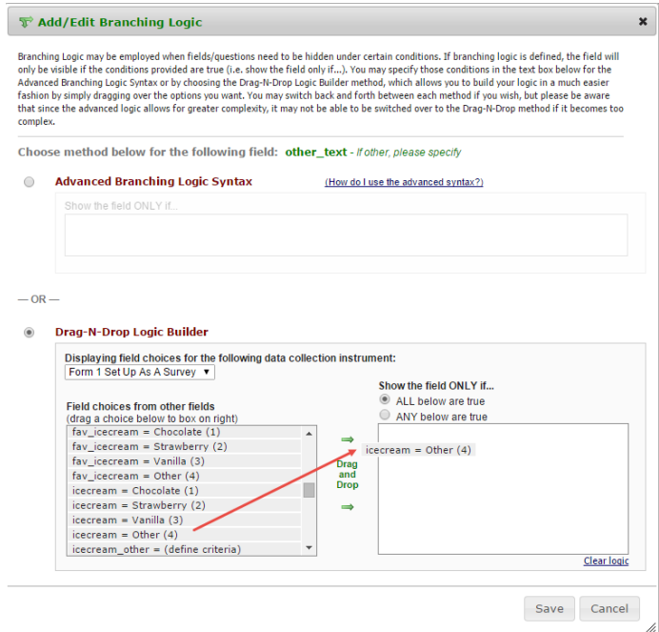
Click on the Drag-N-Drop Logic Building option and scroll through the list of field choices until you find the choice that should trigger this question (the follow-up question) to appear. In this example, you would select ‘icecream = Other (4)’. You then click on that choice and drag the field into the box on the right. Click Save once finished.
The field now indicates that branching logic exists.
This means that the question “If other, please specify’ will now appear to the person entering data only if they select the answer ‘other’ to the previous question.
You can have multiple elements to your branching logic. In other words, it could be a combination of answers to many different questions that can make a field appear.

Testing Your Branching Logic
Determining your branching logic can sometimes be tricky, especially if there are multiple fields that contribute to the branching logic. That’s why it is very important to test out your logic to make sure it is behaving the way you want it to.
To test your branching logic, add a test record (via Add/Edit Records on the left-hand navigation bar) and see if the questions appear/are hidden the way you wish them to. If you are using branching logic on a survey, open a survey and see if the questions appear/are hidden the way you wish them to Applying branching logic to multiple questions. If the branching logic is on the first survey in your project, you can go to Survey Distribution Tools and click on Open public survey and enter test data there.
If you want to apply the same branching logic to multiple questions, it is sometimes easier and faster to use the Data Dictionary to accomplish this. Using the Data Dictionary allows you to copy and paste the branching logic into multiple fields very quickly.
To do this, you would:
- Create the branching logic within one of the fields via Online Designer
- Go to your Data Dictionary (when you are in Online Designer, scroll up to the top of your page to see the tab for Data Dictionary)
- Download the current Data Dictionary
- Save your data dictionary somewhere on your computer – be sure to note where you have saved the file
  - Be sure to keep the data dictionary in .csv format – do not convert it to an Excel workbook!
- Open the data dictionary and find the cell that contains your branching logic
- Copy the branching logic and paste it into the branching logic cells of the other questions for which you wish to apply it to
- Save your data dictionary
- Go back to the Data Dictionary page within your REDCap project
- Click on ‘choose file’ and find the file location of your updated data dictionary
- Click on upload file
Note: if you are making these changes while in Production mode, you will need to enter draft mode first, perform the above steps and then click on the “Submit Changes for Review” on the Data Dictionary page.
For more information on how to use the Data Dictionary, go to this section of this User Guide.

Caution on variable names in branching logic
While in development mode, you do have the ability to change a variable name. Please note that if that variable is used in branching logic elsewhere, REDCap will NOT automatically change the variable name in the branching logic.

Branching Logic across Instruments
In our example, a question is asked in survey 1 “Do you have type 2 diabetes?” This question has the variable name type2diabetes and the potential answers are yes or no. The raw value for yes is 1 and no is 0. Then there is survey 2 where the question is asked “Do you take medication for your diabetes?” The variable name is takediabetesmeds, the answers are yes or no and the raw value for yes is 1 and no is 0.
To set up branching logic so that the question “Do you take medication for your diabetes?” only appears in survey 2 when the person answers ‘yes’ to the question “Do you have type 2 diabetes?” in survey 1…
- In Online Designer, click on Survey 2
- Go to the field “Do you take medication for your diabetes?”
- On that field, click on the green arrows to access the branching logic.
- Click on the button next to Drag-N-Drop Logic Builder.
  - When you do that, you will see a drop-down box that lists all your instruments.
- Select the instrument from which you want to base your branching logic. In our example, we want to access survey 1.
  - You will now see all the variables (questions) that are in that instrument (in our example, survey 1.)
- You can scroll until you see the question type2diabetes = Yes (1) and type2diabetes = No (0) in the list.
- Click on type2diabetes = Yes (1) and drag it to the box on the right
- Click save
You now have branching logic on the question “Do you take medication for your diabetes?”. It will now only appear in survey 2 if the person answers yes to the question “Do you have type 2 diabetes?” in the first survey.

Add Piping Logic
Piping gives you the ability to insert answers and place it in various places within REDCap.
For an example, in the below example there is a field that asks the participant “What kind of ice cream do you like?” Next is a field that asks the participant “How often do you eat ice cream?” Piping logic is included in the second question so that it will insert the answer from the first question.
Before:
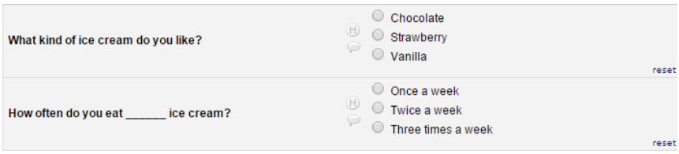
Once the participant answers the first question, the answer is then inserted into the next question.
After:
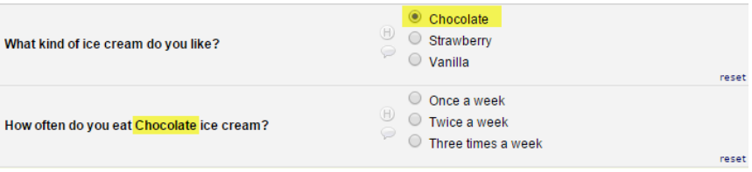

To add piping, add the variable name of the field you want to pipe in. The variable name must be inserted into square brackets [ ]. Note: if the variable you want to use for piping is not adjacent, consider opening the Codebook on one tab and do your design on another tab. This way you can easily reference the variable name in the Codebook. You can use the ctrl+F function to search through the Codebook.
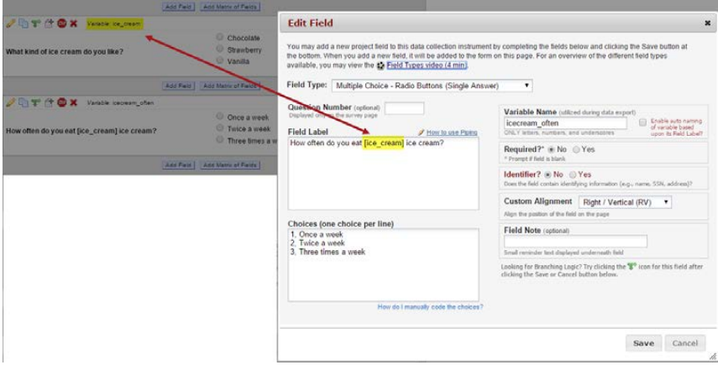
Piping can be used in many different places in REDCap such as:
- Field Label
- Field Note
- Section Header
- Matrix field column headers
- Option labels for multiple choice fields (radio, drop-down, checkbox)
- Slider field labels (i.e. text displayed above slider bar)
- Survey instructions and acknowledgement Text
- Survey invitation emails sent via Participant List or Automated Invitations - both in the subject line and in the message body

Piping in Longitudinal Projects
If your project is longitudinal and you want to pipe in data from an event that is not the current event, you need to pre-pend to the variable the appropriate unique event name also enclosed within square brackets, e.g. [unique_event_name][variable_name]. Unique event names can be found by going to Project Setup/Define My Events. You will see an events table, and the last column shows you the Unique event name, which is automatically generated by REDCap.
Piping tutorial

To see Piping in action, you may view a live demo of Piping on a survey.

Add Styling with HTML and CSS
Additional styling can be added to certain elements in your project using HTML tags with CSS styles. Examples include:
- Field labels
- Section headings and descriptive text fields
- Survey welcome and thank you messages
- Survey invitation emails
For more information for HTML and CSS, visit w3school.com.
To learn more about HTML formats, see this link. It is an interactive online survey that provides information using HTML in REDCap.

Shared Library
The REDCap Shared Library is a repository of validated data collection instruments that can be downloaded and used in your REDCap projects.
To access the REDCap Shared Library your project must be in Development (not Production) mode. You can access the library via two locations:
- The Project Setup tab – see the Design your data collections instruments section
- The Online Designer page – there is a button to import button
You can download any instrument from the library into your REDCap project.
If your project is in production status, you can also upload data collection instruments that you have created to the Shared Library. They will then be available for download by other REDCap users around the world.
Note: Do not share copyrighted material unless you are the owner.

Smart Variables
In REDCap Field Notation, variable names always point to data fields in the project. However, another type of entity exists called 'Smart Variables' that allow you to reference information other than data fields. Smart Variables are context-aware and thus adapt to many different situations in which they can know who the current user is, what event is currently being viewed, whether or not an instrument is being viewed as a survey or data entry form, etc. In this way, Smart Variables are dynamic (and thus 'smart') because they adapt to the current context in which they are used. Smart Variables are easily distinguishable from field variable names because Smart Variables will have dashes and colons whereas field variable names cannot.
Smart Variables can be used...
- On their own - e.g., [record-dag-name]
- In conjunction with field variables - e.g., [previous-event-name][weight_measurement]
- In conjunction with other Smart Variables - e.g., [previous-event-name][survey- url:prescreening_survey]

Enabling Repeatable Instruments
Navigate to Project Setup, Optional Modules. Click Enable for Repeatable instruments.
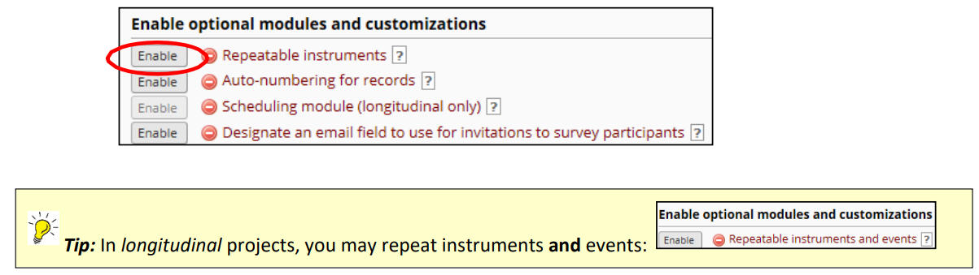
Use the checkbox to indicate which data collection instrument may be repeated.
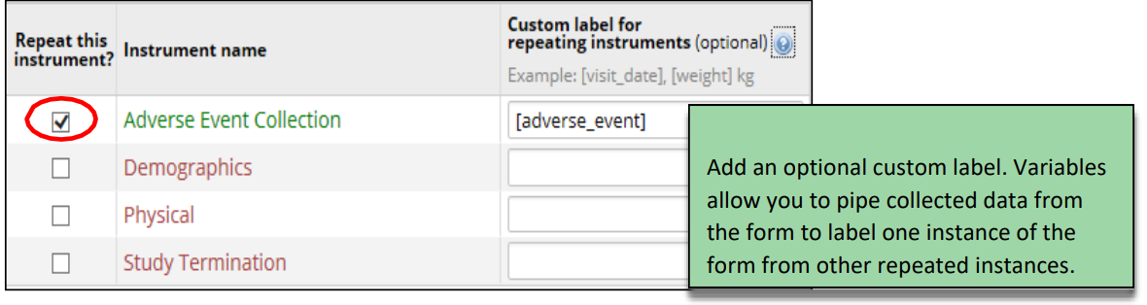

Data Entry for Repeating Instruments
During data entry, click “Save and Add new instance” to immediately create another instance of the instrument.
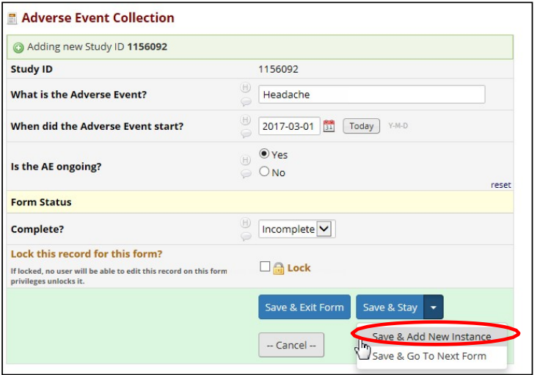
To add a new instance of the instrument after data entry, click the + sign from Data Collection or on the Record Home Page beside the form you want to repeat. Only Repeating instruments display the + sign.

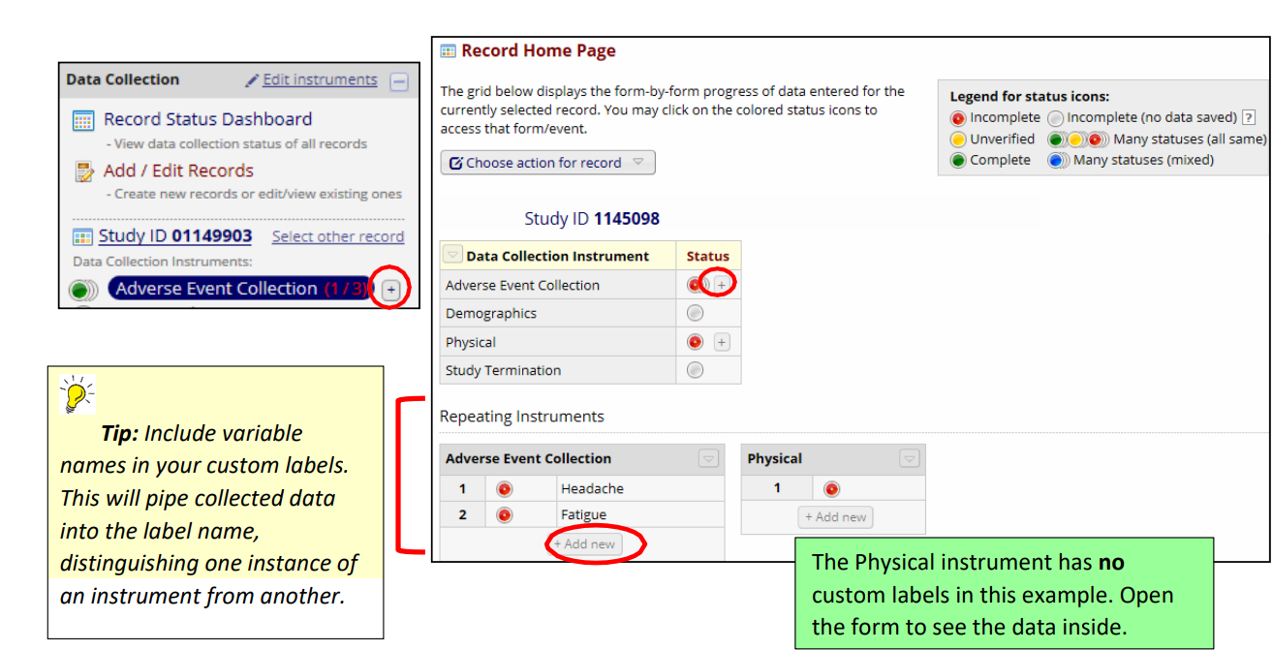

Viewing Repeating Instrument Status Icons
The Record Status Dashboard includes a legend specifying both individual instrument status icons, as well as icons for the repeating instances of an instrument. A single dot indicates a single instrument containing data. The “stacked” icons indicate multiple instances of the instrument.
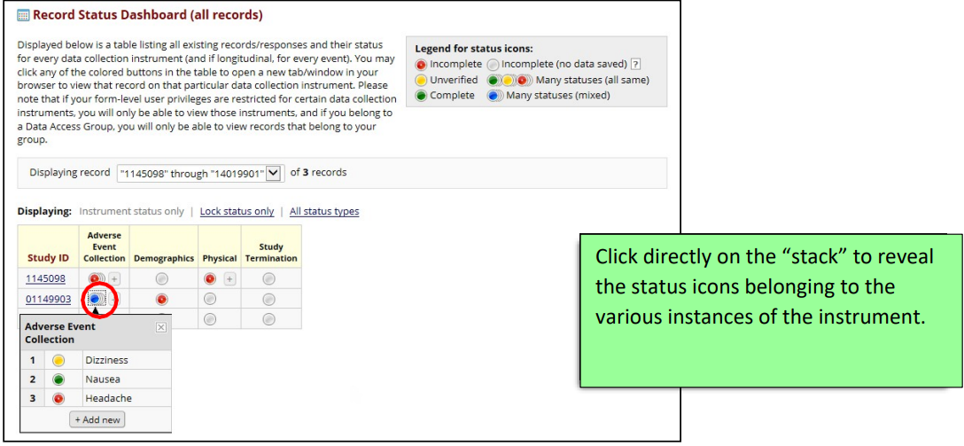

Surveys
There are three options in REDCap how you can work to design and manage surveys:
- Online Designer
  - Enter questions in an instrument
  - Enable instrument as a survey
  - Edit survey settings
  - Set survey notifications and survey login
- Project Setup
  - Enable surveys for project
  - Enable “designate an email field” (if applicable)
- Survey Distribution Tools
  - Access survey link
  - Communicate with survey participants
  - Track survey responses/invitations

Quick Guide to Survey Setup

You can enable a survey in three easy steps:
- Enable “use surveys in this project” on the Project Setup tab
- Enable instrument as a survey in Online Designer
- Save Survey Settings

Enable Surveys within the Project

If you plan to use surveys in your project, you must go to the Project Setup page and click the first option under Main project settings:
If your project is in Production mode, the Enable button will be greyed out:
You will need to click on the ‘Contact REDCap administrator button’ from within your project and request that the project be enabled for surveys.

Enable your Instrument as a Survey
Once you have enabled the “Use surveys in this project” setting under Project Setup, you will want to indicate which data collection instruments are going to be used as surveys.

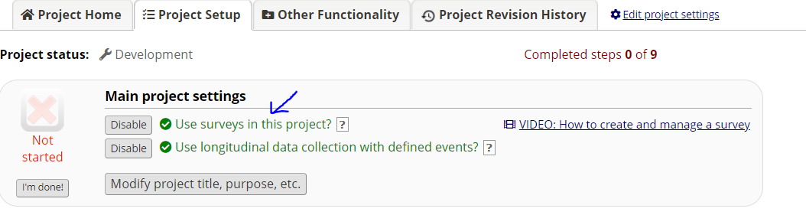

Under Online Designer, click “Enable” next to the data collection instrument you want to use as a survey.
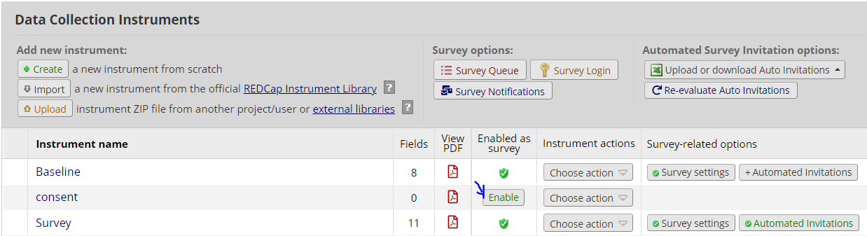

You will then automatically be brought to the page where you can setup Survey Settings. You can leave the default settings or make adjustments. But you must click the ‘save changes’ button in order for the instrument to convert to a survey. If you navigate away from the page and do not save changes, your instrument will remain a data entry form.

Stop Action
The Stop Survey action will prompt the survey participant to end the survey when a specific answer is given. The stop survey action is available on Drop-down List, Radio Buttons, Multiple Answers, Yes/No and True/False field types.
Once you have created one of the field types listed above and you have your data collection instrument set up as a survey, you will see a stop sign icon.
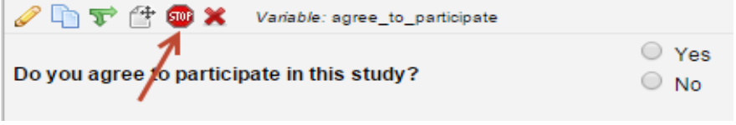
To add the Stop Survey logic, click on the stop sign icon. The Stop Survey logic box will appear. Select the answer choice that should prompt the survey participant to end the survey and click Save.
In this example, I want the survey participant to be prompted when they click No.

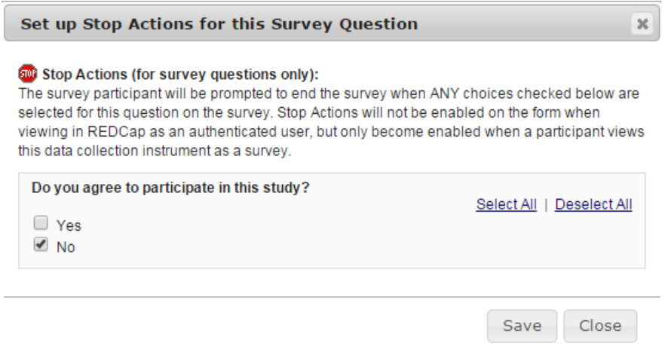

Notice that once the Stop Survey logic is setup, text appears next to the answer choice that will end the survey.
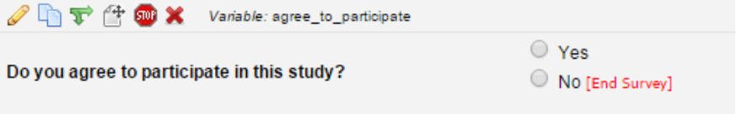

When the participant takes the survey and they answer No, they will receive the following message. The message is hard coded and cannot be changed. The participant can either choose to “End the survey now” which would take them to the Survey Acknowledgment text or they can choose “Continue survey and undo last response”.

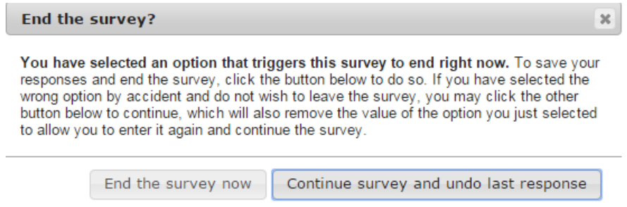

Enable Repeating Instruments for a Survey

A Survey can be set up as a repeating instrument. You need to complete the steps largely in order, however.
- Enable Surveys for the Project
- Build the Instrument (at the very least, name it)
- From Project Setup, Enable Repeatable Instruments. Click Modify to select the Survey(s) to be repeated
- From Online Designer, Enable the Instrument as a Survey, opening the Survey Settings page
- From Survey Settings, Survey Termination Options:
    - Check the Checkbox to Enable the Survey to be Repeated
    - Add optional custom text to the button
    - Select the location for the Repeat button to appear
    - Click Save
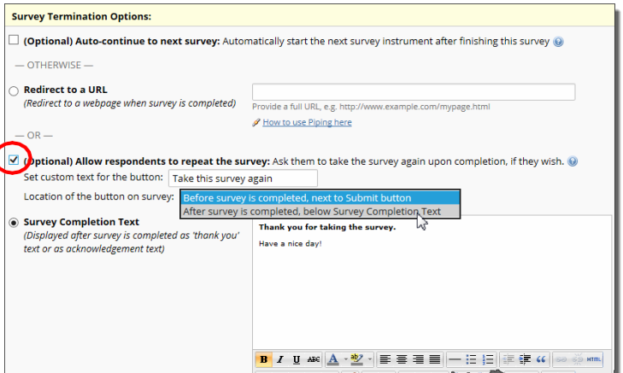

For more information about repeating instruments, visit this section of the user guide.
Survey Design Tip: Descriptive Text fields can be useful for displaying an error message of a cross-field validation check. For example:
<div class="red" style="font-weight:bold;">Diastolic bp should be less than systolic bp</div>
Used with a branching logic expression along these lines:
[systolic_bp]<>'' and [diastolic_bp]<>'' and [diastolic_bp]>=[systolic_bp]
Produces an outcome like this:

Survey Login
You can provide improved security for your surveys with a survey login form, in which respondents will be required to enter some login credentials – their date of birth, for example – in order to begin a survey or (if the "Save & Return Later" feature is enabled) to return to a previously entered survey response.
To enable the Survey Login feature, go to Online Designer and click the Survey Login button at the top of the instrument list.
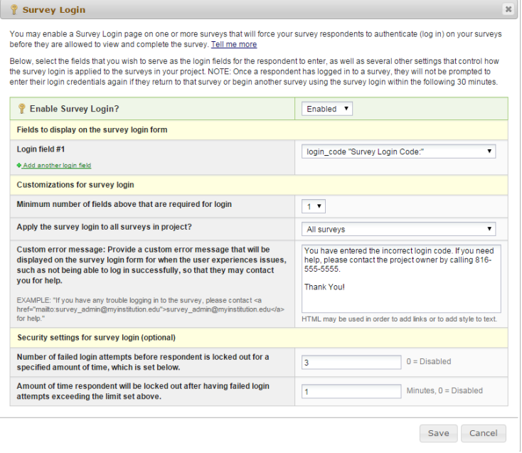

That will open up the Survey Login settings popup:

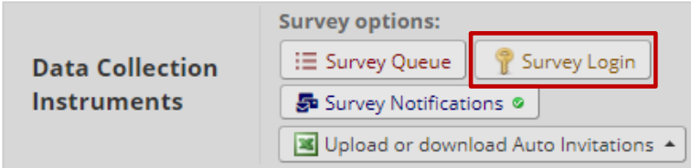
Login Field # 1: Use the drop down and select a field from your project. If you would like to add another login field, click the Add another login field link.
Minimum number of fields above that are required for login: If you have more than one field that you are using as the login, indicate how many of the fields are required. For an example, you might have three fields but only two of them are required to be answered in order to log in.
Apply the survey login to all surveys in this project: Use the drop down and indicate if the survey login should be used for all surveys or if you would like to specify the surveys this will be used for. If you would like to specify which surveys this will be used for, you will need to navigate to survey settings.
Custom error message: Enter a custom error message that will be displayed if the participant experiences difficulty logging in.
Number of failed login attempts: Enter the amount of login attempts you would like to grant to the participant. If you would like them to have unlimited attempts, enter 0.
Amount of time participant will be locked out: Enter the amount of time (in minutes) you would like to have the participant locked out for. If you do not wish to lock them out, enter 0.

When the participant attempts to take the survey, this will receive this log in box:
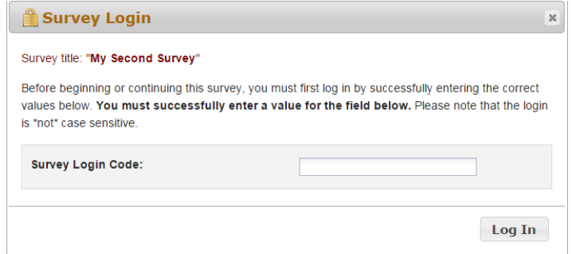
If the participant does not enter the correct Login Code, they will receive this message:
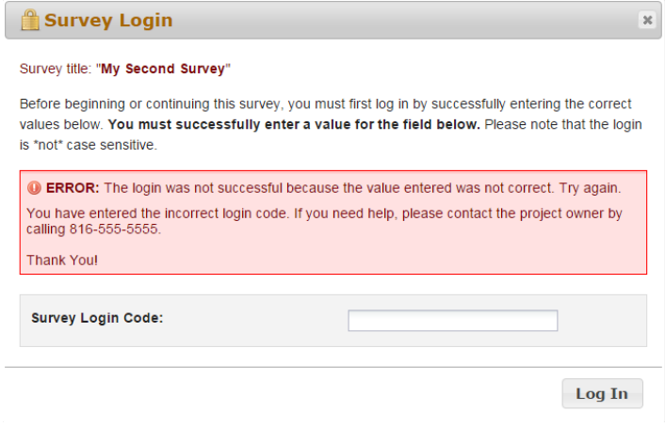
If the participant reaches the maximum number of failed attempts you specified, they will receive this message:
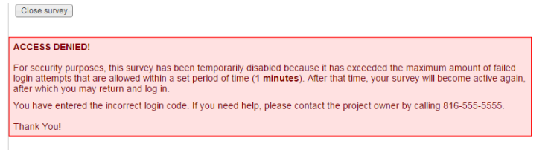

Survey Settings
Once you enable your data collection instrument as a survey, the “Survey Settings” page will appear.
You can make changes to Survey Settings at any time. To get to the Survey Settings click on the Designer link on the left-hand navigation bar under Project Home and Design.

Survey Status
A survey can be Active (online) or Inactive (offline). The default setting is online.
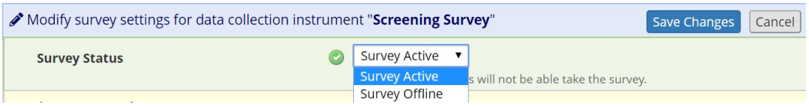
For a comparison of how this differs from other survey expiration options see this section of the user guide

Basic Survey Options
Survey Title: Enter a survey title. It does not have to be the same name as your form.
Survey Instructions: Enter any instructions you wish to give to the participant. The default instructions are “Please complete the survey below. Thank You!” Oftentimes it is helpful to include a contact email address if the person has questions or the deadline by when you need them to complete the survey.
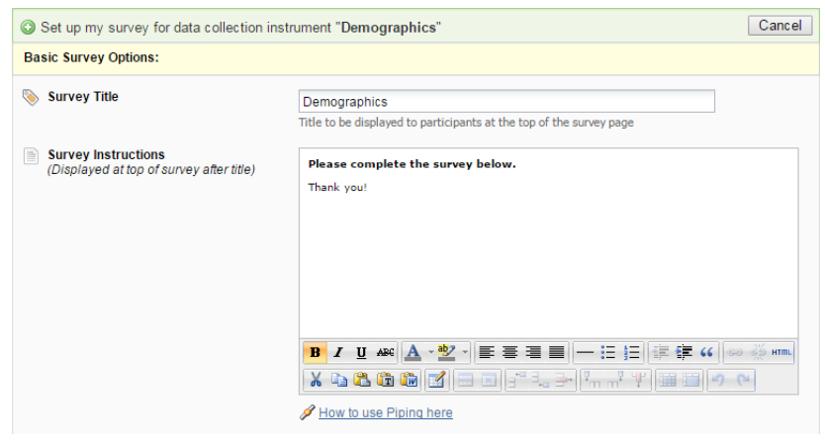

Survey Design Options

Logo: Click the Choose File icon and add a logo.
Size of survey text: Use the drop down and select Normal, Large or Very Large.
Font of survey text: Use the drop down and select the font family you would like to use.
Survey Theme: Use the drop down to select a saved survey theme, including a CMH survey theme. Otherwise, you may click Customize and change the color of your backgrounds, fonts and buttons. If you would like to use the same color choices at a later date, click the Save custom theme icon.
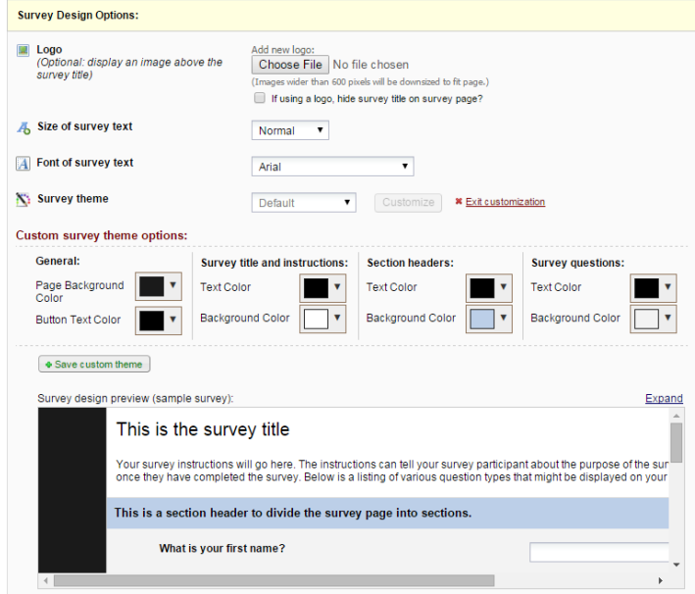

Survey Customizations

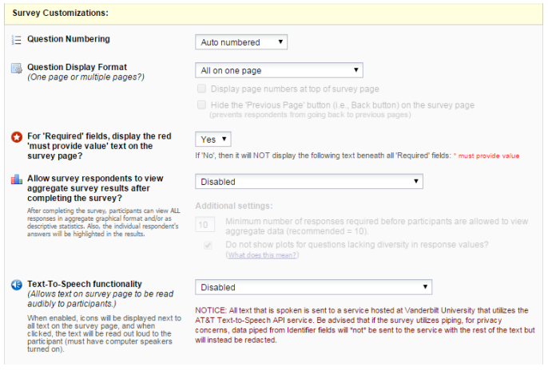

Question Numbering
REDCap will by default auto number survey questions. The exception is if you have branching logic in your survey. In that case, auto-numbering is disabled and instead your questions are custom-numbered.
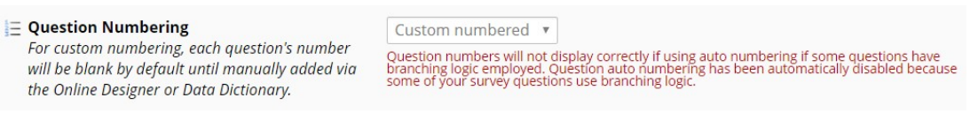

Custom Numbering of Questions in a Survey
If you change the setting to custom numbering, question numbers will be removed. If you set your Survey Settings so that your questions are custom numbered, you will see a ‘Question Number’ box for each field of that survey in Online Designer:
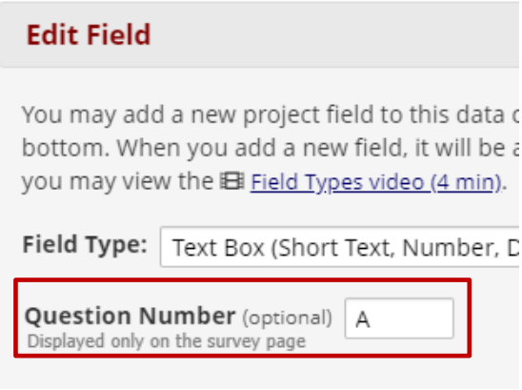
You can enter your custom question number there (or leave it blank.)

Question Display Format

All on one page: Select this if you would like all of your questions placed on one page.
One section per page (multiple pages): Select this option if you would like to like to break your survey up into sections by your section headers (the yellow banner bars). If you select this option, you can display the page numbers at the top of the survey page and also hide the “Previous Page button”.
Survey Design Tip:
If you want to break up the content of the survey page but don’t want the participant to have to go to a new page (which is what a ‘Begin New Section’ field type will cause), use the descriptive text field instead.
For example, using html coding you could type this as your field label:
<div class="blue" style="font-weight:bold;">A descriptive text field used as a sub-heading</div>

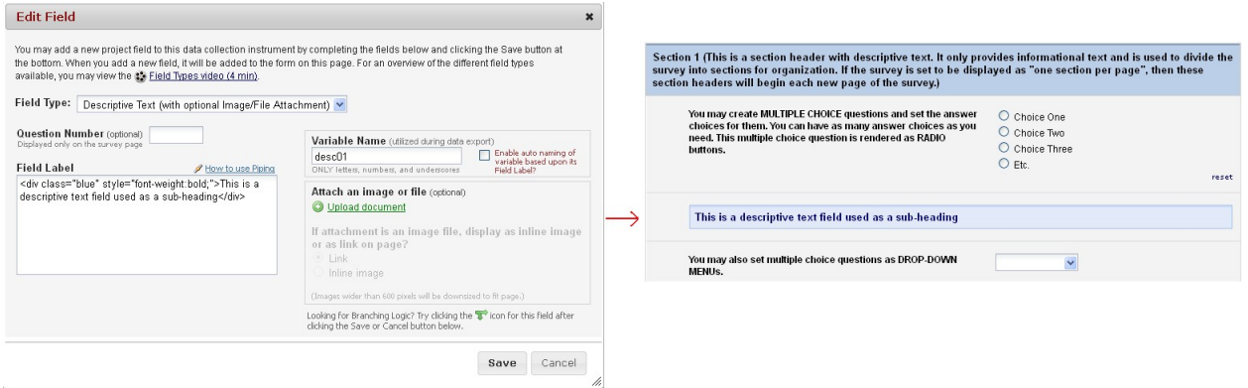

Allow Participants to Download a PDF of their Responses at End of Survey
The default setting is no.
The respondent will see a PDF button on the confirmation screen (screen they see after they hit the survey submit button).
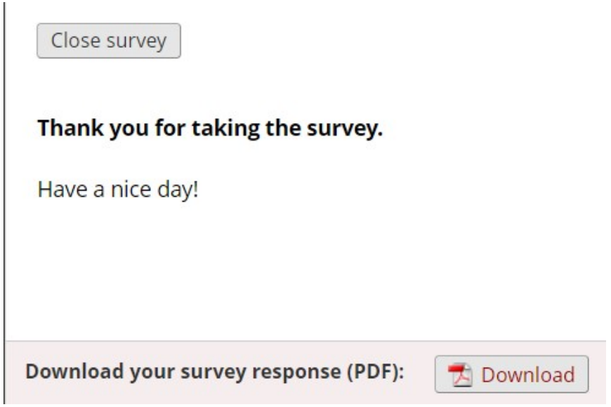

All fields viewable to the survey respondent on the screen, regardless of whether or not they answered the question, are included in the PDF. This means that if a HIDDEN action tag is used on a field in the survey, that field will not be visible in the PDF.
Exception: This option is not available if the Survey Auto-continue feature is enabled or if the Survey queue auto-start option is enabled.

Survey-specific Email Invitation Field
You may have a project with multiple surveys where different people are completing the survey for the same record. If you wish to designate which person should be sent the invitation for that specific survey, you would select that designated email field from the drop-down list.
Note: only text box fields that have been validated as an email address show up on the drop-down list.

For “Required” Fields, Display the red “Must Provide Value” Text on Survey Page
The default setting is Yes. If you do not wish to have the ‘must provide value’ field display on your survey, use the drop down and select No.

Allow Survey Respondents to View Aggregate Survey Results after Completing the Survey
The default setting is disabled. Otherwise you may choose to display Graphical Plots, Descriptive Statistics or both plots and statistics. If you enable this setting, you can choose the minimum number of responses before participants are allowed to view the aggregate data.

Text-to-Speech Functionality
The default settings is Disabled. When enabled, icons will be displayed next to each text that is listed on the survey. When clicked, the text will be read out loud to the participant.

Survey Access
How a survey participant accesses the survey can be set in the Survey Access section of Survey Settings.
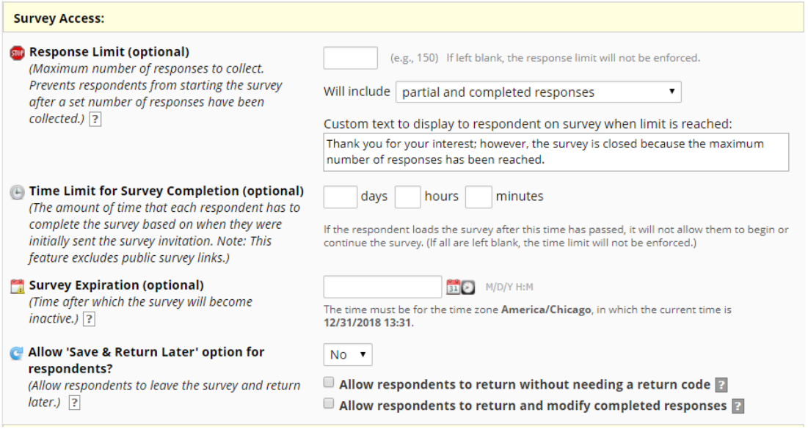

Response Limit (optional)
This setting prevents respondents from starting the survey after a set number of responses have been collected. The default is blank. You can specify if a response is only completed responses or partial/completed responses. You can also modify the stock language that is shown when the limit is reached.
For a comparison of how this differs from other survey expiration options, see this section of the User Guide.

Time Limit for Survey Completion
You can use this setting if you wish to limit the amount of time a respondent has to complete a survey after it was sent to them.
This only works when you have a participant list – it will not work on public survey links. It’s ideal if you want to keep a survey open but will have rotating groups of people taking it.
Note: the language displayed to the participant is not customizable.
For a comparison of how this differs from other survey expiration options, see this section of the User Guide.

Survey Expiration (Optional)
You may enter a date/time you would like for your survey to expire. This saves you the trouble of going to survey settings and changing the survey status to inactive (especially helpful if you want the survey to go offline when you are not at work!)
For a comparison of how this differs from other survey expiration options, see this section of the User Guide.
Allow “Save & Return Later” Option for Respondents:
You may enable this option if you would like your participants to be able to come back and finish taking their survey.
If enabled, the participant will receive a generated code they must enter in order to continue. If you want them to be able to return to the survey without needing a code, you can check that box.
NOTE:
If you are collecting identifying information (e.g., PHI), for privacy reasons it is strongly recommended that you leave the option unchecked so as to enforce a return code.

You may also indicate if you would like your participants to be able to return and modify their completed responses.

Survey Termination Options
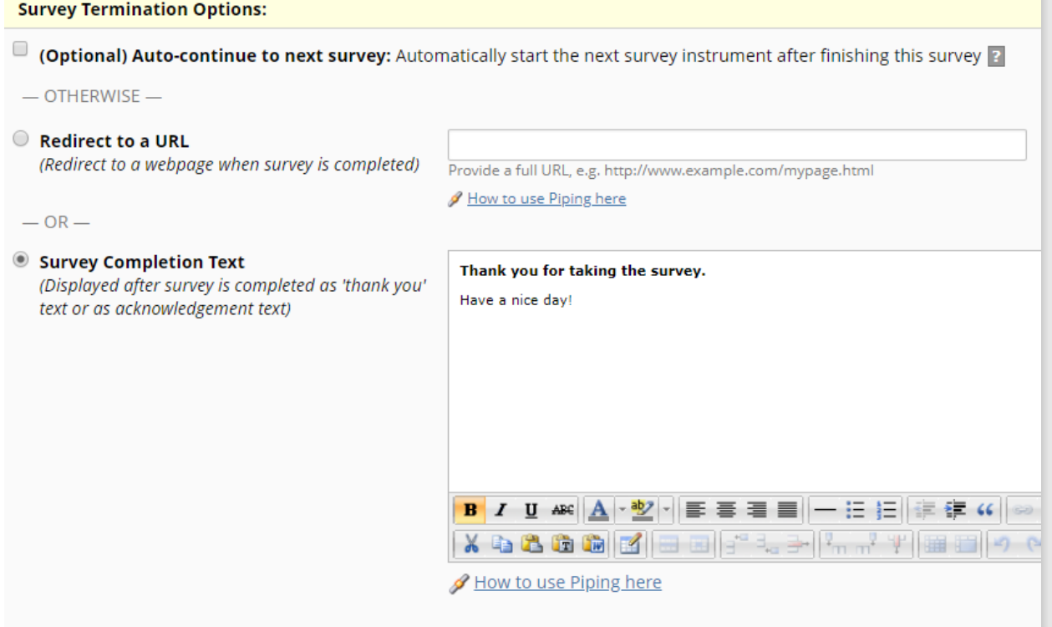
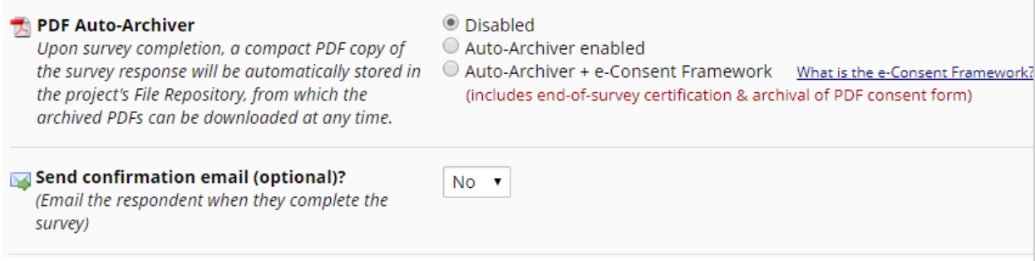

Auto-continue to Next Survey
Click this if you have more than one survey and you would like the next survey to automatically start as soon as this survey is completed. If you want the respondent to complete a subsequent survey at a later time or only if they answered questions with a specific answer, then you would not want to enable this feature. See Survey Invitations for further information.
Note: if you have auto-continue enabled and then set up a Survey Queue, auto-continue is not automatically disabled. In fact, it will trump your Survey Queue settings.

Redirect to a URL
If you would like the participant to be redirected to another URL after they have completed their survey, enter the full URL. For instance, if a person is registering for an event and you have a website for your event, you could enter that website here.

Allow Respondents to Repeat the Survey
If the instrument is enabled as a repeating instrument, you will see these options in the Survey Settings.
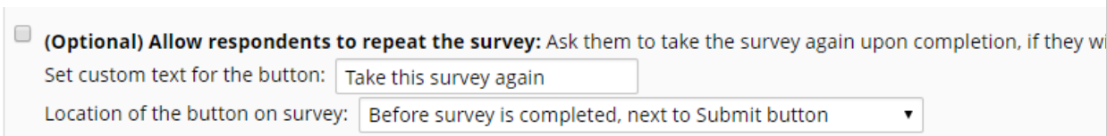

Survey Completion Text
Enter any text you wish to display after the participant has finished taking your survey. The default text is “Thank you for taking the survey. Have a nice day!”

PDF Auto-archiver
With this setting enabled, upon survey completion, a compact PDF copy of the survey response will be automatically stored in the project's File Repository, from which the archived PDFs can be downloaded at any time. The default setting for this option is ‘no’.

Auto-archiver + eConsent Framework
This setting not only will save the version of the completed survey to the file repository, but it will provide a summary screen to the respondent. The respondent has to review that summary screen before clicking submit.
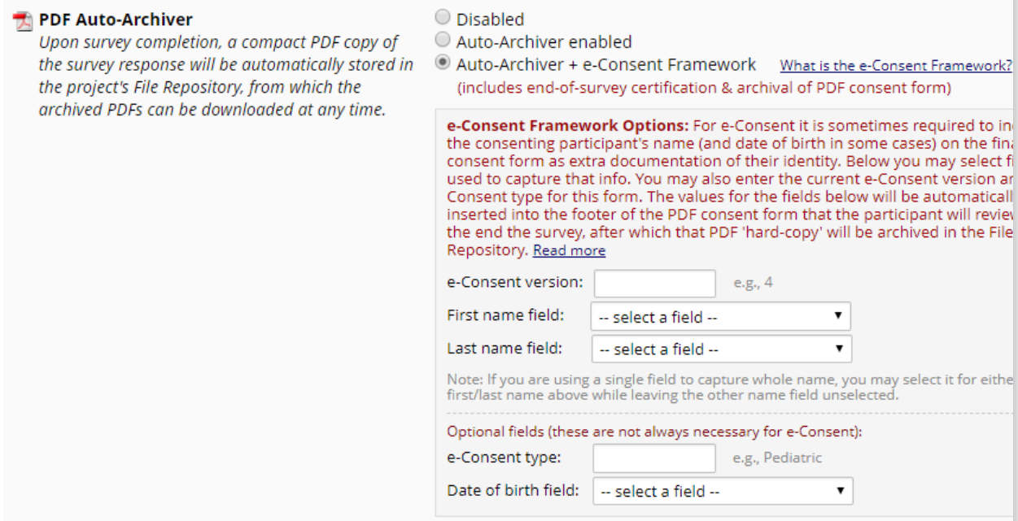
It is highly recommended that you have a discussion with your local Institutional Review Board (IRB) if you wish to do e-Consent in REDCap.

Send Survey Confirmation Email
If you would like the participant to receive a confirmation email once they have completed the survey, use the drop down and select “Yes”. Enter the subject and the body of the message.
You may also add an attachment to the email by clicking Choose File or automatically attach a PDF of the completed survey as an attachment. The PDF of the completed survey will show all the questions and choices in the survey – not just the questions and choices selected.
Please Note: Email is not considered a secure form of communication. Therefore, the PDF attachment
option is not recommended if the survey contains personal and identifying information, such as PHI.

If you send a confirmation email to the participant and you have the eConsent framework enabled, the participant will receive a compact version of the PDF of their survey responses. That means that they will only see the questions they answered (it will omit unanswered questions and unselected choices).
You can use html coding in the confirmation email.

Survey Inactive Options
There are several ways a survey can be taken offline. Here is a side-by-side comparison to help you choose the one that best suits your needs:
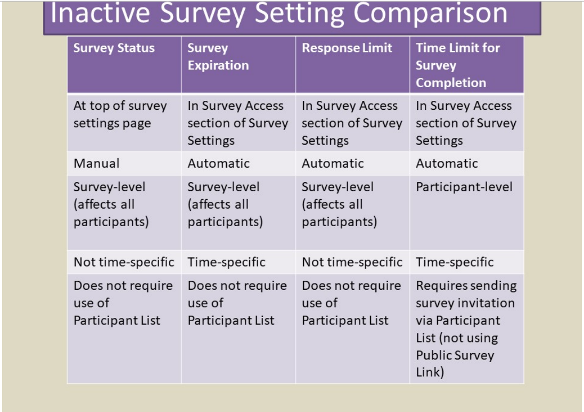

• Navigate to the Project Setup tab and then to the Online Designer.
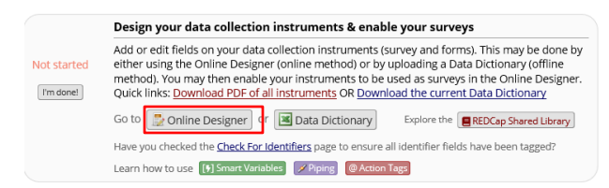
• Click on Survey Settings next to the survey you would like to make inactive
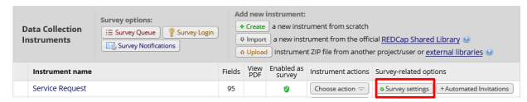
• Click on the Survey Status – change to Survey “Offline.” This will prevent users from being able to access the survey. Click “Save Changes” at the bottom of the page to save this setting.
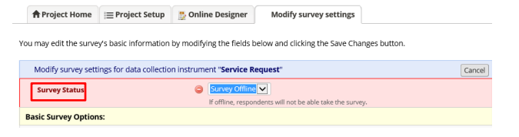

Response Limit
The Response Limit feature allows a user to set a maximum number of responses to collect with the survey. This prevents respondents from starting the survey after a set number of responses have been collected. For example, if a survey is used as a registration form for a seminar with a 50-person capacity, survey settings could be to a limit of 50. When the 51st person opens the survey, they will be presented with a page that tells them that the survey is no longer available because the response limit has been reached.
To enable this feature on a REDCap survey, navigate to the Online Designer and click on the instrument’s Survey Settings.
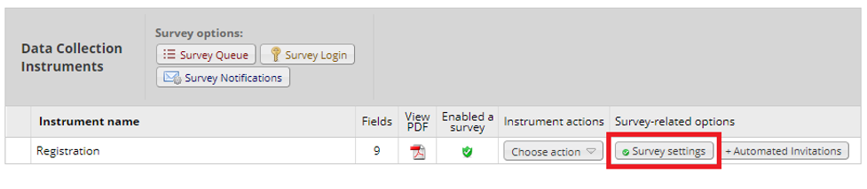
Scroll down until you see the “Survey Access” header. The first option is the feature for setting a response limit. In the textbox, enter the limit to set for the survey (e.g., 50). Next, choose whether to include partial and completed survey responses or just completed responses. In the screenshot below, only completed responses are included. Lastly, edit the custom text to display to the survey respondent when the response limit is reached.
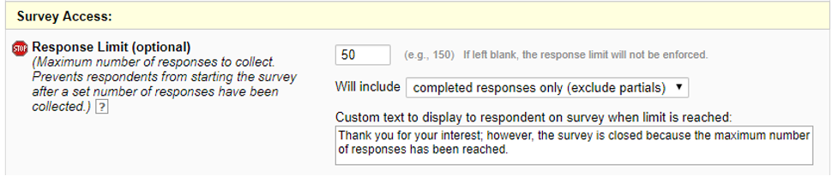
Once the response limit is reached, participants will see the following page when they try to access the survey. This page will display whatever custom text you have typed in the textbox above.

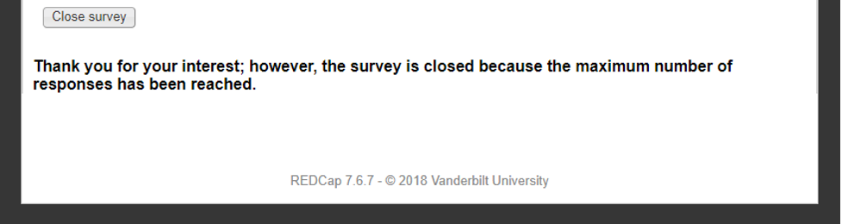

Time Limit for Survey Completion
The Time Limit feature allows a user to set the amount of time that each survey respondent must complete the survey based on when they were initially sent the survey invitation. Please note, this feature is not available when using the public survey link.
To enable this feature on a REDCap survey, navigate to the Online Designer and click on the instrument’s Survey Settings.
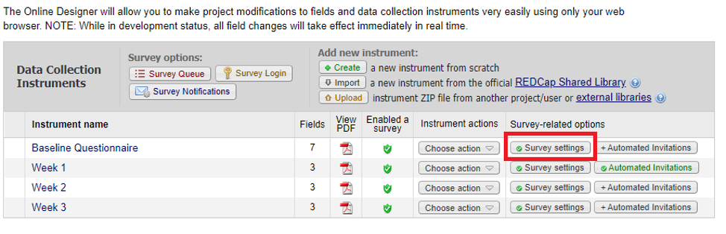
Scroll down until to the “Survey Access” header. The second option is the feature for setting a time limit for survey completion. In the textboxes, enter the number of days, hours and/or minutes (e.g., 7 days).
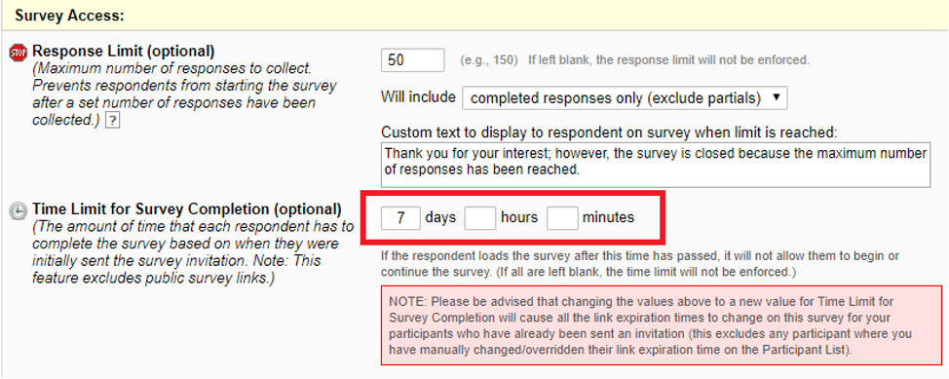
Once the time limit is reached, participants will see the following page when they try to access the survey.
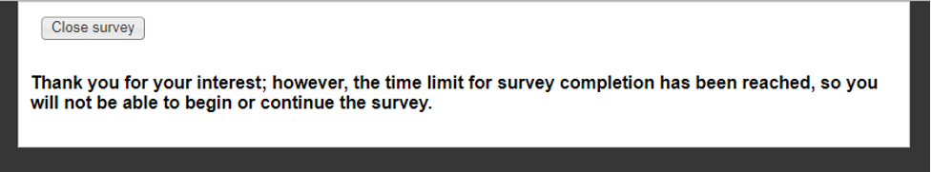

Best Practices for Survey Settings when Collecting Personal Health Information
If you are collecting PHI in your survey, set customization to allow download but do not attach completed responses to confirmation emails. If you have “save & return”, enabled, do not tick the box that allows participants to return without a return code.

How to Change an Instrument from a Survey back into a Data Entry Form
If you have designed an instrument as a survey but want to change it back to a data entry form, go to Survey Settings (Project Setup/Online Designer) and click on the Delete Survey Settings button at the bottom of the page.

reCAPTCHA
This feature allows you to utilize the Google reCAPTCHA functionality to help protect public surveys from abuse from “bots”, which are automated software programs that might enter trash data into surveys. You can enable the Google reCAPTCHA functionality on the Public Survey Link tab of Survey Distribution Tools:
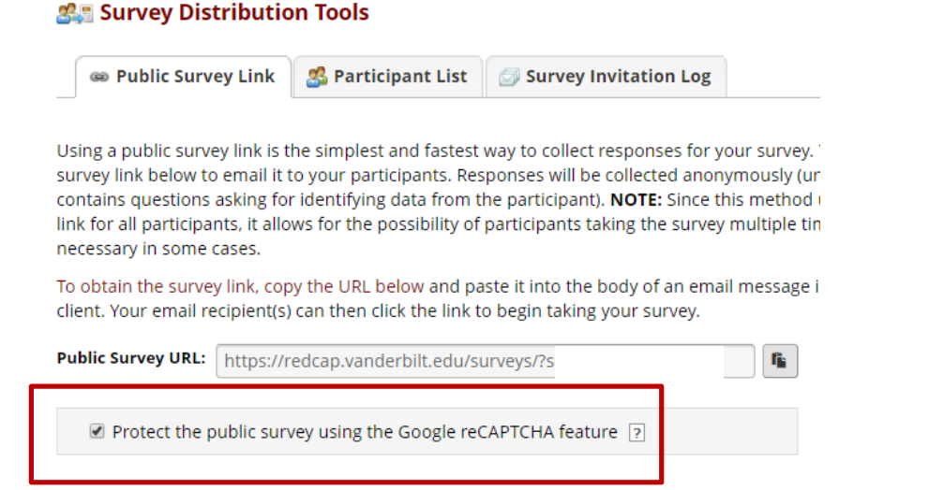
The public survey will display the reCAPTCHA checkbox and “I’m not a robot” text on a survey page prior to allowing the participant to view the public survey:
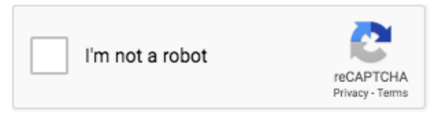
This feature is not employed on any private survey links because those are unique to a record and thus would never be made publicly available like a public survey link would. Note: A survey participant will never have to pass the reCAPTCHA test more than once per day on a given device/computer.

Survey Notifications
If you would like REDCap to email you or a team member every time a survey is completed, you can turn on Survey Notifications. Go to Online Designer and you will see this:
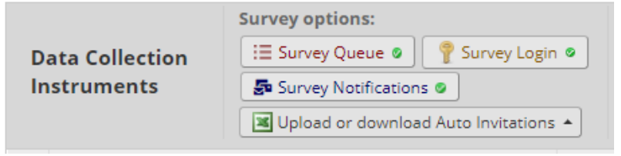
Click on Survey Notifications. Listed are all the surveys in the project and under each survey is a list of email addresses associated with each user that has been granted access to the project. You can select which user should receive the survey notification email.
If you have a lot of survey responses coming in at once, it can be overwhelming to receive a flurry of notification emails. If that is the case, you might want to turn off survey notifications and instead create a reverse chronological order report in your project and check that on a regular basis. For information on creating custom reports, see this section of this User Guide: Create Custom Report.
If you would like to receive notifications not simply when a survey is completed but if a particular response is marked, you can set up an alert for that. See the Alerts & Notifications section of this User Guide for instructions on how to set that up.

Survey Delivery Options.
There are many ways to deliver survey invitations. Outlined below are the delivery options and when you might want to use them.
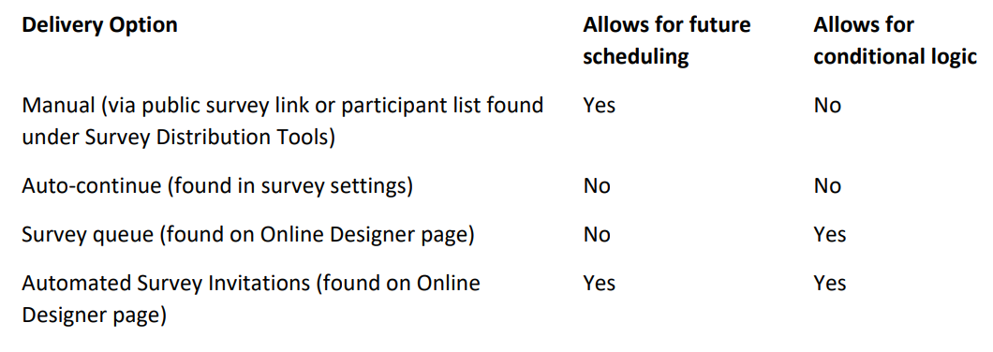

Public Survey Link
Using a public survey link is the simplest and fastest way to collect responses for your survey. Responses are collected anonymously. Three things need to be in place for you to have a public survey link:
- Your project must be enabled for surveys (1st step on the Project Setup page) while in Development mode.
  - If a project is in Production, the use surveys in project’ button is disabled on the Project Setup page. The project must be moved back into Development mode in order for that setting to work. You will need to contact your REDCap administrator to move your project back into Development mode.
- You must have an instrument enabled as a survey within your project (set this in Online Designer)
- The first instrument within your project must be a survey. To access the public survey link, click on Survey Distribution Tools in the left-hand navigation menu:
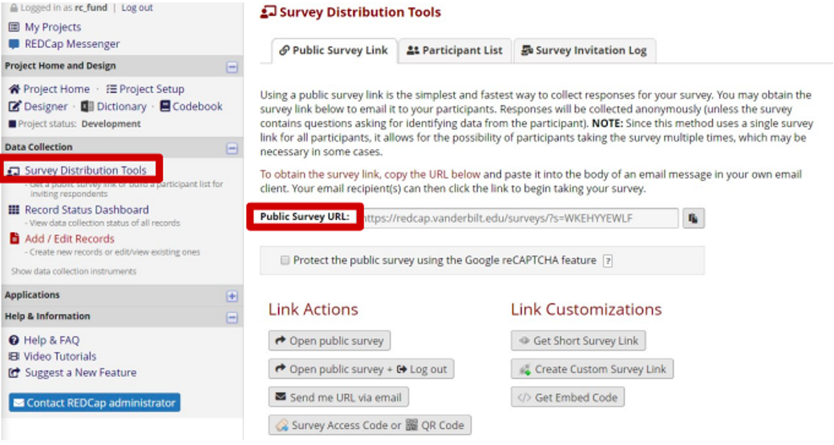
There is the option to obtain a shorter, more easily typed link by clicking the Get shorter survey link. The link generated, when accessed, will redirect the user’s browser to the regular public survey URL.

Project status re: survey link
Your public survey link remains the same when you move the project from Development mode to Production. If you created a short public survey link in development, it will carry through into Production
– you won’t see it at first on the Survey Distribution Tools page but when you click on the ‘get short public survey url’ button, it will generate the same short url that you had in Development.

Only one public survey link per REDCap project
Please note: only the first survey in a project has a public survey link. Any subsequent surveys within the project have their own unique link. There are several ways you can disseminate the private link. This is important in tying the responses from different surveys together. If you wish to disseminate multiple surveys with public survey links for each one, just know that each survey will have to be in a separate REDCap project and the responses cannot be tied together.

Emailing unique survey links to participants
If you know ahead of time the email addresses of your survey respondents, you can email the survey link to those people from REDCap using Compose Survey Invitations. To use that feature, you first need to build your Participant List.

Participant List

REDCap generates a survey URL that is unique to each member of the list, which enables you to track who is responding to your survey invitation – and who is not – without requiring that the survey form contain any identifying information

Participant Identifier (Optional)

The ability to specify an identifier for each member of the participant list is optional. This means that you can choose a tracking model that best suits your project:

- No identifier: the Participant List shows who has responded but there is no link from the participant to a specific response. The responses remain anonymous.

- With identifier: the Participant List shows who has responded and you can navigate directly to the participant’s response.

This setting is available only when your project is in Development. If your project is in Production mode and you wish to enable identifiers, you will need to email REDCap.Administrator@nshealth.ca and request that your project be moved back to Development mode. Once your project is in Development mode, you can enable identifiers. You would then need to move the project back to Production mode via the Project Setup page.
You should not use participant identifiers if you want your responses to remain anonymous.

Enable Participant Identifiers
To enable participant identifiers, click the Enable button on the Participant List page:
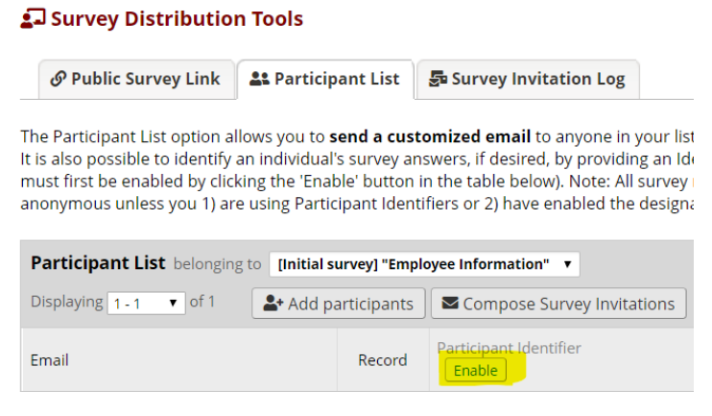
Add Participants
There are two options for populate your participant list:
- Click Add Participants and enter (e.g. copy-and-paste) your list of email addresses (and identifiers, if enabled), one per line:

<email address> email only, with no identifier
<email address>,<id> comma-separated email,id when identifiers have been enabled

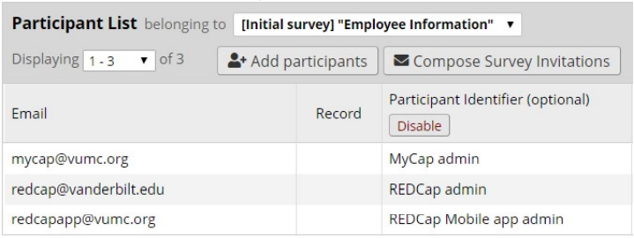
If you add participants with identifiers but you have not enabled identifiers, you will see this error message:

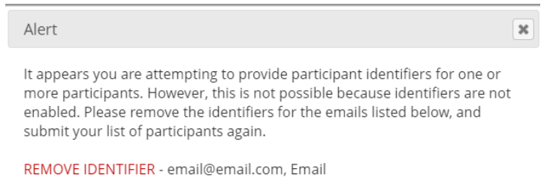

If you wish to build a participant list from a distribution list within your email client (e.g. Outlook), please see the instructions for Converting an Outlook Distribution List into a Participant List.

- Designate an email field from one of your data collection forms. Email data entered into this field will be used to populate the Participant List automatically
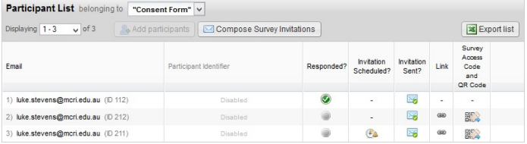

Note:
• Participant Identifier values must be unique
• Email addresses need not be unique. You may add your own (or a project) email address for all records, for example, if you wish to tailor each request to each specific participant and send the request email yourself

Send Survey Invitations
Clicking Compose Survey Invitations enables you to send email invitations to members of your
participant list
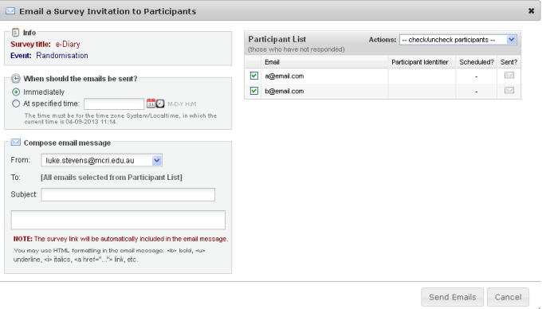

- Indicate whether the message(s) is(are) to be sent immediately or at a specified time

• Select the email address that you want the message(s) to be sent from. You will have the option to select the email address of any user on the project.
- Set the message subject and body: the participant’s unique URL will automatically be appended to the message body. You can edit any of the pre-populated text, but you must keep the unique survey link string, which will be listed within brackets.

• Select the desired recipients by ticking the relevant checkbox. The Actions drop-down list gives
Provides shortcuts to ticking:
o Check All
o Uncheck All
o Check Sent
o Check Not Sent
o Check Scheduled
o Check Not Scheduled
o Check Not Scheduled and Not Sent

• There is no limit to the number of times an invitations may be manually sent and re-sent to a participant.

Survey Queue
The survey queue enables your survey respondents to see a list of the surveys that you are asking them
to complete. This can be a powerful feature because it enables you to, for example:

1. Force respondents to complete surveys in a particular order
2. Give different surveys to different respondents based on certain criteria. Age-specific
questionnaires, for example.
- Control when surveys become available.

To activate your survey queue, navigate to Online Designer and click the Survey Queue icon located above your data collection instruments

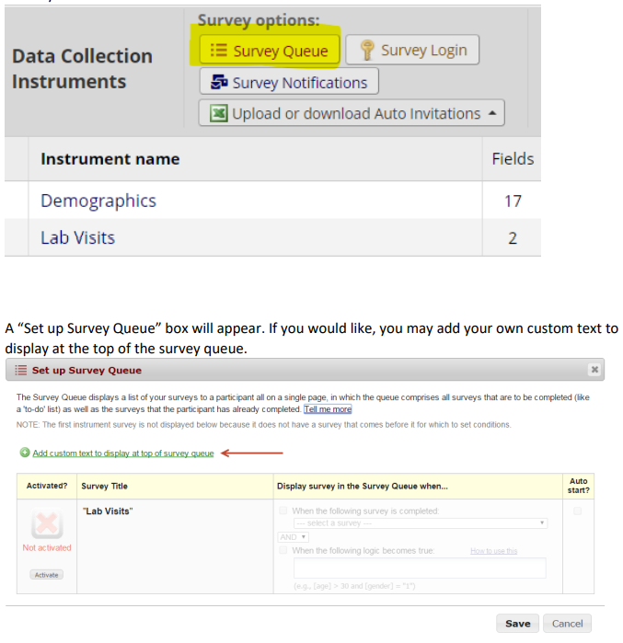

Click the Activate icon for each survey you would like to set up. Under the “Display survey in the Survey Queue when…” column, use the drop down to indicate when the survey should be displayed. For an example, you might want your second survey to display after the first survey is completed.

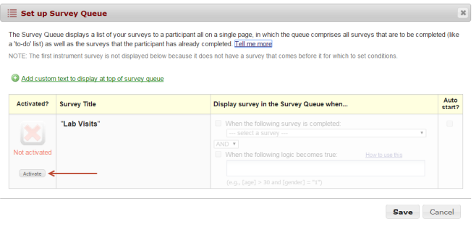

If you would like to add additional logic as to when the next survey should be displayed, use the operator drop down and select AND/OR and then check the box next to “When the following logic becomes true” and finally add your logic in the formula box. See further down for tips on how to configure complex Boolean logic.

For an example, I want my second survey to start after my first survey is completed AND the participant’s age is greater than 12. To do this, I added the variable for the participant’s age field in square brackets, the greater than sign and the number. [age] > 12

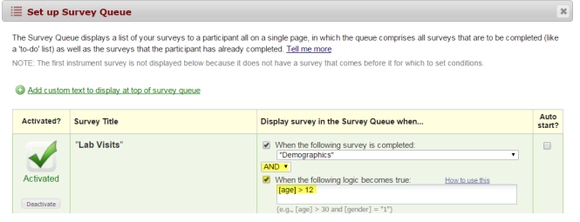

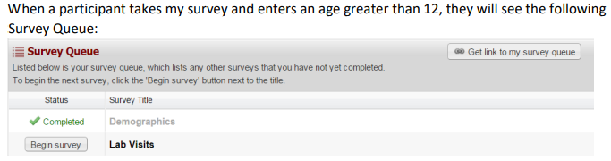

They can click the Begin Survey to start the second survey. If you would like the second survey to automatically launch and do not want to force the participant to click the Begin Survey icon, you can accomplish this by going back to the Survey Queue settings and click the box underneath the Auto Start column. When the participant finishes the first survey and they are at least 13 years old, the second survey will display.

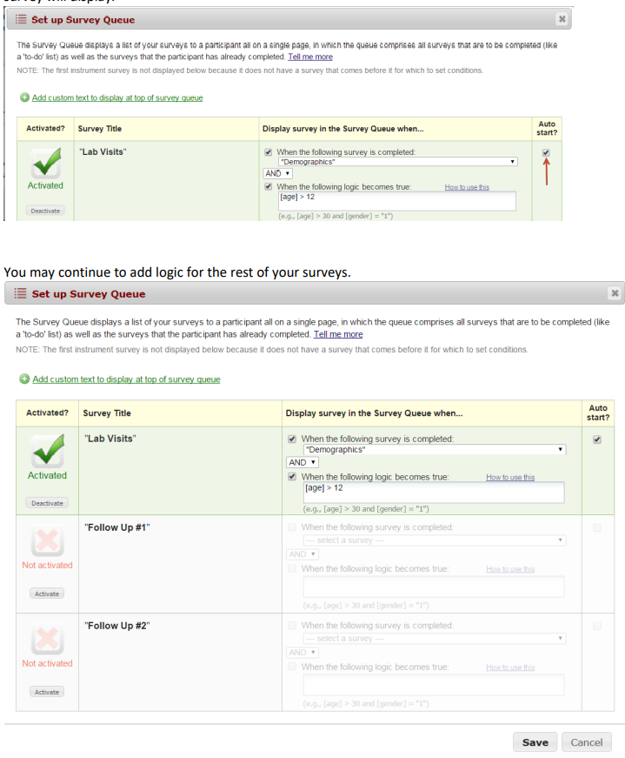

As with all features in REDCap, it is a good idea to test this feature before using it with real participants.

Caution when using Survey Queue

The auto-continue option overrides the Survey Queue. So, if you want to use Survey Queue, make sure that auto-continue is turned off for surveys in your project. Otherwise, the participant will automatically be taken to the next survey even if they do not meet the conditions specified in the Survey Queue.

The auto-continue option is in Survey Settings for the individual survey. Survey Queue is found on the Online Designer page.

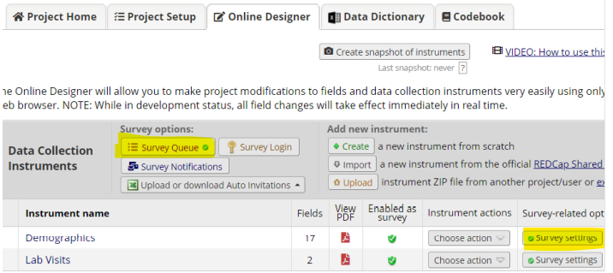

Design tip: writing conditional logic for a Survey Queue
Sometimes it can be tricky writing conditional logic, especially when working with checkbox fields or date ranges. What you can do is create a test report using the filter section of the custom report to figure out your logic.

In the example below, we are essentially saying that we want to see the results where the box is checked for any of the three boards and the roster date is between 1/1/2018 and 12/31/2018.

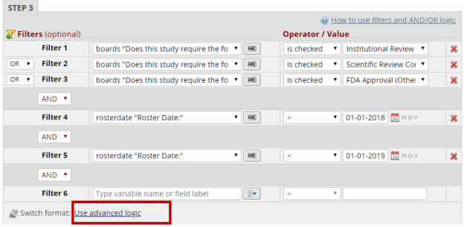
You can check the results of the report to make sure you have your logic configured correctly.

Once you get it right, you can click on Advanced Logic (not it in the red box above) and click the ‘convert’ button. You will see your logic written for you in Boolean form.

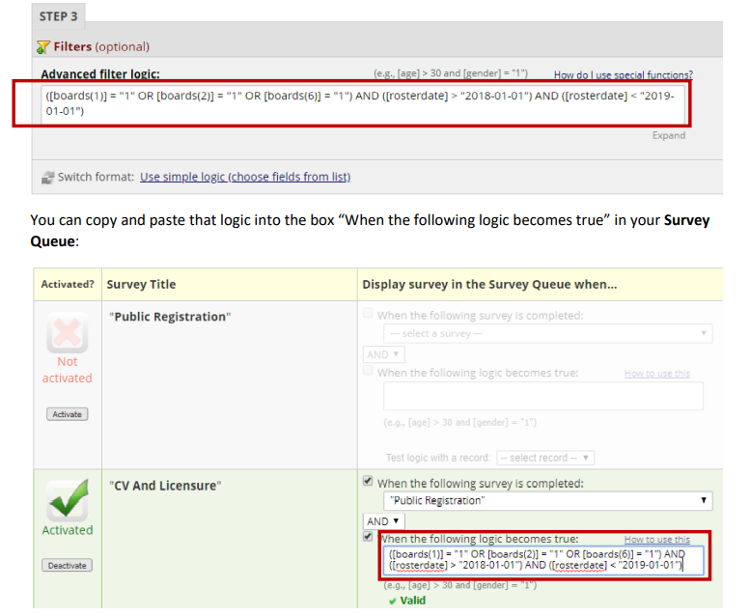

If you want to use a datediff function to return results that satisfy the conditions for the last year, you can add the datediff function to your advanced logic. The advanced logic builder does not have the capability of constructing it.

For the above example, our date validation is in the format of ymd. To capture results from the last year, you could add datediff([rosterdate],"today","d","ymd")<=365 to your advanced logic.

Converting an Outlook Distribution List into a Participant List

Using the Participant List in REDCap is very helpful in sending out survey invitations. One of the biggest benefits is that it
creates a unique survey link so that a person can only complete the survey once. You can also enable reminders when
composing your survey invitation, so that people who have not completed the survey are sent a follow-up email, reminding them to complete the survey.

To create a participant list, each participant needs to be listed on a separate line, with the email address being listed first. When viewing members of a distribution list, the information may not be listed in the format required by REDCap. To convert your distribution list so that REDCap will accept it, please follow these instructions.

Please remember that if you use a participant list, technically your participant’s responses are not considered anonymous. That is because they are tied to an email address, which is identifiable.

These instructions are adapted from this online article
The options you see may vary slightly depending on your version of Excel or if you are using a Mac. Whichever version you are
on, you should be able to follow the prompts on your screen to accomplish the conversion. If the images shown don’t align
with what you are seeing, and you find it confusing, try searching for a similar article online. It’s possible you can find one that
matches what you are seeing.
- In Outlook, click on Contacts
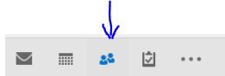
2. open the contact containing the specified contact group or distribution list

Automated Survey Invitations (ASIs)

You can set up your survey invitations to be sent automatically by using Automated Invitations. Instead of adding your survey participants through the Participant List, the automated invitations can be scheduled to be sent automatically based upon specific conditions.

To use this feature, you must first designate an email field to use for invitations to survey participants. Designate an email field to use for invitations to survey participants To use this feature, navigate to Project Setup and click Enable next to “Designate an email field to use for invitations to survey participants”.
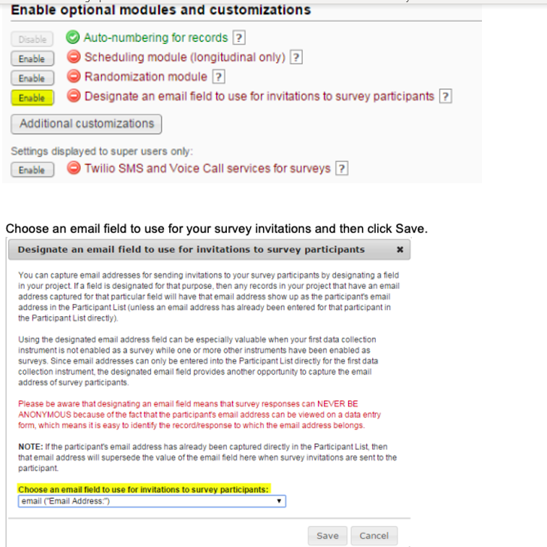
Note: If you enable this feature, your survey responses will not be anonymous since the participant’s email address can be viewed on the data collection form.
Automated Invitations
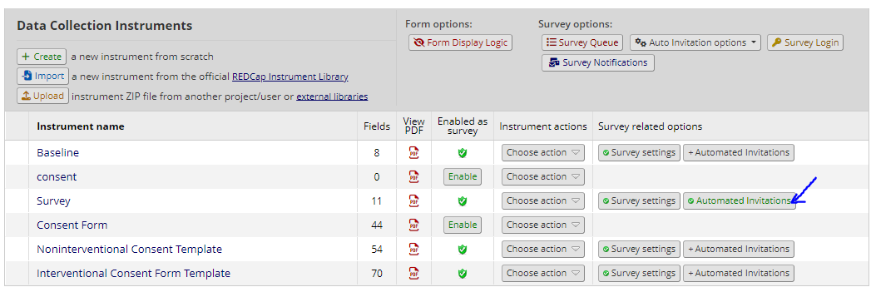
An automated invitation can be setup by finding the "Automated Invitations" button in the survey options on the Online Designer page:
- Go to the Data Collection Instruments page by clicking on the "Edit Instruments" link or the following:
Project Setup -> Online Designer
2. Click on the "Automated Invitation" button to the far right of the survey you want to schedule an automated invite for.
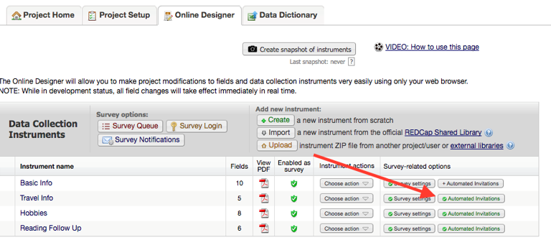
In "STEP 1: Compose Message From: Use the drop down and select an email address To: This will automatically include all participants who meet your criteria. Subject: Enter an optional subject Message: Enter an optional message. Note: you may use piping and/or HTML in your survey invitations!

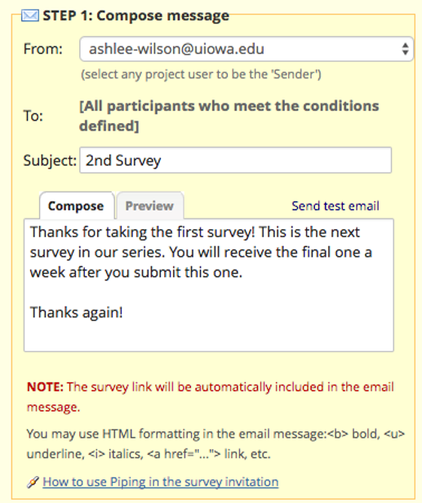
In "STEP 2: Conditions – Specify the conditions for sending the invitations You may select “When the following survey is completed” and then use the drop down and select a survey. If you would like to add additional logic as to when the next survey should be displayed, use the Boolean operator box and select AND/OR and then check the box next to “When the following logic becomes true” and then add your logic in the text box. For an example, you may want your second survey to start after your first survey is completed AND the participant’s age is greater than 12.

To do this, I would add my variable for the participant’s age field in square brackets and then the greater than sign and the number in quotations. [age] > 12. If you would like REDCap to check the logic in real time prior to sending the message, click the box next to “Ensure logic is still true before sending invitation”. REDCap will re-evaluate the logic against the record’s data values whenever the record values are changed AFTER the invitation has been scheduled but BEFORE it has been sent to the respondent. If the logic is no longer true, the invitation will not be sent.
In the example below the survey will only be sent to those who answered their age was above 18 and who specified the gender they had coded as "1". You can use any variable you create in your project with this logic.

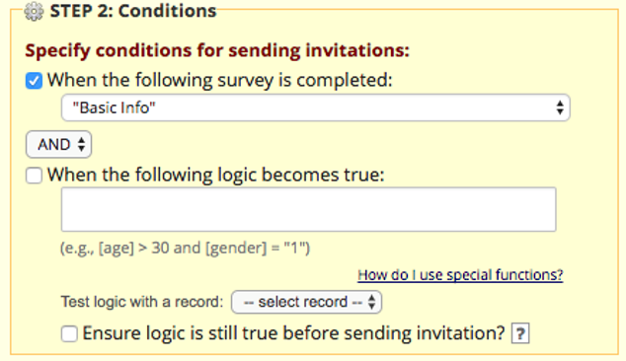

In "STEP 3: When to send invitations AFTER conditions are met" section, specify when REDCap should send the invitation after the trigger condition has been met. Note that an invitation will still be triggered even if by the time the invitation is sent the participant data has changed such that the trigger would not be met.
Enable reminders: Choose the settings you want for automating the resending of the survey invitation. The invitation will be sent at most five times (i.e. the initial invitation and four resends).

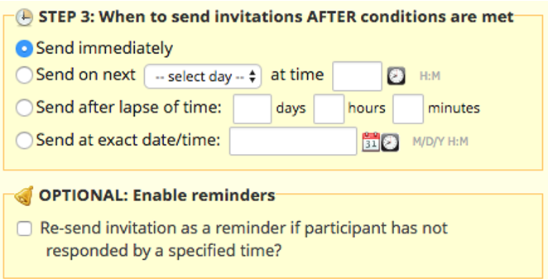

Finally, in "STEP 4: Activated?" section, select the "Active" radio button in order to schedule these invitations with the specified conditions. To cancel this automated invitation in the future, change this status to "Not Active". : To save your ASI settings, click on save. By default, the settings will remain Inactive. This is helpful during the design phase of the ASI.
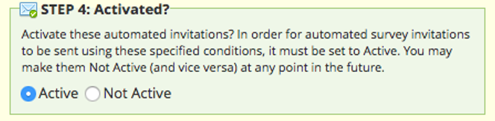

7. After entering an email message subject and body, press the "Save" button. The status of the responses are recorded on the Manage Survey Participants page under the "Participant List" tab. After participants reply to the initial screening survey, if the defined conditions are met, the second follow-up survey will be automatically scheduled.
A participant list is maintained for each survey. To see the generated schedule of the automated invitations, select the name of the second follow-up survey from the drop-down list.
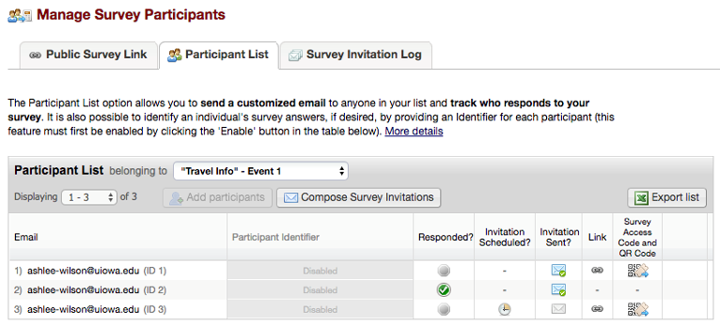

Note:
- You can still send invitations manually via the participant list irrespective of the Automated Invitations settings.
- Scheduled invitations (and reminders) may be deleted via the Survey Invitation Log.

Automated Survey Invitation online tutorial
Please click on this link for an interactive tutorial in Automated Survey Invitations (ASIs): https://redcap.vanderbilt.edu/surveys/?s=LKM4DPEHL4

Design tip: writing conditional logic for an Automated Survey Invitation
Sometimes it can be tricky writing conditional logic, especially when working with checkbox fields or date ranges. What you can do is create a test report using the filter section of the custom report to figure out your logic.

In the example below, we are essentially saying that we want to see the results where the box is checked for any of the three boards and the roster date is between 1/1/2018 and 12/31/2018.

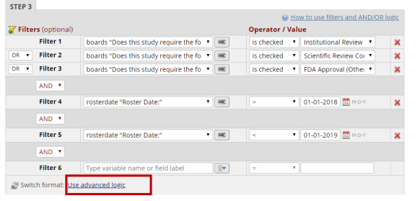

You can check the results of the report to make sure you have your logic configured correctly. Once you get it right, you can click on Advanced Logic (not it in the red box above) and click the ‘convert’ button. You will see your logic written for you in Boolean form.

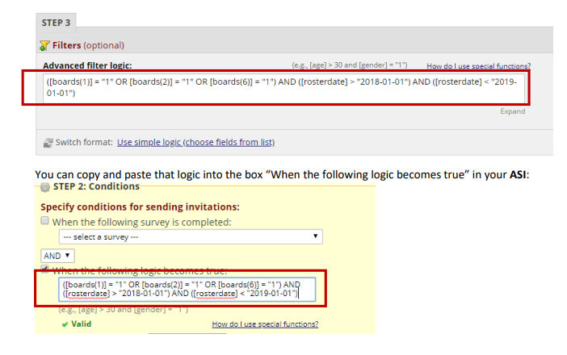
If you want to use a datediff function to return results that satisfy the conditions for the last year, you can add the datediff function to your advanced logic. The advanced logic builder does not have the capability of constructing it.
For the above example, our date validation is in the format of ymd. To capture results from the last year, you could add datediff([rosterdate],"today","d","ymd")<=365 to your advanced logic.

Conditional logic in ASI of Longitudinal Project
If your project is longitudinal and you want to use a variable in your conditional logic that is from an event that is not the current event, you need to pre-pend to the variable the appropriate unique event name also enclosed within square brackets, e.g. [unique_event_name][variable_name]. Unique event names can be found by going to Project Setup/Define My Events. You will see an events table, and the last column shows you the Unique event name, which is automatically generated by REDCap.

Giving device to survey participant in person
If you want a person to complete a survey as a participant and they are in the same physical space as you, it is best to use the logout feature when handing the device over to the participant. That will prevent the participant from having access to your project. This protects the security of the data that is stored in your project. If the survey you wish the person to complete is the first survey in the project and there is a public survey link, you can go to Survey Distribution Tools and select the logout option from there:

On that record home page, click on the empty circle of the survey you want the person to complete. In this example, you’re clicking on the highlighted circle in the image above. You will see a screen like this:
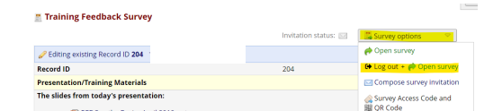
If you click on the Survey options button on the top right, you see an option to Log out and open the survey. This means the person will now be entering their information into the instrument as a survey. They will not see the left-hand navigation bar. This protects the security of the data that is stored in your project.
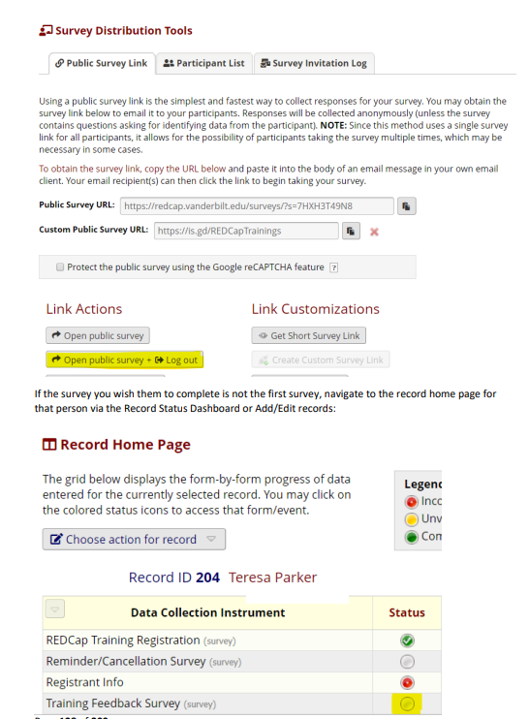

Viewing Survey Invitations
The Survey Invitation Log tab of the Survey Distribution Tools page can display all of the survey invitation messages sent for your project and the date and time that any future invitations are scheduled to be sent.
Use the filter criteria to specify the criteria for the invitations you are interested in seeing. Click Apply filters to refresh the list.
Unsent invitations (including reminders) may be deleted by clicking the red X. There is no undo, but you may always send or invitation manually.
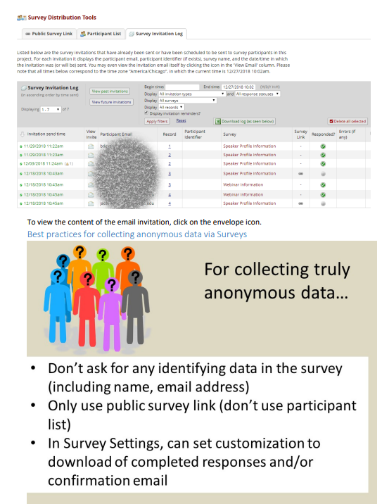
Testing the survey
It is critical to test your survey to make sure it looks and behaves the way you want it to for your survey participants. See Adding test data for suggestions on how to do that.

Longitudinal projects
If your project will contain instruments that will be used to collect data numerous times, you will want to enable your project as a Longitudinal Project. An example of a project that is well-suited for longitudinal design is when participants undergo certain assessments at defined time points over the duration of their participation in a study, as defined in the study protocol.

Project Setup
Enabling longitudinal data collection will allow you to use the same form or survey at multiple events. For instance, you may create a demographics form which you will use at Baseline but then a questionnaire that you may want to use at V1, V2, and V3. If there is one form or survey that will be used multiple times for a participant, you would want to enable longitudinal data collection use. When you enable the longitudinal data collection, you will have a step on your project setup screen that will allow you to define your events and then designate the forms you will be using at each event.

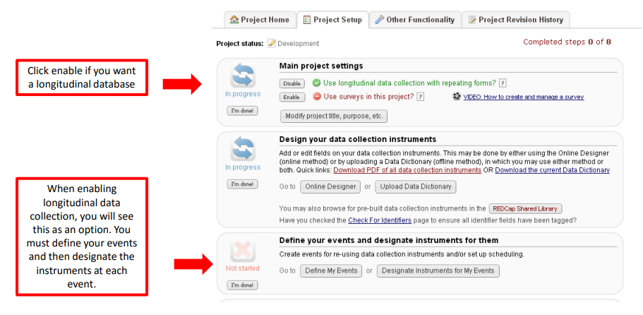

Design instruments
Click on “Online Designer” on the right panel, then click on “create” under Add new instrument. To begin building your data collection instrument, click on the instrument name.

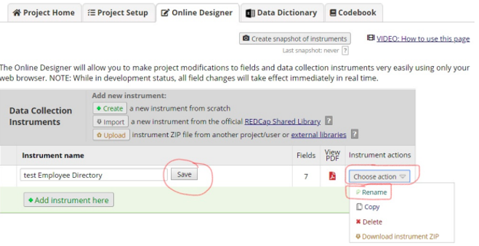
Design Tip: calculated fields and branching logic in longitudinal projects
When using calculations and branching logic that reference variables in different events, be sure to include the unique event name before the variable. If the unique event name is not added before the variable, the calculation/bl will not work.

If you want to pipe in data from an event that is not the current event, you need to pre-pend the appropriate unique event name, also enclosed within square brackets. For example, [enrolment][first_name]. Unique event names can be found by going to Project Setup/Define My Events. You will see an events table, and the last column shows you the Unique event name, which is automatically generated by REDCap.

Enabling repeating instruments and events in a longitudinal project
While the repeating instruments feature allows you to repeat a given instrument as a single unit, the repeating events feature allows you to repeat an entire event of instruments together, in unison. This might be useful when multiple instruments have data correlating together, such as multiple surveys which are collected back to back for a specific time-point or visit, for example.
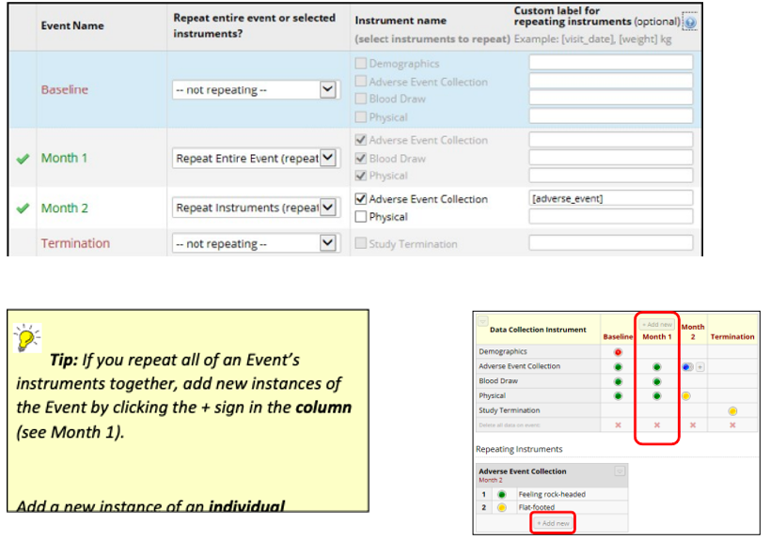
Note: this option assumes 1) events are already defined and 2) instruments have been designated to events

Design your Event Grid
When your project is configured as longitudinal you can define a series of events and associate data collection forms with those events.

An Event Grid determines how scheduling will work and how data will be created in your longitudinal project. Designing your Event Grid is comprised of two steps:
1. Defining your events
2. Designating (or assigning) instruments to your events

Those two steps can be found on your Project Setup page, after you have enabled your project for longitudinal data collection.
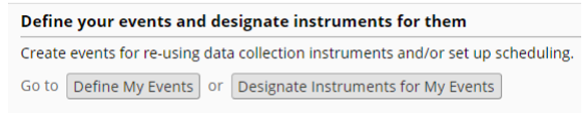
These steps should only be done while the project is in Development mode (not Production.)

Define My Events
To define events click Define My Events on the Project Setup page. The Define My Events page opens. 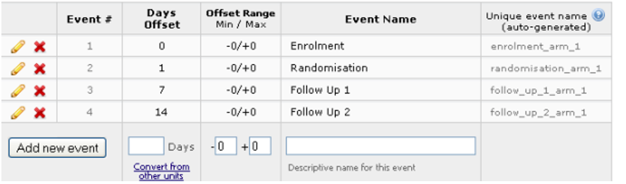
Notes:
• The edit button ( )facilitates editing a record
• Use the delete button ( ) to remove an event from the schedule
• To add an event, enter data into the text boxes then click Add newevent
• The number of events you can define is limited only by your patience for creating them and assigning forms!
• Days Offset is the number of days from an arbitrary baseline on which an event will be created when using the Scheduling module. If not using the Scheduling module Days Offset is just for information.
• Days Offset can be negative
• Offset Range is a number of days before (-) or after (+) the date set using Days Offset. There is no special significance to this range within REDCap, other than that a warning message is displayed if you move the scheduled event date to a date that is outside of the range. For example, an event is scheduled on 10th June +/-5 days. If the event is rescheduled to a date before June 5th or after June 15th a warning message is displayed that prompts the user to confirm that they accept the new out- of-range date.
• Note the settings for Unique event name. These codes are used when importing and exporting longitudinal data.

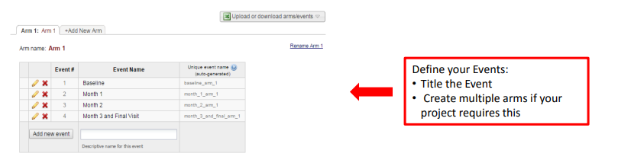

Designate instruments for My Events
After you have defined your events, you must designate instruments for events. Check the boxes where you want each form to appear. If you do not check a box for a form, it will not appear when you are entering data. Each form must be attached to at least one event.
To assign data collection forms to events click Designate Instruments to My Events on the Project Setup page or on the My Events page. The event setup page opens.
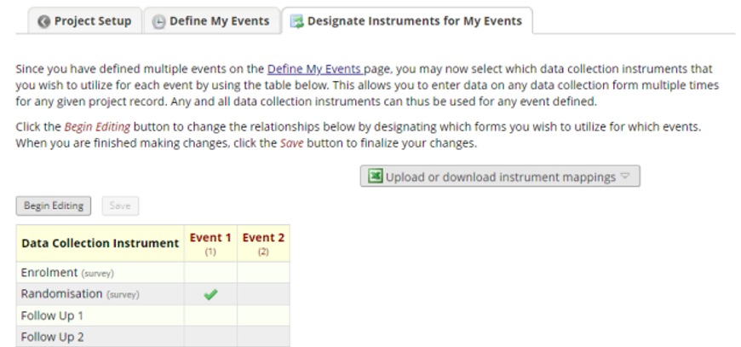
The Designate Instruments page displays a grid of events, instruments and arms. Each event has its own column, each instrument has its own row, and (if applicable) each arm has its own tab. Designating instruments to your events is a required step for your longitudinal project to work. To designate the instruments to events, click on ‘Begin Editing’ and select the instruments that are to be assigned to events by ticking the boxes.
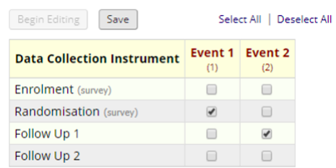
Remember to designate instruments for each arm of the project. Each arm uses a separate series of events, but all arms use the same instruments. For more information about defining arms, see below.

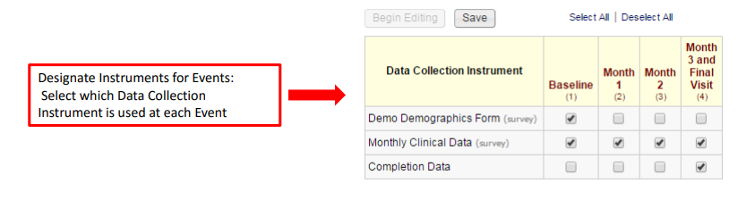

Defining Arms
REDCap’s Arm functionality enables you to create alternative event schedules for different groups of participants: different randomized treatments, for example.
Name your arms and set up the events as described for Define My Events.
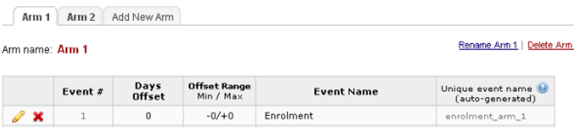
Participant records are assigned to an Arm when they are created. It is not possible to later edit the arm to which a record is assigned, although it is straightforward to export data, delete the record and recreate it in the correct arm, and then import the record’s data. Projects where the arm is not known at the time records need to be created (a project with an enrolment phase, followed by a randomization at a later date, for example) should be set up with an arm specifically for the initial phase, as well as arms for the randomized treatment phase. Following randomization, a record can be created in the appropriate randomized arm with a record id that matches the record in the initial arm.

Creating a new record: Arms
You must select the arm appropriate to your new record before creating the record in the same manner as described above.
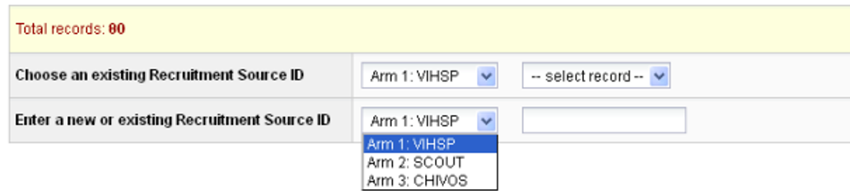
For longitudinal-type projects where multiple Arms are defined, each arm functions essentially as a distinct project. Record identifiers are unique only within an arm: you can have a record identified with study_id=1001 in both Arm 1 and Arm 2, for example.
It is not possible to ensure that a record identifier is unique within the project, although REDCap does provide a warning when creating a new record with a record identifier that matches one from another arm:
Records are assigned to an Arm when they are created, and it is not possible to later edit the arm to which a record is assigned. There are ways to handle the need for a record to switch to another arm, however, depending on the reason why the switch is required.

Switching Arms: Correcting an incorrect arm assignment
A switch of arm can be achieved indirectly via an export-import “shuffle”:
1. Using the Data Export module perform the “Export all project data” task and download the data in Raw CSV format
2. Locate the data row (or rows) that relate to the record to be switched to a different arm. There will be more than one row if data exists for more than one event: rows are uniquely identified by the combination of record identifier (e.g. study_id) and event reference (e.g. enrolment_arm_1).
3. Delete all rows that correspond to other records
4. Correct the event reference, e.g. change enrolment_arm_1to enrolment_arm_2.
5. Save the file in CSV format. Ensure that all dates remain in yyyy-mm-dd format and any leading zeros in numeric fields are preserved. Excel can be unhelpful here: see Note on CSVFiles.
6. Use the Data Import tool to re-import the record’s data
7. View the newly imported record to ensure that the data has been imported as you expect
8. Delete the original record from the incorrect arm
To perform these tasks user(s) require Create Record and Delete Record permissions and permission to access the Data Export and Data Import modules.

Switching Arms: Progression through study
Projects where the arm is not known at the time a record is created should be set up with an arm specifically for the initial phase, as well as arms for any subsequent phase(s). Create the record in the initial arm, then later create a record in the appropriate subsequent arm with a record id that matches the record in the initial arm. REDCap warns you of the duplicate identifier, but in this case, you expect to see this message: you have mistyped the identifier if you don’t.

Scheduling
The Scheduling module is optional for longitudinal projects. It works in conjunction with the events you have created to enable you to generate an event schedule for each individual project record. Typically, this is a calendar of a participant’s study visits.

Enabling scheduling module
To make use of the scheduling module, you must first enable the feature on the Project Setup page under Enable optional modules and customizations:
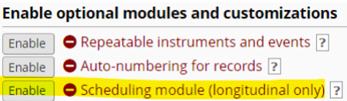
Once it is enabled, you will be able to access it via the Scheduling button in the left-hand menu in the Data Collection section.
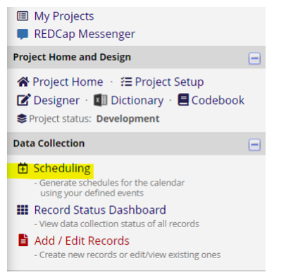

Create a schedule
Create participant schedules on the Create Schedule tab.
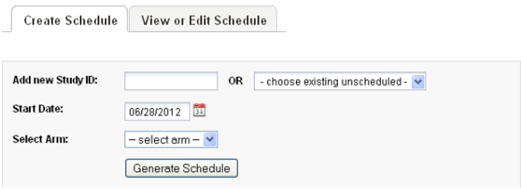
Notes:
• You can create a new record here by entering a new record identifier in the text entry box: be sure to select the correct arm if your project has multiple arms.
• Start Date is the baseline date for the schedule: the date from which each event’s offset days is calculated.

A “projected schedule” is generated and displayed, allowing you to adjust event dates and times (avoiding weekend visits, for example). The schedule is not saved until you click Create Schedule.
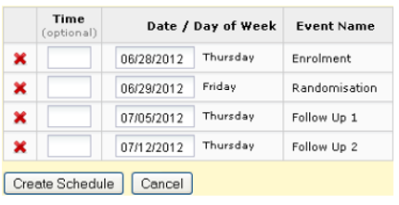

Automatic generation of schedules

View/edit schedules
Select the relevant record to view the associated schedule.
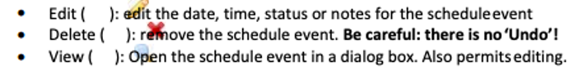
Do not delete event records unless you really mean to!
Schedule events across all records in your project may be viewed in a calendar format using the Calendar module.

Calendar
The Calendar module integrates with REDCap’s scheduling functionality to provide a calendar-based view of participant events.
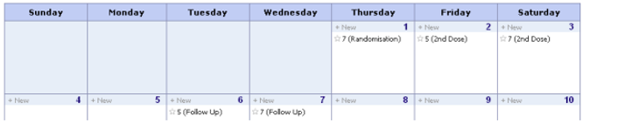
• Select the Day, Week or Month to view the events for that period
• Agenda shows a list of the events for the period in date order
• The + New button will add a new ad-hoc event to the calendar, but you cannot associate data entry forms with adhoc events.

Calendar Events
• Click on an event to view and make edits to the calendar event
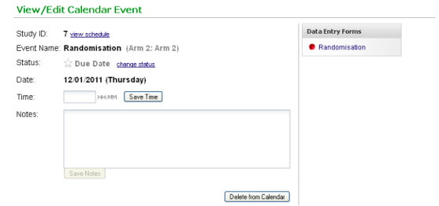
• Note the link to the data entry forms that are associated with the study event. Click the link to go to the form for data entry.
• The Event Status field has five settings:
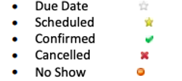
The colored event status indicator changes (as shown) according to the status of the event.
REDCap ascribes no particular significance to the status of an event, which means that you can use these status flags in any way that suits you. The wording of the label does not bind you to any specific meaning.

Exporting longitudinal data
With longitudinal projects you will find that your exported data contains multiple rows per project record: one row per record per event for which data is exported, as illustrated below:
It is done this way to handle situations where a field occurs on a form used in more than one event, such as follow_up_datein the illustration above. For your analyses you will often (but not always) need to manipulate the data so that it has all data for a record in a single row. Your stats package will have tools for accomplishing this kind of task (e.g. reshapein Stata, casestovarsin SPSS).
After reshaping, the data above will appear in a manner similar to this:

Longitudinal reports
The current report builder is very limited when it comes to building report in longitudinal projects. Due to the fact that a field may be associated with multiple events, you get a result row for each record for each event, as illustrated below.
It severely restricts the usage of limiters because report records for events not associated with the field will never contain data for the field the limiter is applied to and will therefore be excluded from the report results.
For example, say we wanted to view data for project records with dob < 01-01-2000. If we specify a filter of dob< 01-01-2000 then data from Randomization and Follow Up events will no longer appear in the result set because there can never be a value for dob associated with those events.

Importing data for longitudinal projects
Follow the Instructions for Applications/Data Import. Additionally, when importing data into a longitudinal project, you must include a column that specifies the unique event name for each record. Find the values to use on the Define My Events page from Project Setup

Public survey links within a longitudinal project
If you have surveys in multiple arms, REDCap will generate a unique public survey link for the first survey in each arm.
To access your public survey links, go to Survey Distribution Tools on the left-hand menu. You’ll see your Public Survey Link tab and a line of text that reads “The survey link below applies only to “x.” There is a drop-down menu next to the name of your first arm. You can click on the drop-down arrow to get the public survey link for the other arms within the project.

Double Data Entry
Double data entry is a tried and tested strategy for validating data entered manually. Ideally all records would be entered twice by different data entry persons, but if this is not practical, double entry and checking of just a sample can be a worthwhile compromise.

REDCap contains specific functionality for managing double data entry, but there is a requirement that specific users are allocated to entry roles 1 and 2. This is often too restrictive for projects that have several data entry staff that might fulfil different roles at different times.
An alternative – similar – method is for each record to be entered as normal once, then for a duplicate record to be entered as a new record but with a suffix appended to the record identifier, for example:

Validation of the data entry is performed using the Data Comparison Tool (and source data e.g. paper CRF). Each pair of records is viewed in the tool, which highlights any instances where a field value differs between the pair. Data can be corrected and the “-duplicate” records dropped from data exports prior to analysis.

Testing the survey
It is critical to test your survey to make sure it looks and behaves the way you want it to for your survey participants. See Adding test data for suggestions on how to do that.

Codebook
The Codebook is a list of your projects questions and serves as a quick reference for viewing the attributes of any given field in the project without having to download and interpret the Data Dictionary or access the Online Designer. This is particularly helpful when you are in Production mode since the only way you can access an instrument via the Online Designer is by entering into Draft Mode.
Times when it may be helpful to access the Codebook:
• When you are writing conditional logic for an Automated Survey Invitation
• When you are writing calculated fields
• When you are using piping
Access the codebook view by clicking the Codebook button ( ) on the left-hand navigation bar Under Project Home and Design.
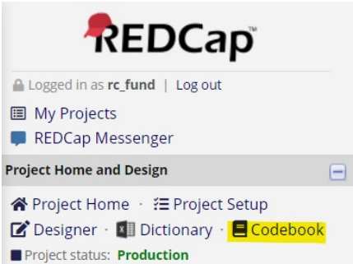

Collapse/expand instruments in Codebook
If you have multiple instruments and many fields within your project, the Codebook page can be very long. There may be times when you want to only look at the fields for a specific instrument. To condense the page so that you are only viewing the specific instrument you wish to look at, you can use the ‘collapse’ option.

Data dictionary
Creating a Data Dictionary in REDCap
You can create your database fields either using the Online Designer or a Microsoft Excel spreadsheet. In either case, what you’re creating is referred to as the data dictionary, a description of all the field (variable) names, field types, possible values, etc. We recommend using the Online Designer when you first begin using REDCap to get a feel for how it works, and also anytime you are making minor changes. In time, you might find it is easier to create a data dictionary in Excel, and upload this into REDCap. You don’t have to create similar variables individually as in the Online Designer – you can take advantage of using Excel’s copy/paste functionality. To learn how to create a data dictionary in Excel, a Data Dictionary demonstration file with coding examples can be downloaded from the Data Dictionary tab of any REDCap project.

Data Dictionary Excel Spreadsheet Columns
This section describes the function of each column in the data dictionary spreadsheet, and whether or not it is required or optional.
Note: The term “Column” here refers to Excel spreadsheet data dictionary columns. Also, the terms “field” and “variable”, as used here, are essentially interchangeable. Both terms refer to a unique item of data to be collected and analyzed. “Field” is a database term, while “variable” is a data analysis term

Making changes to your project with the Data Dictionary
The Data Dictionary is a helpful tool to use when making global changes to your project (for instance, changing a word that appears several times in the project) or moving blocks of fields. Why are there two methods that are essentially equivalent? There are different situations that suit the use of one method over the other:

These are merely considerations to keep in mind: feel free to use whichever method you are most comfortable with.

The REDCap data dictionary is a CSV file that contains the specification of all fields in your data collection forms: the form metadata. In other words, the data dictionary is your project’s code book.

Download current Data Dictionary
You can access the Data Dictionary from a couple places within your project. On the left-hand navigation bar, click on Dictionary (listed under Project Home and Design):

Or if you are on the Online Designer page, you can click on the Data Dictionary tab:

Download the Data Dictionary
Always download the current version of the data dictionary before making new updates. Changes made using the online designer or by other users will be lost if you make changes in and upload an outof-date data dictionary.
To download the data dictionary, click on “Download the current Data Dictionary’ from the Data Dictionary tab:

Design tip: create snapshot of instruments when in Development mode
Because any changes you make to the design of your project go into effect immediately when in Development mode, there is not an ‘un-do’ button if you change your mind.
It is more likely that you would want to un-do a change if there are multiple people designing the project at the same time and one person is making a design change that another team member is not aware of and who doesn’t agree with the change.
To give yourself the opportunity to revert the design of the project to a previous iteration, it is a best practice to use the ‘create snapshot of instruments’ feature. You can find that feature on the Online Designer tab:

That feature automatically creates a data dictionary of the project at the time that you click the button. That data dictionary is saved to the Project Revision History tab. So, if you want to revert to that data dictionary, you can go to Project Revision History, download that data dictionary and then upload it back into the project. You can access the Project Revision History tab via Project Home or Project Setup:

Edit the Data Dictionary
The data dictionary is in CSV format, which is plain text with values delimited with commas. Excel is generally the tool of choice for editing CSV files, but you may use any spreadsheet program or text editor.

Data Dictionary in Excel

Data Dictionary in Notepad

Things you can and can’t do in the Data Dictionary
When editing the data dictionary there are certain things to bear in mind about what is, and what is not permitted:

Saving the Data Dictionary
After making changes in the data dictionary, ensure that it is saved in CSV format, i.e. with the file extension .csv. Files with other extensions (e.g. .xlsx, .txt) cannot be uploaded.

Upload the Data Dictionary
Browse to the file you saved and click Upload File. REDCap will load your file and perform a number of validation checks that ensure your settings are valid, for example:

• Check that the file is a valid CSV file containing the expected column headers
• Ensure all required settings are present (e.g. field name, form name, field label)
• Ensure settings are valid (e.g. no spaces in field names, choices specified in the correct format)
• Ensure type and validation settings are consistent (e.g. you cannot have a drop-down list field with a validation type of date)

Viewing Data Dictionary history
The Project Revision History tab gives you access to the details of each version of the data dictionary. You can download any of the data dictionary CSV files.

Other Functionality
You must have Project Design & Setup permissions to perform actions on the Other Functionality page. You can navigate to the Other Functionality tab via Project Home or Project Setup.
The Other Functionality tab provides some additional project tools:
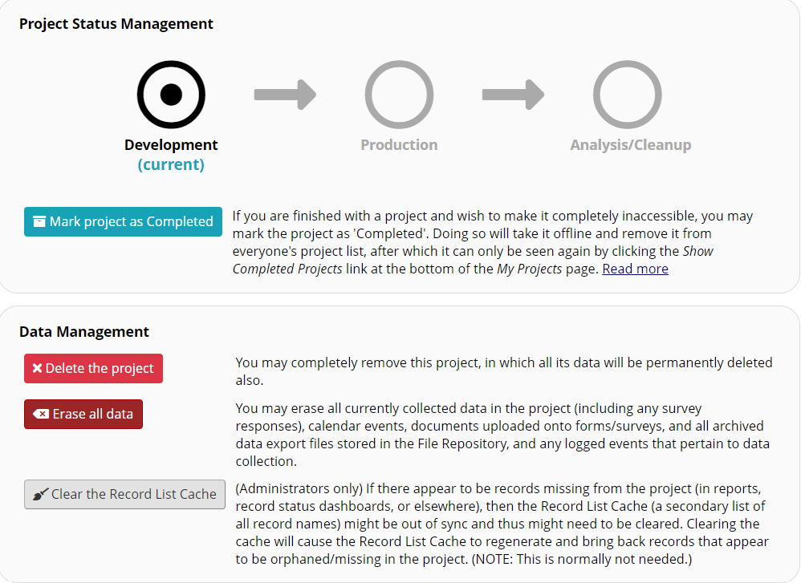
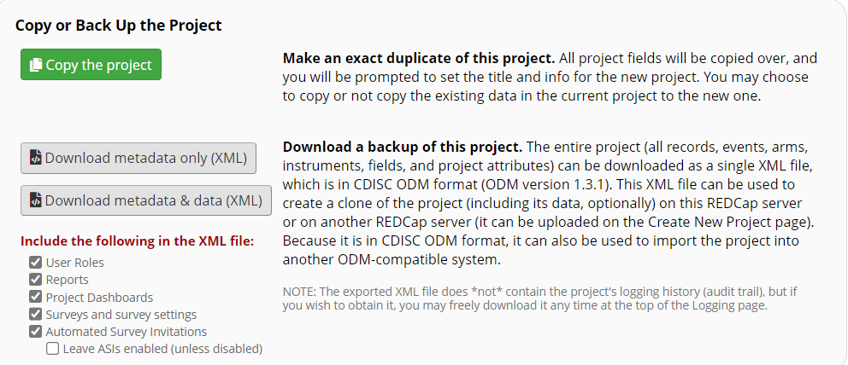

Move to inactive Status (production only):
Prevent access to all project functionality except Data Export, File Repository, Logging and User Rights
If your project is in Production status, and you are finished using it, you may shut it down and take it offline by moving it to Inactive status. To do so, click the Move to an inactive status button on the Other Functionality tab in REDCap. Once a project is Inactive, no responses can be entered or collected. Anyone trying to take a survey will be informed that the survey is no longer active. An Inactive project may be brought back to Production status by clicking the Move project to production button, located on the Other Functionality tab.
Most functionality is disabled – including access to individual records – but data can still be exported.
Prevent access to all project functionality except Data Export, File Repository, Logging and User Rights

Move to production status
Return the project to its pre- archival state.
Before moving a project from development mode into production mode, please ensure you have tested the project thoroughly. Once the project is in production mode, changes can still be made but must be submitted to a CTSI REDCap Administrator to be committed to the project. Please refer to the REDCap - Making Changes while in Production Guide for more information.

• Step 1
o Navigate to the Project Setup tab for the project. The last checklist item is “Move your project to production status.” Click on ‘Move project to production.’
• Step 2
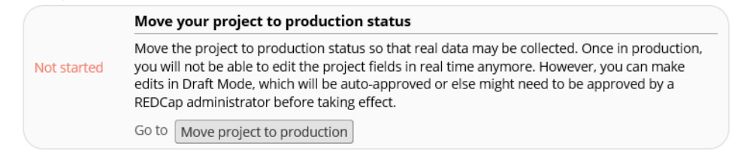

- A pop-up notice will appear with the red box pre-checked to ‘Delete ALL data, calendar events, documents uploaded for records/responses, and (if applicable) survey responses’. If you have entered test data that needs to be deleted prior to moving to production, please leave this box checked. Real data should not be entered while in development mode. If you have accidentally entered real data, then you should select ‘Keep All Data saved so far.’
- Click on ‘Yes, Move to Production Status.’

- Step 3
o If you have selected to delete all the data, then another warning will appear.
o After reviewing the box, make the appropriate selection.
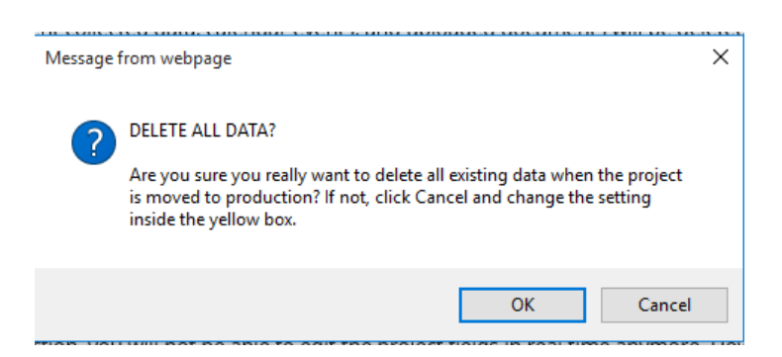
• Step 4
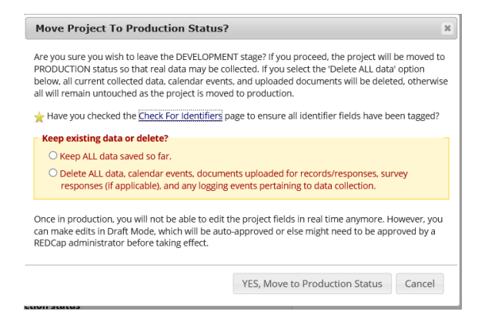
- The system will provide a notification that the project has been moved to Production status. You may confirm the status by referring to the top-left corner of the screen:
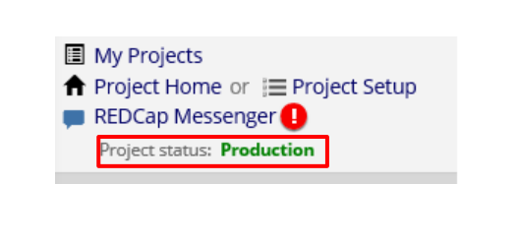

Copy the project
Make an exact duplicate of the project configuration and forms/fields plus (optionally) all project data, reports, data quality rules and users. You will be prompted for a new project title.
Please Note: You need to have copy project permissions if you do not please email the NSHA REDCap administrators to ask how to obtain this access. Creating a project from an existing data dictionary
1. Log into REDCap
2. Select your required project from the ‘My Projects’ tab that you want to copy and create a new project of
3. On the ‘Other Functionality’ tab, under ‘Copy or Back up the Project’ select the ‘Copy Project’ button.
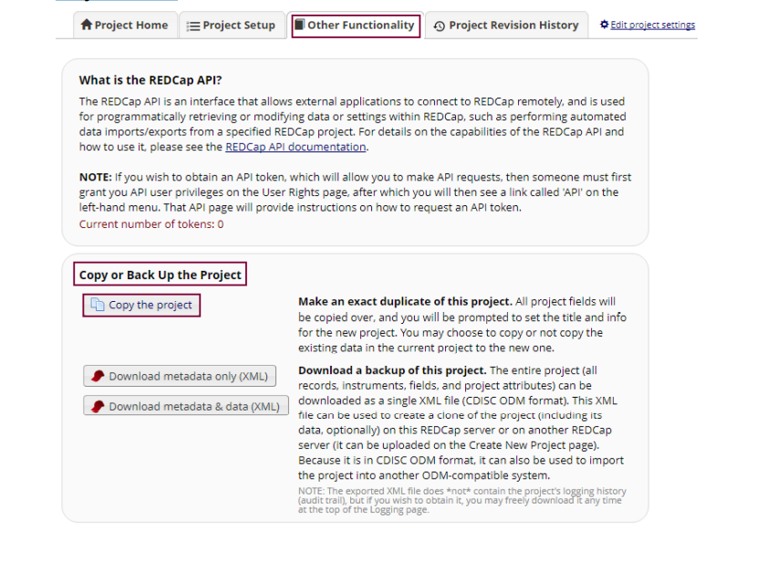

4. On the ‘Make a Copy of the Project’ tab, check the following and update or select where required:
a. Project Title: Change this title so you can distinguish between the project you are creating a copy from and the new project
b. Purpose of this project: Change the dropdown list selection and any other information if this option or any of the details have changed
c. Also copy the following: If you want to copy all the records, or keep any of the reports, setting, reports etc., select the required tickbox to copy the information to the new project
d. Select the ‘Copy Project’ button
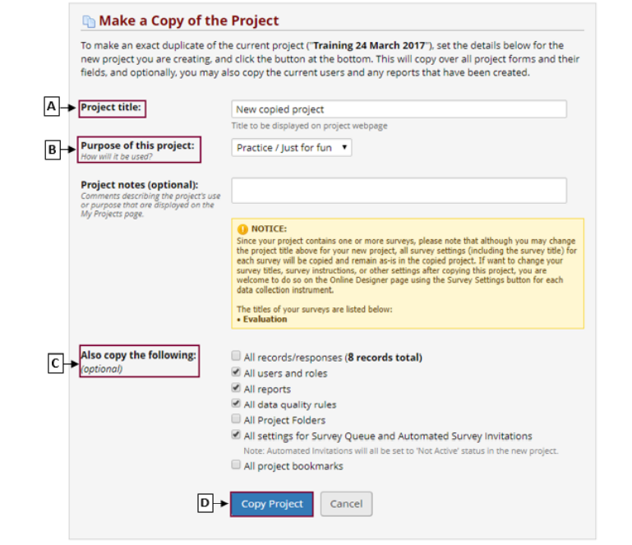
- Once the changes have been made and successfully committed, taken to the ‘Project Setup’ tab and advised your project has been successfully copied. You can continue to setup your project and make any required change to the instruments on the online designer.
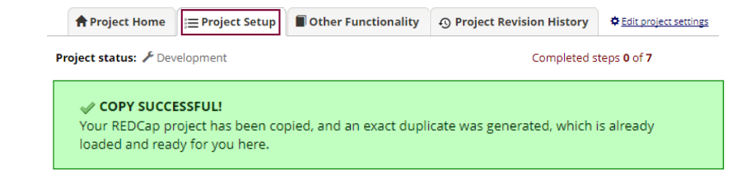

Delete the project (development only):
Removes the project entirely. All data will be deleted.
Erase all data (development only):
Clears out all data from your development project, including participant records, form data and scheduling and calendar data.
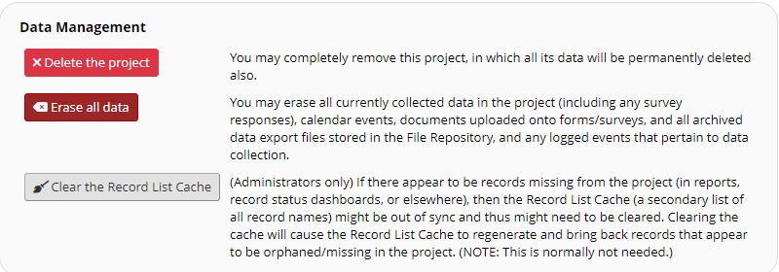
A pop-up window will display. Type “DELETE” in the text box and hit the ‘Delete the project’ button.
Note: This will permanently delete the project, and you will not be able to retrieve any data or forms from this project once it has been deleted.
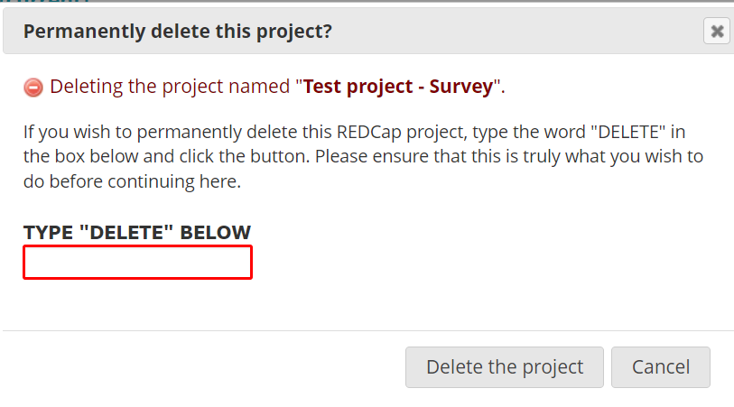
NOTE: Projects are permanently removed from REDCap 30 days after they have been deleted. Until that time, REDCap Administrators can undelete the project. After 30 days, deleted projects cannot be recovered.

Archive the project
Prevent access to all project functionality except Data Export, File Repository, Logging and User Rights. Also removes the project from the My Projects list, unless the Show Archived Projects option is selected.
Note: You can still access archived projects from the My Projects page by scrolling to the bottom of your projects list and selecting ‘Show Archived Projects.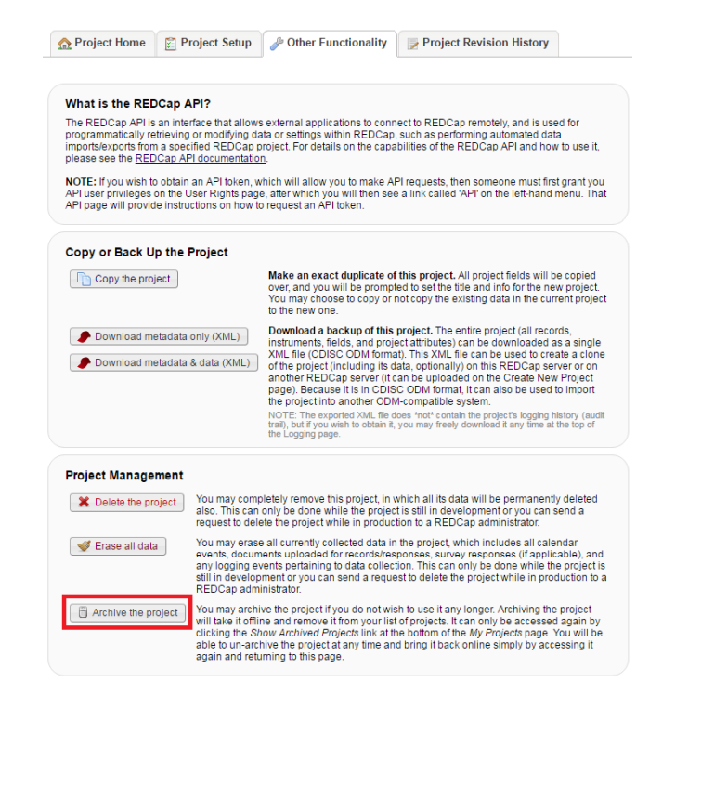

Data

Add data
For a video overview of Data Entry, see this link. It is 19 minutes in length. You can access the video from the Home or My Projects tab by clicking on Training Videos. If you are in a REDCap project, look on the left-hand navigation bar under the Help & Information section at the bottom of the navigation bar.

What to know about data entry
• You can use the tab key to move from one question to the next
• Validation will force you to enter data enter a specific way
• Branching logic will determine what questions you see
• Required questions force you to enter an answer for those questions in order to save
• Each entry creates a record

View data

View individual record
You can view any individual record within your project by clicking on the Add/Edit records link on your left-hand navigation bar.
Select the record from the drop-down menu. You will be brought to the Record Home Page of the record you selected. For longitudinal projects, you will see the Event Grid.
Design Tip for Viewing Records
You can add a label to a record number, so that as you are viewing a list of records in the Add/Edit records or Record Status Dashboard, you will know more information about the record rather than having to open it to see what data is in it. For instance, if the record represents a person, you can add the person’s first and last name as the custom record label.

So instead of this:

You will see this:

For more information, see the Set a Custom Record Label section of this User Guide.

Search records
To search for an individual record by something other than the record identifier, you can use the Data Search section of Add/Edit Records. Only non-categorical fields appear in the list as they are most likely to contain useful identifiers.

With each keystroke of your typing, records with saved data matching your entry are shown in a list. Click an item in the list to select that record. You will be taken directly to the event/form for the data item you selected

Record status dashboard
This is a table that lists all records/responses and their status for every data collection instrument in the project. To access it, click on Record Status Dashboard on the left-hand navigation bar, in the Data Collection section.
You may click on one of the icons in order to open the data collection instrument for a specific record.

A record that has been entered as a data entry form will have the circle filled with color. A record that has been entered as a survey will have the color and a checkmark in it.

Viewing Aggregate Data
See the Applications section of this User Guide re: Data Exports, Reports and Stats. You will learn how to view all of the data in your project and also how to select a sub-set of data for viewing.

Printing PDFs of your Data
There are multiple ways to print PDFs of the records in your project. To customize the appearance of the PDF, please see PDF Customizations.

Printing PDFs of one record across all instruments
From Add/Edit Records - Select record from drop-down menu. You are now on the Record Home Page.
You can download either a full version (1st option listed) or compact version (2nd option listed) of the data. The first version will give you all the fields and all the responses in the instrument, regardless of whether the question was hidden due to branching logic or if it was left empty. A compact version shows only the fields that were asked and does show questions that were hidden due to branching logic. If you have multiple instruments, the PDF will contain data across all instruments.

Printing PDF of one Instrument for a Record
If you wish to download a PDF of only one instrument, click on the record for that instrument. You can get to a specific instrument for a record by going to the Record Home Page via Add/Edit records (see above) or via the Record Status Dashboard.
You will then have 3 options available:

Again, the compact version simply means that it will not show the fields that were hidden due to branching logic.

Note about printing PDFs of blank instruments
Note that the document produced is not suitable for use as a paper data entry form because it does not provide sufficient guidance on expected data formats and coding to the person completing the form and the data entry person. For example, even three simple fields in the screenshot below would lead to a number of questions:

1. Is Randomization Number expected to be numeric? Could it be alphanumeric?
2. How many characters are expected for Randomization Number?
3. What format should be used for writing dates? dd-mm-yy? mm/dd/yyyy? dd-mmm-yyyy? yyyy-mm- dd? Consistency is very important, especially for projects running in a number of countries.
4. How does the data entry person encode the response for Randomization Stratum? 1=present, 2=absent? 1=present, 0=absent?
5. For all fields, what code can the data entry person enter if data is missing from the form? What about if data is illegible or otherwise raises some query?

Change Data

Edit records
To edit a data entry form, you must have the data entry right “view & edit” selected for your username on the project. That is set using the User Rights application. For instructions on editing User Rights, please see this section of this User Guide.
With this user right, you could then go to the record, make changes and save. If you over-write data that has been previously entered, you may view the history of the response by clicking on the ‘H’ next to the field:

To edit a survey response, you must have the data entry right “edit survey responses” selected for your username on the project. That is set using the User Rights application. For instructions on editing User Rights, please see this section of this User Guide.
With this user right, you could then go to the record, click on the ‘edit response’ button.
You can make changes and save. If you over-write data that has been previously entered, you may view the history of the response by clicking on the ‘H’ next to the field:

Delete Records
To delete a record:
1. Navigating to any data entry form for the record
2. Click the Delete Record button that appears at the bottom of the form
3. Confirm the deletion

Delete Record Rights
To delete records a user must have been given the necessary permission on the User Rights page. Access to this function should be restricted to a limited set of project users. If you want to grant this right to yourself, go to the User Rights page, click on your name and then the Edit User Privileges button. You can then tick the box for Delete Records.

If you do not see that option or it is greyed out, you will need to contact the Project creator/owner and ask them to assign that right to you.

Double Data Entry
Double data entry is a tried and tested strategy for validating data entered manually. Ideally all records would be entered twice by different data entry persons, but if this is not practical, double entry and checking of just a sample can be a worthwhile compromise.
REDCap contains specific functionality for managing double data entry, but there is a requirement that specific users are allocated to entry roles 1 and 2. This is often too restrictive for projects that have several data entry staff that might fulfil different roles at different times.
An alternative – similar – method is for each record to be entered as normal once, then for a duplicate record to be entered as a new record but with a suffix appended to the record identifier, for example:
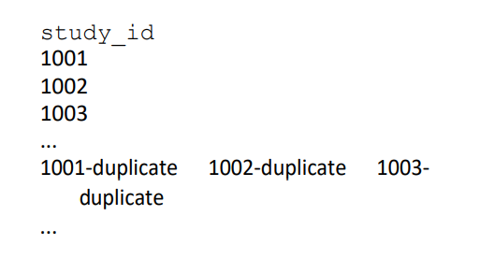
Validation of the data entry is performed using the Data Comparison Tool (and source data e.g. paper CRF). Each pair of records is viewed in the tool, which highlights any instances where a field value differs between the pair. Data can be corrected and the “-duplicate” records dropped from data exports prior to analysis.

Applications

Alerts and Notifications
The Alerts & Notifications feature allows you to construct alerts and send customized email notifications. These notifications may be sent to one or more recipients (a user on the project, a survey respondent or someone else) and can be triggered or scheduled when a form/survey is saved and/or based on conditional logic whenever data is saved or imported.
When adding/editing an alert, you will need to 1) set how the alert gets triggered, 2) define when the notification should be sent (including how many times), and 3) specify the recipient, sender, message text, and other settings for the notification.
For the message, you may utilize customized options such as rich text, the piping of field variables (including Smart Variables) and uploading multiple file attachments.
Alerts apply to both data entry forms and surveys, and they also allow for more options regarding who can be the recipient of a notification (project users, survey participants, etc.).

To create Alerts and Notifications
To create an alert, click on Alerts & Notifications in the Applications section on the left-hand navigation bar.
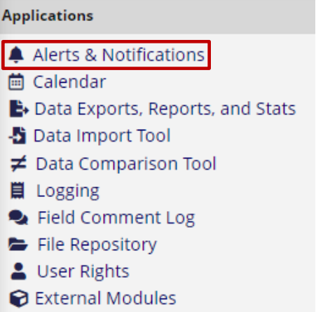
Then click on the Add New Alert button:
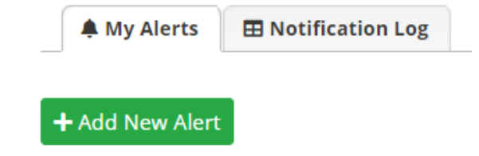
You will then see the following sections for you to configure:

Title the alert
You can title your alert, which is helpful if you have many alerts. This is a way to distinguish one alert from another.

Step 1 of Alert setup
If the condition for triggering the alert is simply that a record is saved, these would be your choices in Step 1:
If the condition for triggering the alert is based on conditional logic, these are the choices you will see in Step 1
If the condition for triggering the alert is based on data import, these are the choices you will see in Step 1:

Step 2 of Alert Setup
This is the section where you tell REDCap when to send the alert and how many times to send it.

Step 3 of Alert Setup
This is the section where you configure who the alert comes from, who it will go to, who to email if there are message send failures, the subject line and body of the email and upload attachments.

Email from: This field will pre-populate with your email address. You can change it to another email address associated with your REDCap account or another user on the project.
Email To: This can be an email address captured in a field on the project or a user on the project. If you wish the alert to go to someone who is not a user on the project, simply manually type the email address in the second box (labeled ‘or manually enter emails’).
Email CC and Email BCC: click on the ‘show more options’ link located below Email To to see these.
Email to send email-failure errors: put the email address of the person managing the alert. If the recipient’s email client rejects your message for some reason (e.g. the file size is too big), then this person will be notified.
Note: if you are attaching a file(s) to the alert, it is highly recommended that you put an email address in the ‘Email to send email-failure errors’. That way, if the recipient’s email client rejects your message for some reason (e.g. the file size is too big), then someone will be notified.

Piping in Alerts
The box ‘Prevent piping of data for identifier fields’ is automatically checked for all alerts. This means that any field variables (e.g., [date_of_birth]) that exist in the alert's subject line or message will not have their value piped if the field has been tagged as an 'Identifier' field. In this case, it will simply replace the field variable with [*DATA REMOVED*] rather than piping the actual data into the message.
This is a preventative measure, since an Alert is sent via email and email is not a secure form of communication.
If you wish to pipe identifiable information into the subject line or body of the email message, you will have to un-check that box.

Optional setting in Alert
If you wish for REDCap to automatically expire your alert at a specified time, you can set that here.

Alert listing
Once you have created your alert, an abbreviated listing will appear, showing the highlights of the alert.

Alert Activity
To see a summary of what activity has occurred for the alert, you can look at the Activity section of your alert on the Alerts & Notifications page,
If you click on the view list link, you will see something like this:

Please note, the record numbers are not hyperlinks. To see a detailed listing of Alerts sent, click on the View sent alerts in Notification Log link.

Notification Log
The notification log is a detailed listing of what alerts have been sent. It might look something like this:
You will note that the alert number, not the name that you gave the alert, is listed. Also, the email address in this image has been obscured but you will see the first email address of the person to whom the alert was sent to. If you wish to view other recipients of the email (other people listed in the To, CC or BCC sections), click on the View Notification icon. You will see there a copy of the Alert.

Deactivating Alert
If you wish to manually deactivate an alert, go to your Alerts & Notifications page, find the alert and click on the Options button. You can then click on the Deactivate alert option:

Copying Alert (Copy alert)
Sometimes you might need to set up an alert that is very similar to one you’ve already created, but with a small change. To easily copy the existing alert, you would go to the Alerts & Notifications page, find the existing alert and click on the Options button. You can then click on the Copy alert option:
You would then edit the alert.

Editing Alert
To edit an alert, you would go to the Alerts & Notifications page, find the existing alert and click on the Edit icon:
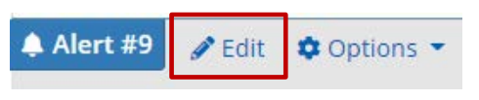

Calendar (for longitudinal projects only)
The calendar application can be used when the project is a longitudinal project. Please go to the Longitudinal Projects section of this User Guide for more information. You can also see the training video embedded in the application or find further information on the topic in the Help & FAQ section within REDCap itself.

Data Exports, Reports and Stats
This will allow you to easily view reports of your data as well as export your data to Microsoft Excel, SAS, Stata, R or SPSS for analysis. If you wish to export your *entire* data set or view it as a report, then Report A is the best and quickest way. If you want to view or export data from only specific instruments (or events) on the fly, then Report B is the best choice.
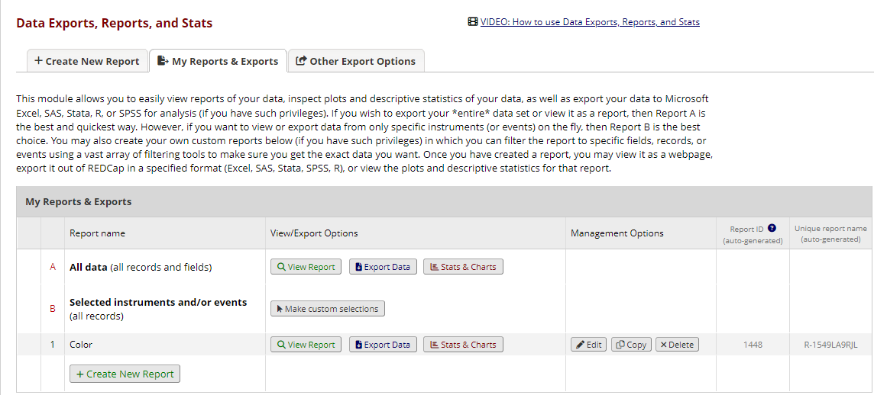

Create a Custom Report
You may create your own custom reports in which you can filter the report to specific fields, records, or events using a vast array of filtering tools to make sure you get the exact data you want. Once you have created a report, you may view it as a webpage, export it out of REDCap in a specified format (Excel, SAS, Stata, SPSS, R), or view the plots and descriptive statistics for that report.

Custom report: step 1
To get started, click Create New Report and enter a name for the report. This name will be listed in the Reports section of REDCap’s left-hand menu column.
Indicate who should be able to access the report:
• All users
• A list users specified by name
• All users from a particular user role orroles
• All users from a particular data access group or groups (see User Rights for more information about user roles and data access groups).
Indicate who should have access to editing, copying or deleting the report. This feature will only be available to users on the project who have “Add/Edit/Organize Reports’ privileges. Multiple users might want to use a report in different ways and might choose to change some of the fields, filters or sorting options. This setting will allow you to restrict other users’ ability to make those changes.

Custom report: step 2

Specify the fields to include in the report
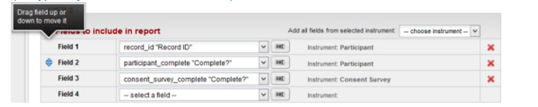
Note:
• If your list of fields is very long it can be easier to find them by clicking ABIand opting to have a text entry box with an autocomplete dropdown.
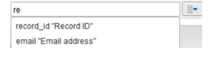
• You may reorder fields by dragging a field to a new position
• Remove fields using the red X

Additional Report Options

Survey identifier field and survey timestamp field
If your project includes surveys, you have the option to tick a box so that the survey identifier field and survey timestamp fields are included in your report.
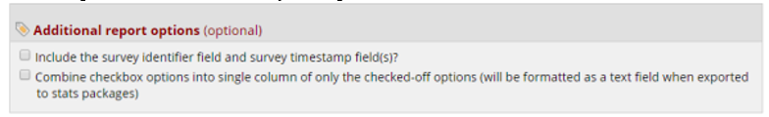
If you use multiple choice checkboxes in your project, you will note that each choice takes up its own column in a report or export. If you prefer to have those columns combined, tick the option to combine check box options.

Custom report: step 3

Specify a filter for the records (optional)
You can apply straightforward filters by selecting the relevant fields and specifying an operator (e.g. “equals”) and a value to match. For complex expressions involving functions or requiring parentheses click Use advanced logic to write your filter expression. The syntax for the expression follows the same rules as for calculated fields and branching logic.

Live filters
Live filters can be selected on the report page for dynamically filtering data in real time. With the exception of the Record ID field, only multiple-choice fields can be used as Live Filters.

An example of when this might be useful is if you are looking at a report of all patients who have diabetes. You could have a live filter on gender and race. So when you first view the report (with no live filters), you would see all patients with diabetes. If you wanted to know how many of them are female, you could click on the live filter for gender and select to only see females. You would then be looking at a sub-set of your data: patients with diabetes who are female. You can then click the live filter for race and select African American. That would deliver you a further sub-set of data, this one displaying only the African American female patients who have diabetes.

Custom report: step 4

Specify up to three of the report fields by which the records will be sorted
You will then click Save Report. You will be asked if you wish to View the Report, Return to My Reports & Exports or Continue Editing report. Once you click View Report, your report will be added to your report list on the left-hand navigation bar.
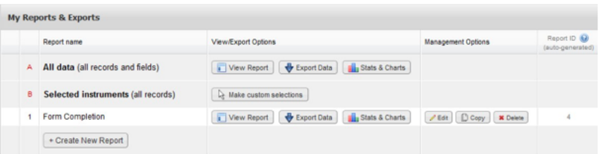
Reports are also listed in their own section of the left-hand menu and are available directly from any project page
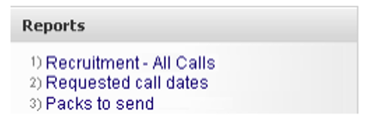
Design tip: Survey Timestamps
While you do have the option in the Reports section to add a survey timestamp to a report, that timestamp is solely for the first survey in your project. If you have multiple surveys, REDCap does not automatically capture those survey completion times in the Report. Additionally, the survey timestamp is not a field on which you can sort your report. So if you need to sort your responses based on completion time, you will not be able to do that.
You can automatically capture the timestamp of subsequent survey completion times (and the initial survey completion time, should you wish to use that field to sort results) using action tags. To do that, add a validated date field as the last field in your survey. When in that field, click on action tag and add ‘TODAY’ (if your validated option is for date only) or ‘NOW’ (if your validated option is for date and time.) Also click on ‘HIDDEN-SURVEY’. What that does is instruct REDCap to capture the date behind the scenes without the survey participant having to fill it in.
See below for a screenshot example.

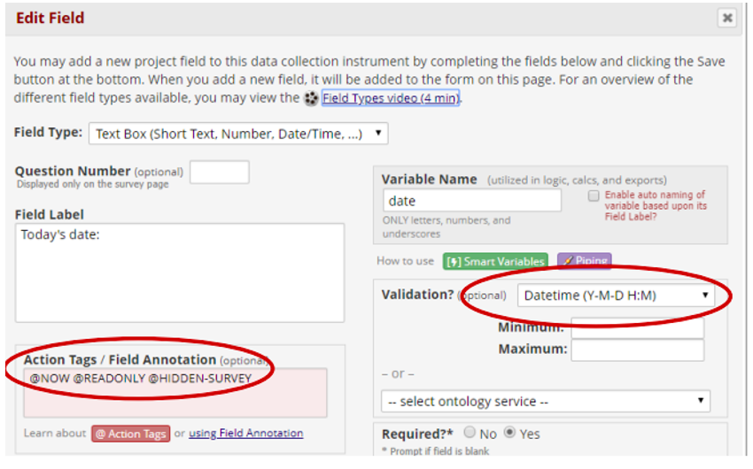

Managing and using your Reports
The list of Reports & Exports displays the two built-in reports and then any that have been created for your project. The table supports the following tasks:

View Report
Run the report and display the results in a table onscreen

Export Data
Select an export format and any de-identification options and download report data in CSV format, plus a syntax file for the stats package option

Edit report
Return to the edit screen to make changes to the design of the report.

Copy report
Create a new report as a copy of the report selected. A new title must be entered, and you may then make alterations to other aspects of the new report’s setup (allowed users, fields, record filter, sort).

Delete report
Remove the report. There is no Undo!

Reorder report list
You can reorder the list of reports by hovering your mouse pointer over the left-hand column of the table of reports and dragging a row in the table to a new position.

You can reorder the list of reports by hovering your mouse pointer over the left-hand column of the table of reports and dragging a row in the table to a new position.
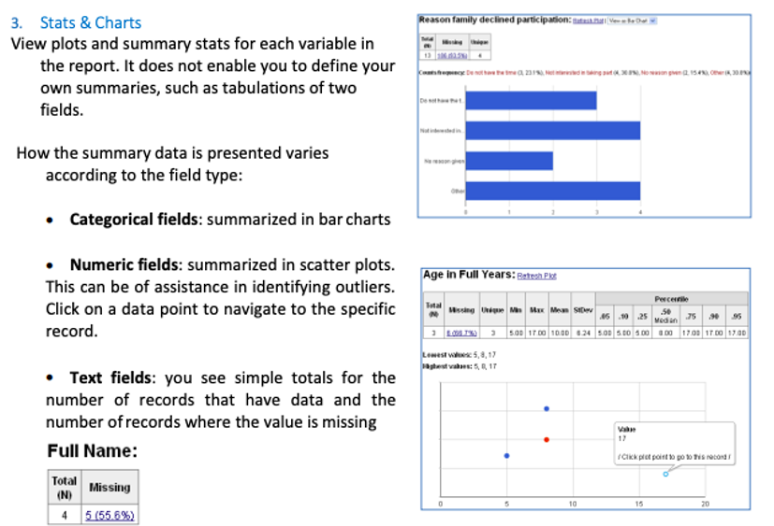

Reports and Data Exports with Repeating Instruments and Events
Two new fields will be automatically included in Reports and Data Exports if data is collected through repeating instruments or events. Each repeated instance of an instrument or event will be displayed as a new row in the report or export file.
A Repeating Instrument will populate both columns and provide multiple rows for each instance.
A Repeating Event will provide one row without populating the Repeat Instrument column (all of the I instruments for the event are repeated). The Repeat Instance number is an auto-numbered value (beginning with 1) that is incremented with each repeat of the instrument or event.
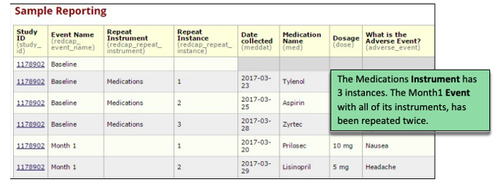

If the report contains data specifically from a repeating instrument (as opposed to a repeating event), a field named 'redcap_repeat_instrument' will additionally be included, representing the instrument name for which the row of data belongs.

Export Data
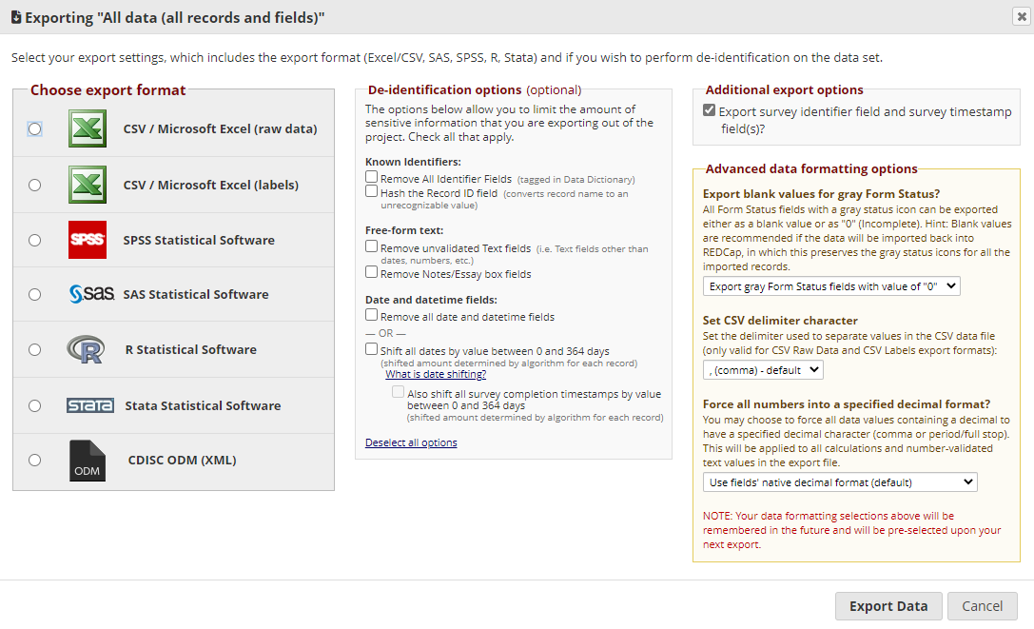

After clicking Export Data for a report, you must select the format for the export and any deidentification options.

Export Formats
Choose how you would like to download the data. Either:

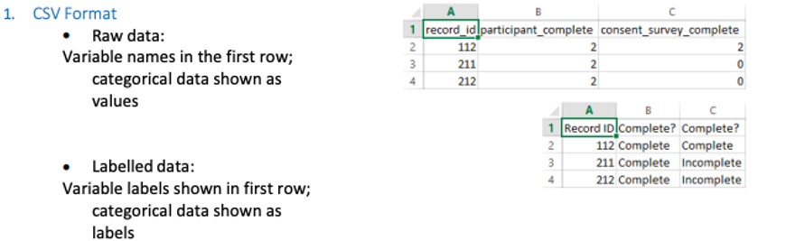
Use the “Raw” option if you are wanting to take a backup of your data or if you want to use the data for producing charts or to prepare a file to import back into REDCap (or indeed another system).
Remember that CSV files are NOT Excel files, and Excel may not display CSV data exactly how it is in the CSV file. See Note on CSV Files.

Statistical Software
For each stats package option (SPSS, SAS, R and Stata) REDCap will give you a raw data file in CSV format and a syntax file that will read in the data from the CSV file and apply the appropriate column formatting, variable labels and value labels.

De-identification
- Known identifiers: obfuscate record identifiers and/or ensure all fields that are flagged as identifiers in the online designer or data dictionary are excluded from the export
- Free-form text: text entry fields with no validation (and particularly Notes-type fields) may well have identifying information entered into them. You can opt to exclude such fields from the export
- Date and datetime fields: can be excluded or date-shifted whereby all dates for each record are shifted by a random but consistent number of days (for example, record 1 dates all +23 days, record 2 dates all +201 days etc.)

For users whose export permissions are set to De-identified only (see User Rights) these options (with the exception of record identifier hashing) are always applied.

Downloading
After the export is run and you have confirmed the citation reminder you are presented with buttons for downloading the files in the format you chose. For example, here a raw data file and Stata syntax (.do) file:
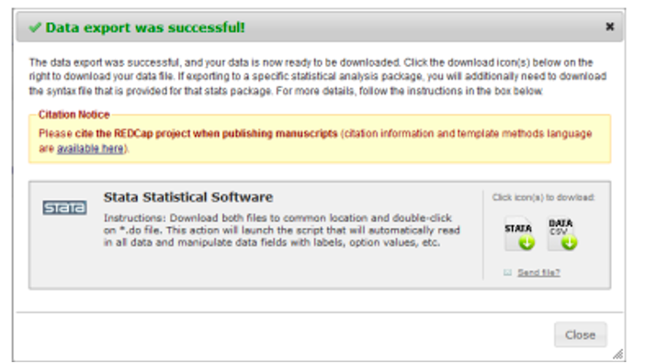

Note on CSV Files
A CSV file is simple plain text with one record per line and columns delimited with a comma – i.e. each individual value in each record is separated by a comma (CSV is an acronym for “Comma-Separated Values”). On Windows computers CSV files are set to open using Excel by default, and Excel will generally use the commas to separate the values into columns, but a CSV file is NOT an Excel file.
Beware Excel’s not-so-helpful automatic data formatting: it can cause you to lose format information from CSV data such as leading zeros and specific date formatting.
It may be preferable to open your CSV file in Excel not by double-clicking on the file in the usual way, but by opening a blank Excel worksheet and using the import wizard: on the Data tab in the ribbon is the option From Text.
This method enables you to specify that you want Excel to treat some (or all) of your columns as text, thus displaying the data exactly as it appears in the source file, not using Excel’s opinion of what you want to see.

- The data in the Excel CSV Raw and stats package DATA CSV files are identical – raw, unlabelled data in CSV format – but the stats package DATA CSV files do not contain header rows (field information is included in the syntax files)

- The Pathway Mapper files for SPSS and SAS are Windows batch files. When you have downloaded the associated syntax and data files, you can run (double-click) the pathway mapper. It will update the syntax file’s file handle/infile statement so that it includes the full file path to the location where the files are saved.

Using the Pathway Mapper is optional (and not possible if you use Mac or Linux). You can perform the same task by manually setting the path in the syntax file, or by setting the current working directory to the appropriate location.
- Send file? loads the export files into REDCap’s Send-It application, enabling you to send the files securely to everyone
- All exports are saved to the database and can be downloaded again using the File Repository

PDFs and Other Export Options
The PDF & Other Export Options tab gives you options for downloading:
- A ZIP file containing all files uploaded to all of your project records
- A single PDF containing all data for all forms for all of your project records Further information is available in the text on the page.
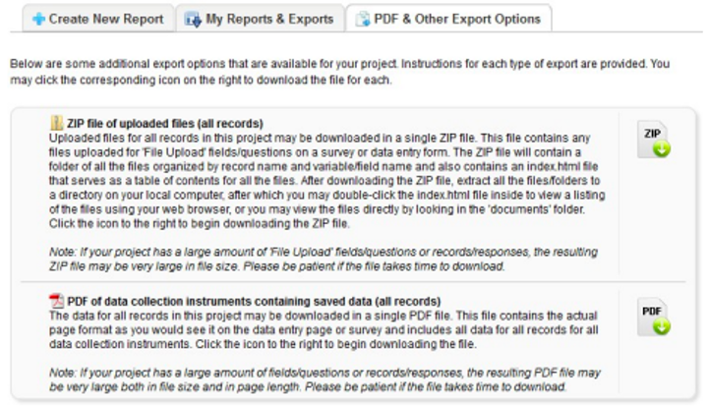

Data Import Tool
This application is used when you have existing data that you would like to enter into your project. Detailed steps are provided on the application page. Note that you will need to download the data import template first and the then paste your data into that template.
This tool is helpful to use if you have created a condition that will then schedule an Automated Survey Invitation.

Import Template
First download an import template file (CSV format). The template contains column headings labelled with the field names from your data dictionary plus the form status indicator fields. Calculated fields are omitted from the template – you may not import data into a calculated field, but calculated fields will be updated following an import.
Your template can be formatted with records in rows or records in columns. “Records in rows” is overwhelmingly more common.

Importing to Checkbox Fields
Checkbox groups are treated as separate fields named according to the field name specified plus a zero-based index. Below illustrates the import template for a checkbox field named checkboxquestion that has three checkboxes. Following import, the first checkbox will be unticked (value=0) and checkboxes two and three will be ticked (value=1).

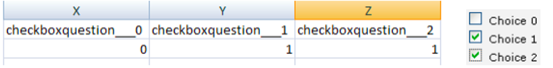

Importing to Data and Date/Time Fields

Importing to Data Access Groups
When importing data into project that uses Data Access Groups, you must include a column that specifies the Data Access Group (DAG) for each record. Find the values to use on the Data Access Groups tab from User Rights.
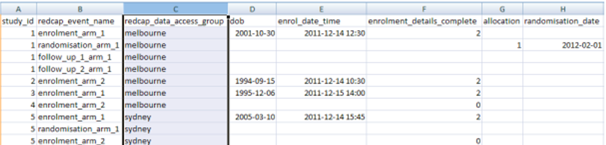
Where the user performing the import is assigned to a DAG, records are automatically assigned to the user’s DAG. Such users cannot import records to other DAGs.
Records can also be assigned and re-assigned to a Data Access Group individually from their data entry forms following import.

Calculated Fields
You may not import data into a calculated field, but calculated fields will be updated following an import. Calculated fields are omitted from the import template.

Upload File

Upload Summary

Data Comparison Tool
This application may be used for comparing two records currently in the project. It is typically used for projects using Double Data Entry.
Select a record from each of the lists below and hit the 'Compare' button. A comparison table will then be displayed showing the differences between the two records. Only the fields that have differing values are listed. If you need to correct or change the value of one of the records, you can click on the data displayed in red, and it will take you to that form for that particular record.

Note: Data Comparison Tool and Repeating Instruments
While repeating instruments/events are fully supported when using Double Data Entry, REDCap states that the Data Comparison Tool does not *fully* support the Repeating Instruments and Events feature. Data can be compared (and even merged if using Double Data Entry), but REDCap will only allow comparison and merging of Instance #1 of a repeating instrument or repeating event. In other words, all other repeating data will be ignored on this page. Also, all non-repeating data can still be compared and merged.

Logging
The Logging module is where you can view audit trail information, i.e. a log of data changes in your project. You can view and reconstruct a history of record creations, updates and deletions and review the activity of your project’s users. This will list the date and time and user or survey respondent who made changes made to the project. This includes data exports, data changes and the creating or deletion of users. Note: It does not give you the details of the changes made.
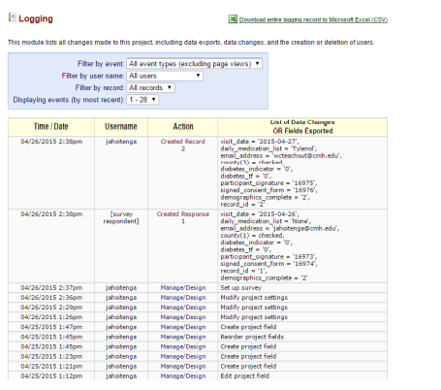

Notes:
• Note the different filter options to help you narrow the scope of log records included in the view
• You may Download the entire logging record, just be aware that this may take some time for large or
very active projects.

Field Comment Log
An application that lists all field comments for all records/fields. Field comments can be keyword searched and filtered.

Notes:
• Note the different filter options to help you narrow the scope of comment records included in the view
• You may Export entire log in CSV format
• Unfortunately, it is currently not possible to change the month/day/year date format
• Clicking on the Record link for a field will open the associated data entry form and record

File Repository
This application may be used for storing and retrieving files and documents used for this project. For instance, if you have an SOP (standard operating procedure document) or any other reference document which team members might need access to, you can upload it here.

User Files
The User Files menu tab is where you view all files that have been uploaded for a project.

Data Export Files
The Data Export Files menu tab gives users with Data Export permissions access to the history of data exports

Upload New File
Uploading a new file is very straightforward: select the Upload New File menu tab, select the file to upload and give it a label, then click Upload File.

Data Access Groups (DAGs)
Data Access Groups (DAGs) restrict viewing of data within a database. A typical use of DAGs is a multi-site study where users at each site should only be able to view data from their site but not any other sites. Users at each site are assigned to a group and will only be able to see records created by users within their group. Records that a group user creates are automatically assigned to that group. A user in a Data Access Group has access only to records that are also assigned to that Data Access Group.
For example, you as the project owner create a Data Access Group called “Nashville Site”. Your collaborator from another institution has had a NSHA/Meharry REDCap account created for them by the REDCap administrator, and you assign her username to the Nashville Site group. The collaborator can view records that she creates or that you assign to Nashville Site, but not any records that are assigned to other groups, or that are unassigned to any group.
- To create a Data Access Group, click on the DAGs tab.
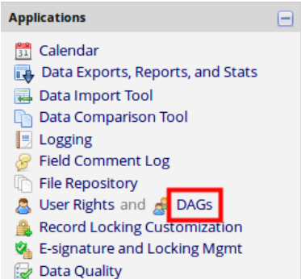
- Enter the Group Name and select Add Group
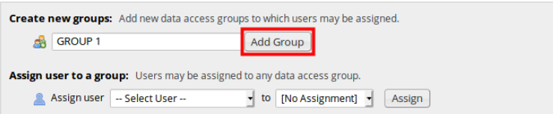
- The new group will appear in the Data Access Groups table. You can add as many DAGs as required.
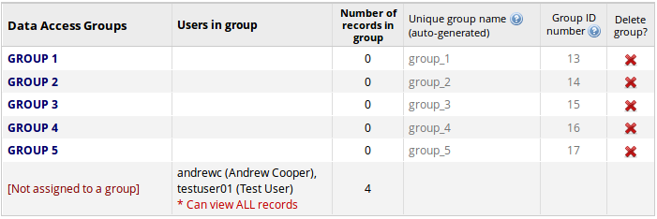

Adding Users to DAGs

All users must first be added to the project on the User Rights page. Once the users have been added to the project, you can then assign them to a Data Access Group.
- Navigate to the DAGs tab and click on the dropdown beside Assign User. Select the username and the appropriate Data Access Group from the next dropdown list. Then click on Assign
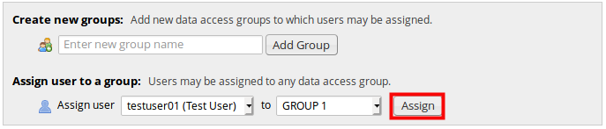

- The username will then appear within the Users in group column of the Data Access Group table.
- Users can be assigned to multiple DAGs
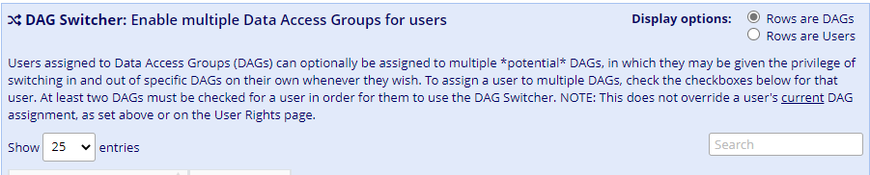

Using the Data Import Tool to add records to a Data Access Group
Once a Data Access Group is created on a project, REDCap creates a field named “redcap_data_access_group’ behind the scenes. To bulk add records to a data access group, go to the Data Import Tool under the Applications section of your left-hand navigation bar. Follow the directions listed on that page. Essentially, after you download the data import template, you will see a column with the header redcap_data_access_group in it. That is the column into which you will enter the DAG group name (not the unique group name or Group ID number listed on the DAG page.) Note that the DAG group name is case-sensitive. You can then enter the record numbers (one per row) that you want to assign to that DAG. You will then upload the new file (with the records and DAG name) back into REDCap on that same page.
For more information on using the Data Import Tool, please see this section of this User Guide.

User Rights (Adding a user to your project)
If you would like to grant other users access to your project, click on User Rights on the Project Setup page or on the left-hand navigation bar.
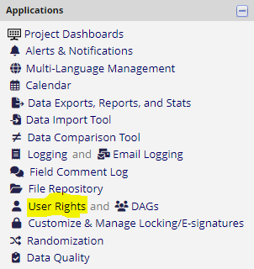
You will see this image in your workspace (area to the right of the left-hand navigation bar)
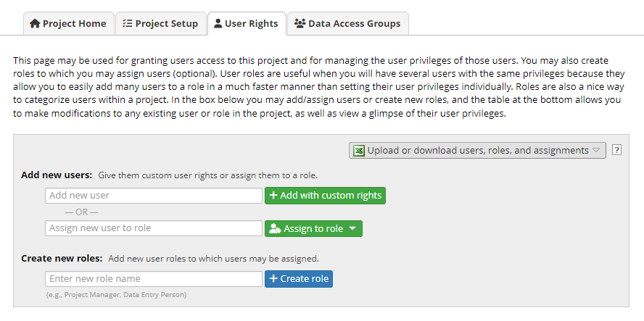

Enter the person’s REDCap username in the Assign new user to role.
• If the person is found click on Add new user and then click on Add with custom rights. You will get this screen;
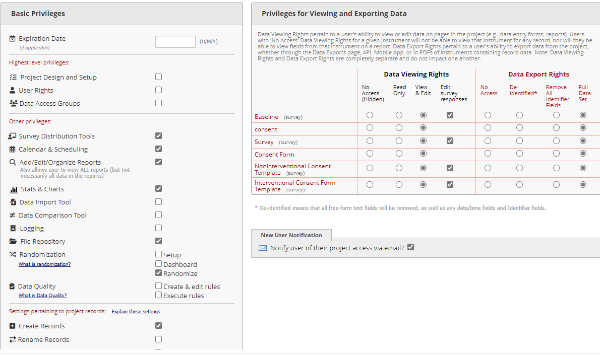
Or click on their name and then click on Assign to role, select the user’s role and click Assign.

• If the person is not found, this either means they do not have access to REDCap or they have not logged into REDCap before. You have to create a REDCap account using their email address and full name as username. Then add them to your project by entering their username e.g chris.scott.

Choose what you want the user to have access to. Select the appropriate rights and then click Add User.

Customizing User Rights
The Basic User Rights section is a checklist of REDCap modules that the user can access.
In general, users should be given access only to the modules that they require, and no more. This is known as the Principle of least privilege and acts both to increase the security ofyour project and to aid usability by removing unnecessary clutter from a user’s view.
Note the Project Expiration Date field gives you the option of permitting access for a specific period of time. Please note: this is different from an external user’s ACCOUNT expiration date.
The Data Entry Rights allows you to limit which instruments the user can access and how they will be able to edit data. If the project has surveys enabled, there will be a column for editing survey responses. A project with only data entry form(s) will not have that column. The Principle of least privilege applies here too.
At the bottom of the page are three buttons:
• Save Changes
• Cancel
• Remove User: remove the user from your project
For further questions about access to the NSHA REDCap installation, please see this section of this user page.

Removing a user (remove a user)
To remove a user from your project, select their name from the User Rights list and click on Edit User Privileges. You can click on the “Remove User” button.
Please note, if you wish to remove a user from your project and that user has been assigned to a role, you must first remove them from the role and then remove them as a user.
An alternative to removing the user is to expire them as a user by putting the last date they should have access to the project in the expiration date field of their user rights.
User Roles
A role is simply a template of user rights. Users assigned to a role are granted the set of rights that the role is configured to have.
Create a Role
You may name and define project-level user roles (e.g., Data Manager, Data Entry, Project Manager, etc.), then assign users to the appropriate role. This feature allows you to quickly and consistently designate user privileges by their specific role in the project.
Creating a role is similar to creating a user with custom rights: enter a name for the role (e.g. “Project Manager”, “Data Entry” etc.) and click Create role.

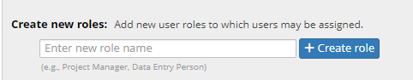
Configure the rights associated with the role and click Create role

Add a New User to a Role
Enter the user’s name or username into the “Assign new user” text box, click Assign to role and select the role to which the user should be assigned.
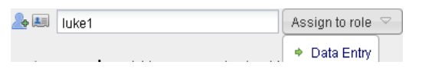
Change a User’s Role
You can change a user’s role (or assign an unassigned user to a role) by clicking on the user’s name, then clicking Assign to role and then selecting the role.
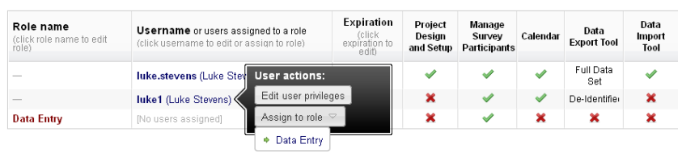

Data Imports
- Create the project and fields/questions within REDCap.
o Note: Before importing real data, move the project to PRODUCTION status.
- Once the project is in Production, navigate to the Data Import Tool.
- Please review the detailed instructions on the Data Import Tool page.
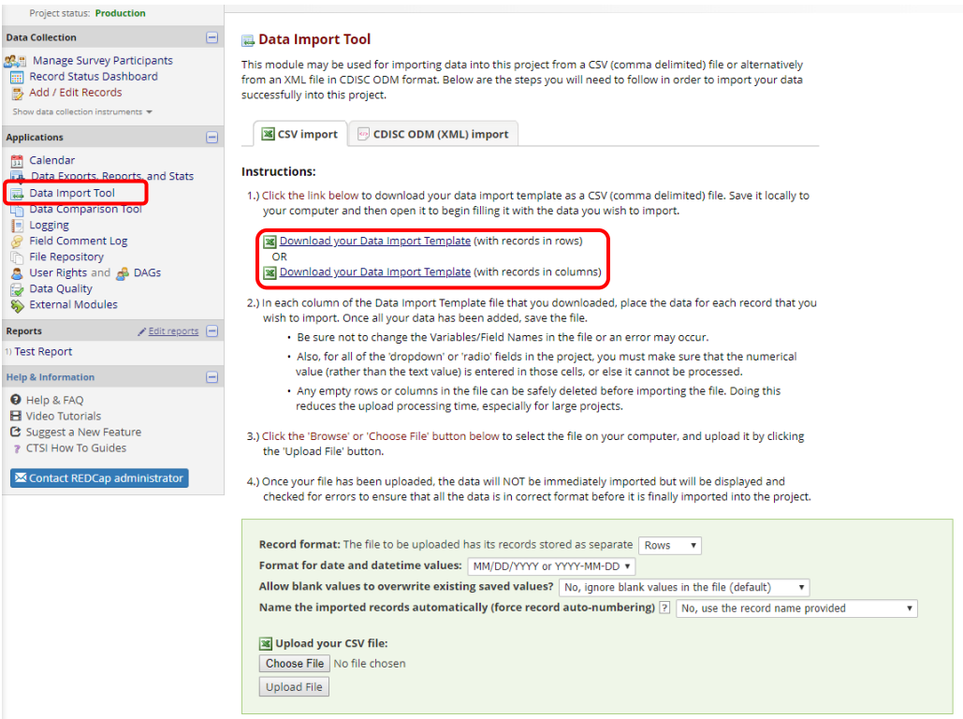

Download the Data Import Template.
• Save the Data Import Template locally to your computer. Begin completing the template with the data to be imported.
o Note: Each record will need a RECORD ID before the data can be imported.
o Save the file in the .CSV (comma delimited) format.
To follow is an example:
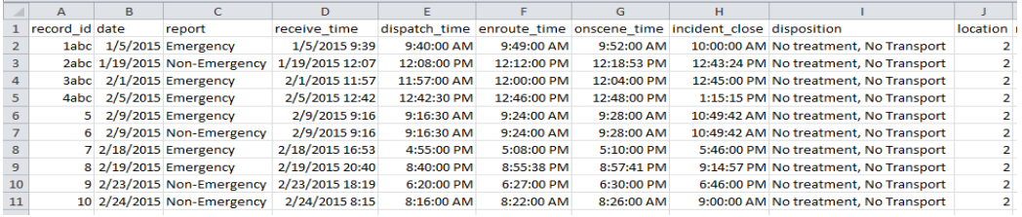
- Once the data is ready to be imported, navigate back to the Data Import Tool. Click on ‘Choose File.’
o Select the file then and select Upload File.
- Review the import for any errors.
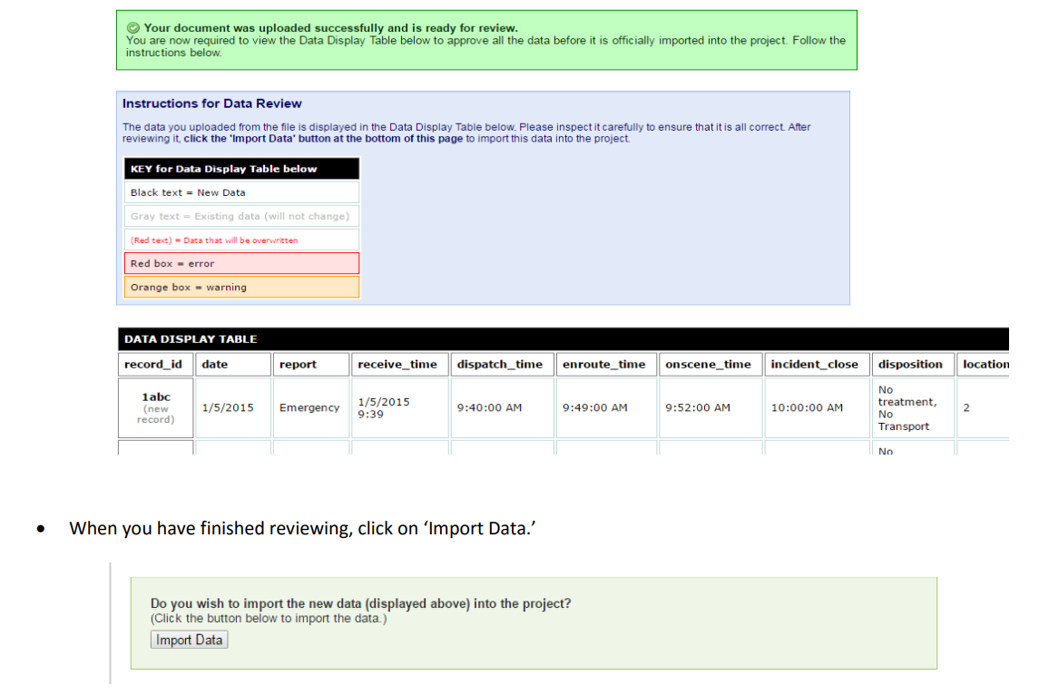
Best Practices when importing:
o When importing date fields, ensure all dates for the variable are in the same format.
o Text can only be imported into Text Box (Short Text) or Notes Box (Paragraph Text) fields.
o When importing multiple choice (Single Answer radio button or dropdown), ensure the raw value that correlates to the appropriate text selection is in the field associated with the variable name. You cannot import the text (label) values into multiple choice fields

File Repository
This application may be used for storing and retrieving files and documents used for this project. For instance, if you have an SOP (standard operating procedure document) or any other reference document which team members might need access to, you can upload it here.
The User Files menu tab is where you view all files that have been uploaded for a project.
Notes:

E-signature and Locking Management
Record locking and e-signatures are optional features that can help you gain greater control over the status of the data in your project.
Records that are locked cannot be updated unless the lock is first removed by a user with record Lock/Unlock permissions.
Locked records can be electronically signed. A signature becomes invalid if the record is later unlocked.
The Customization Module enables configuration of your preferences for locking and e-signatures. By default, they are switched off, but you can enable locking and/or e-signatures for specific forms.
The E-signature and Locking Management page gives you various views over the Lock/Sign status of your data entry forms.

Data Quality
This application will allow you to execute data quality rules upon your project data to check for discrepancies in your data. Predefined data rules that are already developed for you in the application are for such things as missing values, field validation errors and outliers for numerical fields.
A “data quality rule” is a calculation expression that must evaluate to True or False. When a rule is executed on your project data any records for which the expression evaluates False can be viewed and potentially corrected.
The Data Quality page includes detailed instructions.

Execute Rules
Execute rules one at a time using Execute, or all together using Execute All Rules.
The Clear button refreshes the view to the state before any rules have been executed.
Discrepancies
Rules that identify discrepancies (i.e. where your project contains data for which the calculation expression returns False) are highlighted in red.
• Navigate to the record / form that contains the discrepant value by clicking on the value
• Clicking exclude will mark a discrepant value as not to be included as a discrepancy in future executions of this rule.

Add a New Rule
Add a new rule by entering a description of the rule and the calculation expression. Then click Add
For more information on calculation expressions see Calculated Fields. Remember that data quality rule expressions must evaluate to True or False.
Important Tip! If your expression includes a “less than” sign (<) ensure that you include a space after it (as shown above). This stops the page thinking that you’re entering a potential harmful HTML tag and stripping out the remainder of your expression! Using “Less than or equal to“(<=) is fine – this problem does not occur.
Real Time Execution
Ticking the Execute in real time option is a useful mechanism for performing cross-field validation checks during data entry. Rules where this option is ticked will be execute each time you save a data entry form that contains a field that is part of the expression.
Note that the rules are executed on data entry forms only: NOT when importing data via Data Import or API, and NOT during survey data entry.

eConsent
There is an electronic consent (or eConsent) framework available in REDCap. This is typically used when consenting participants for a research study. The eConsent framework only works as a survey (not a data collection instrument.) Please see Survey Termination Options/Auto-Archiver = eConsent Framework above.
Setting up eConsent
You will need to design the content of your eConsent form. That will be dictated by what was approved by the IRB. You will add the fields to that instrument that provide the information you want given to the participant and then have the fields that you want the participant to complete. The eConsent framework then provides the mechanics by which the participant is able to review the information they have provided before submitting and also saves an electronic version of their consent into the file repository of your project.
1. Design your consent survey in Online Designer
2. If you wish the consent survey to be distributed via the public survey link, the consent survey will need to be the first instrument in your project
3. Enable the eConsent instrument as a survey by clicking ‘enable’ under the column “Enabled as survey.”
a. If you are not seeing the Enable button, that means you do not have surveys enabled on your PROJECT. Go to Project Setup and click on the button ‘use surveys on the project’
4. You will be brought to Survey Settings
5. To set up eConsent framework, see the section called “PDF Auto-Archiver.” In that section, select the option “AutoArchiver + e-Consent Framework.” You can read more about that framework by clicking on “What is the e-Consent Framework?” hyperlink in that section.
6. Be sure to click the Save Changes button at the bottom of that page.

Viewing eConsent Documents
As a participant submits their survey in a project that has the eConsent framework enabled on it, their signed eConsent form will go directly to your Projects File Repository. You can access the File Repository on the left-hand navigation bar under Applications.
Editing e-Consent documents
You may need to edit a participant’s eConsent form (for instance, if they entered their name as Rob and it should be Robert. If you anticipate this might happen, tick the box for “Allow e-Consent responses to be edited by users?” (see image below.)

Updating your e-Consent Form
As your study progresses, you may find that you want to edit the terms of the consent form. To do that, update your e-Consent survey fields and then change the e-Consent version number in the Survey Settings. This will make it very clear which version of the consent document that the participant signed.

